College of Engineering, Design and Computing
infoEd Preaward Manual

This manual is to guide the PI/department staff member through the steps of creating a proposal in infoEd. The manual contains instructions for both manual proposals (NSF, industry, non-system-to-system proposals) and for system-to-system proposals that go from infoEd straight into Grants.gov.

Contents
Step 1: log into infoEd 3
Step 2: Login 3
Step 3: Create new proposal 4
Step 4: PI name 5
Step 5: Grants.gov or Manual selection 6
Step 6: Proposal type 7
New 7
Supplement 7
Step 7: Sponsor name 8
Step 8: Title 8
Step 9: Dates. 9
Step 10: Review and confirm 10
Step 11: Setup screen. 11
Deadline type definitions 11
Facilities and administrative cost rate 12
On-campus vs off-campus rates: 15
Step 12: Budget. 17
Salaries 17
Other Direct Costs: 21
Subrecipients: 22
Subrecipient budget justification: 24
F&A rate: 25
Cost share: 27
Budget justification: 29
Changing budget dates or PI: 30
Completing the budget: 32
Step 13: The Personnel tab 33
Step 14: Performance Site. 34
Step 15: The S2S forms 34
Step 16: Approvals. 34
Step 17: Other Project Info. 36
Step 18: The UCD/AMC Documents tab 37
Routing Form 37
Supporting documents 42
Step 19: Finalize 46
Step 20: Submission 52

Step 1: log into infoEd at https://era.cu.edu/

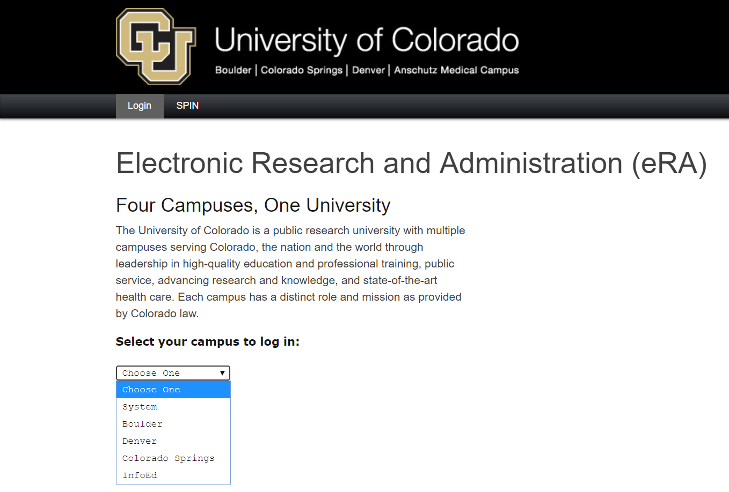

Step 2: Login You will be asked to provide your campus login information to access infoEd
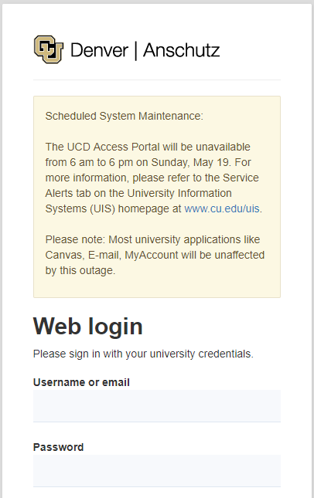

Step 3: Create new proposal Choose “Create New Proposal” from the menu under “Proposals”.
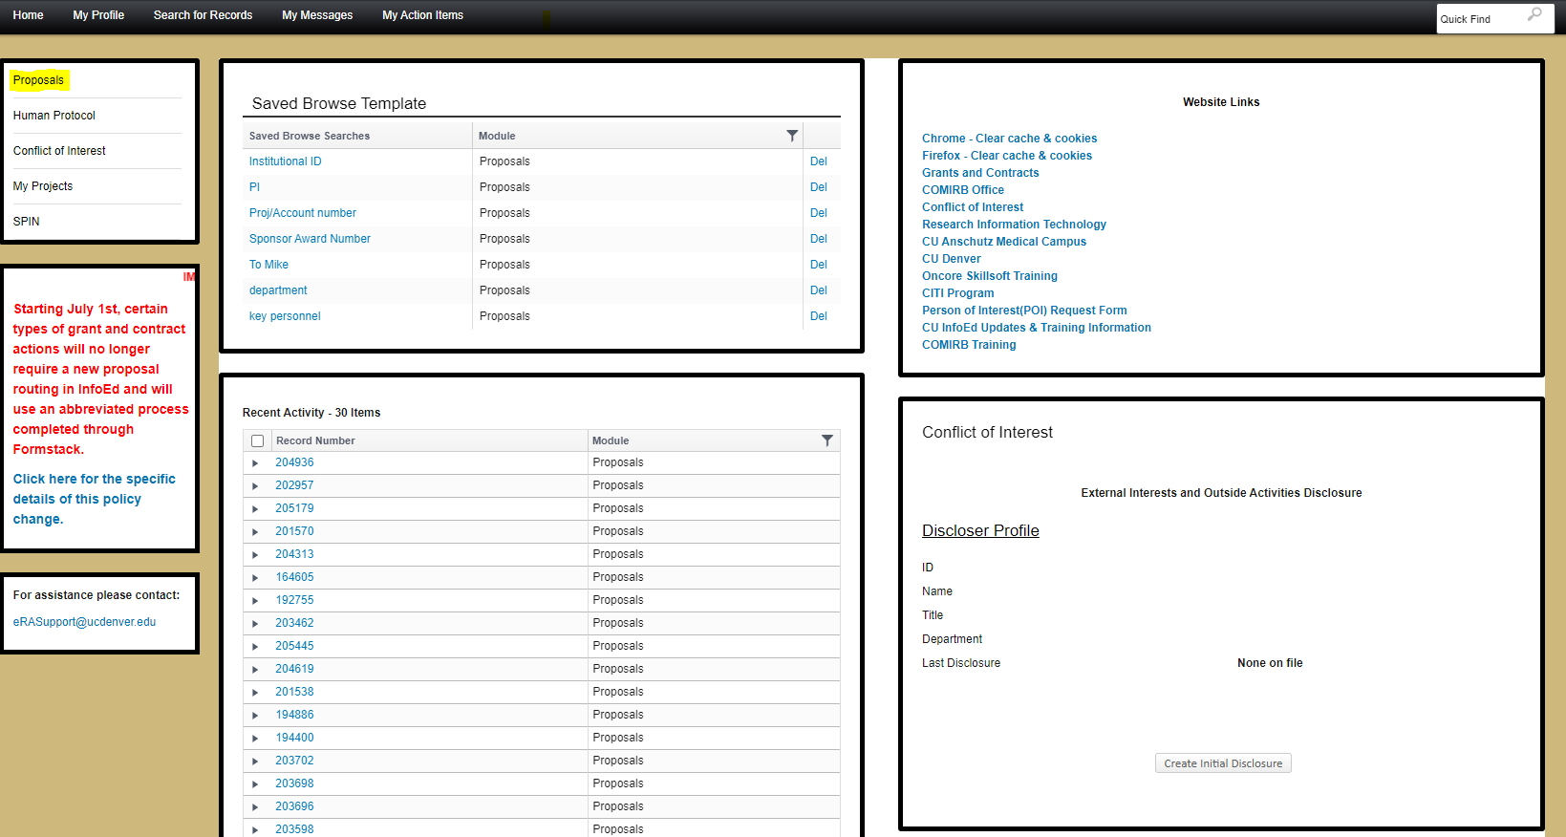

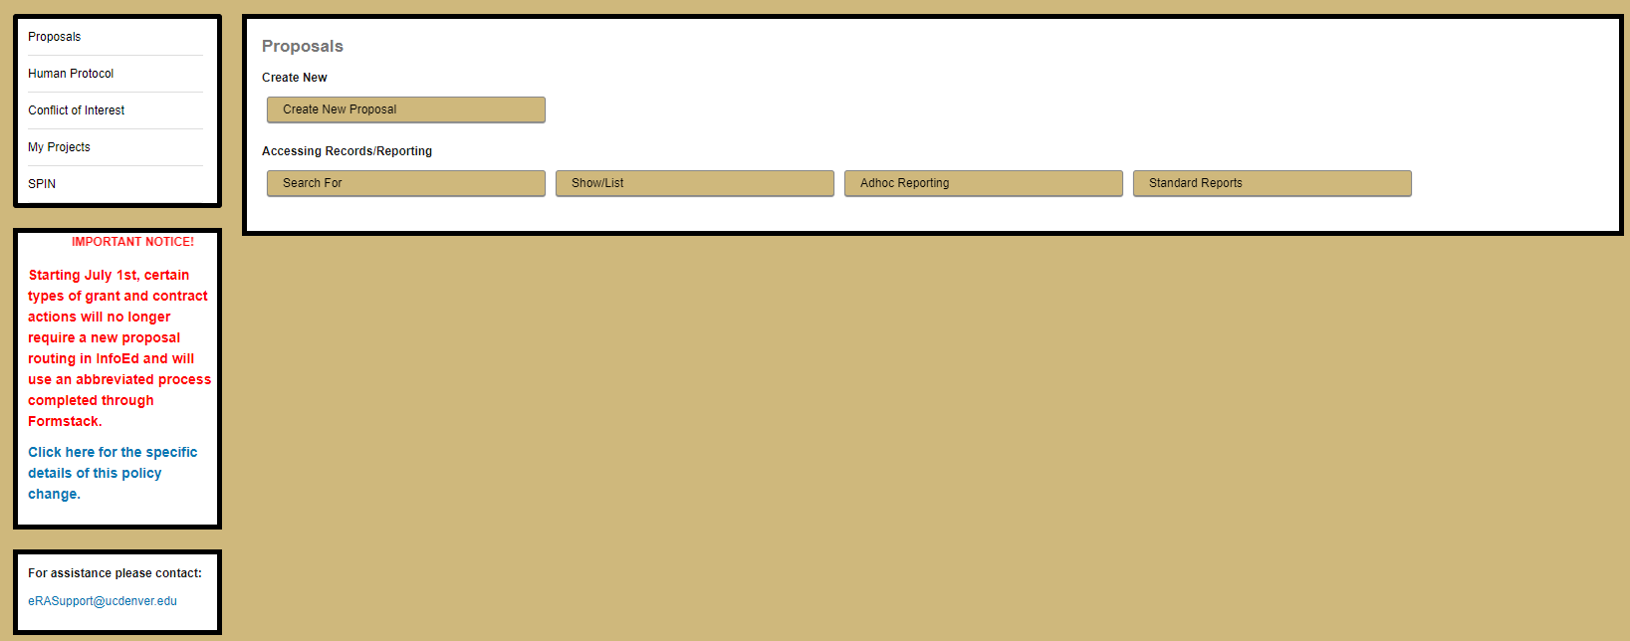
A pop-up window will open titled “New Proposal Questionnaire.” If you don’t see this pop-up window, make sure your browser is not blocking pop-ups.

Step 4: PI name If you need to change the name of the PI, click the blue hyperlink next to the name

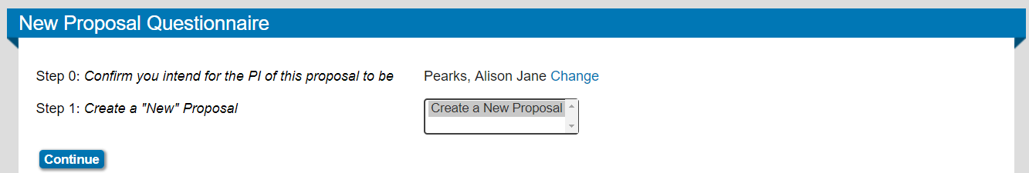

Make sure you have the correct institution chosen, and then type the name in the box and pick it from the drop-down menu.

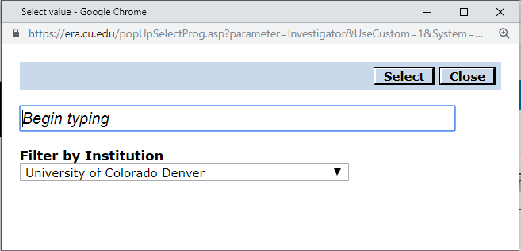

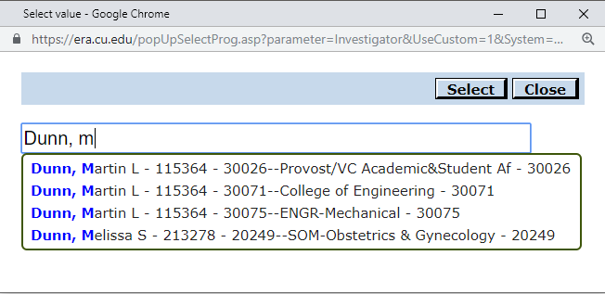
Press the “continue” button to move to the next step.

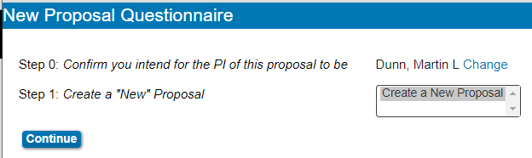

Step 5: Grants.gov or Manual selection If the proposal is to be submitted through Grants.gov, choose “Select from Grants.Gov Opportunities” and then click the “continue” button.

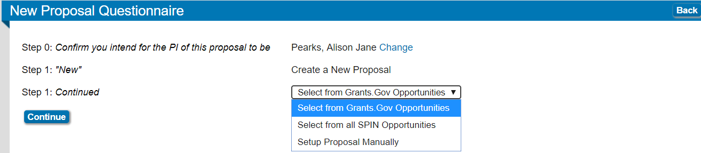

Enter the solicitation number into the search box and click “search”.
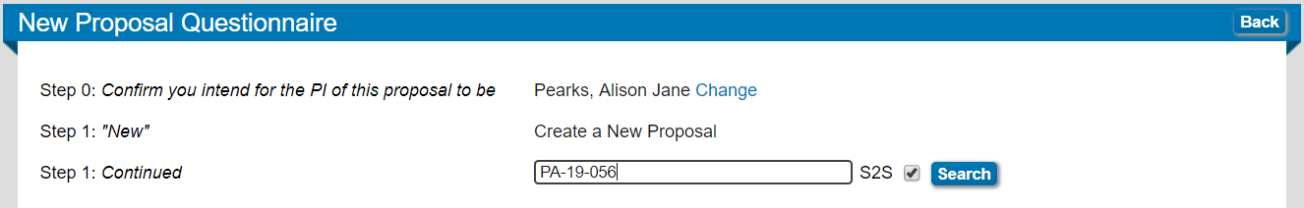

Confirm the correct solicitation has been found, and click the “select” hyperlink to choose it.
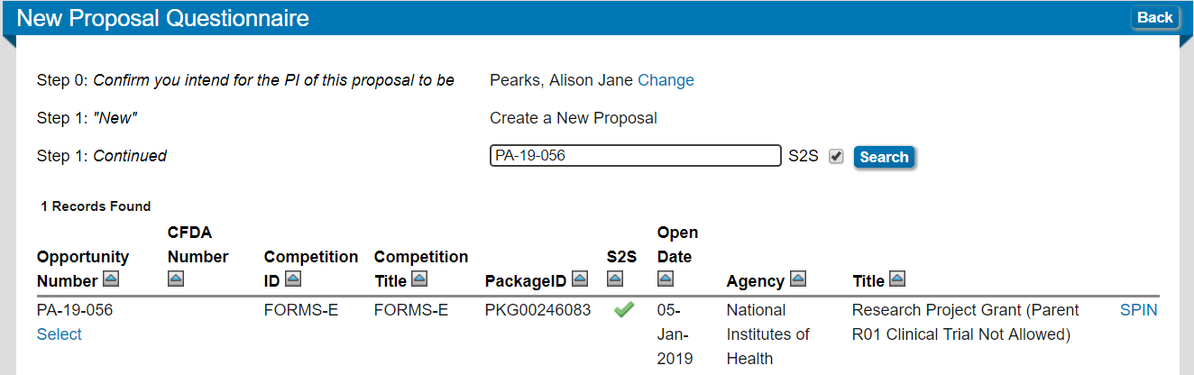

Otherwise, choose “Setup Proposal Manually” and click the “continue” button.
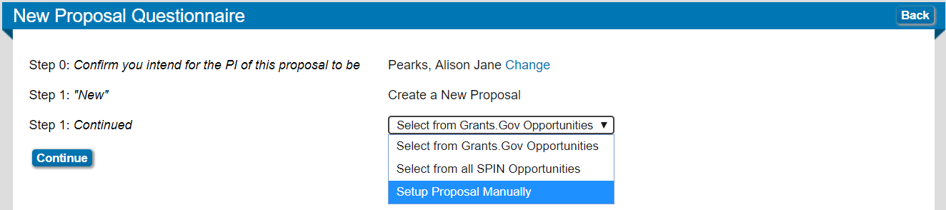

Step 6: Proposal type Select the proposal type (see definitions below), and click the “continue” button.

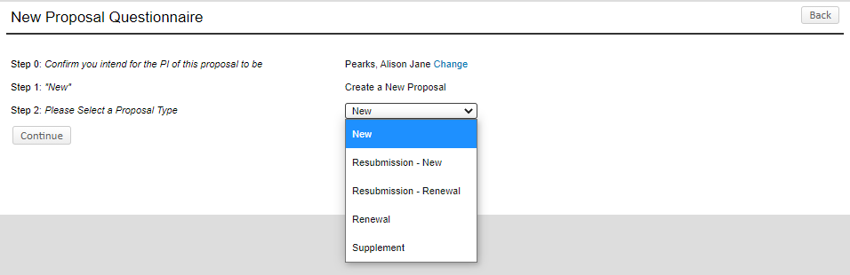

New – new proposals or contracts requesting new funding. This includes new notices of awards and option periods not included in the original award.

Resubmission – New – a second submission of a previously rejected proposal.

Resubmission - Renewal –NIH renewal applications can be resubmitted once; they are given the designation Resubmission – Renewal in infoEd.

Renewal - a type of NIH proposal requesting additional NIH funding for a period subsequent to that provided by the current award.

Supplement – proposals for supplemental funding to a parent award to expand the project’s scope. NIH refers to these types of proposals as Revisions; other sponsors refer to them as Supplements. OGC also uses this designation for a change in grantee institutions (transfers).

Step 7: Sponsor name Type in the sponsor name, select it from the drop-down list, and then click “continue.”

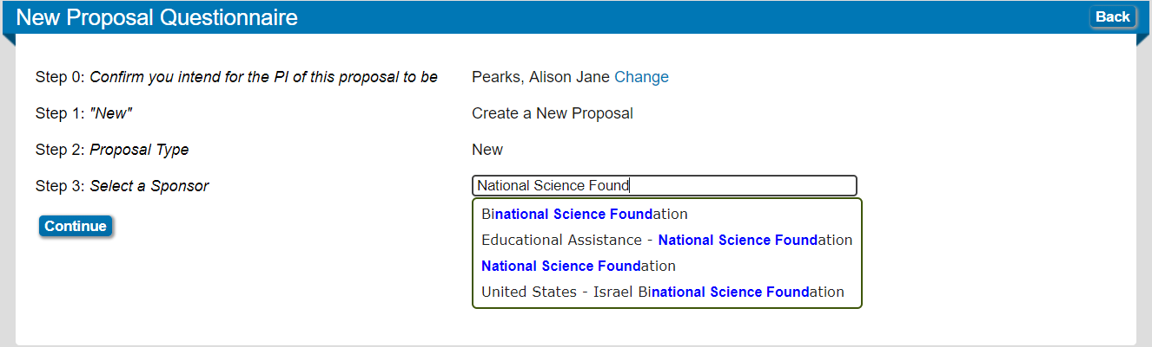

Step 8: Title Enter the proposal title into the box. The title can be changed later via the routing form if needed. Click “continue.”
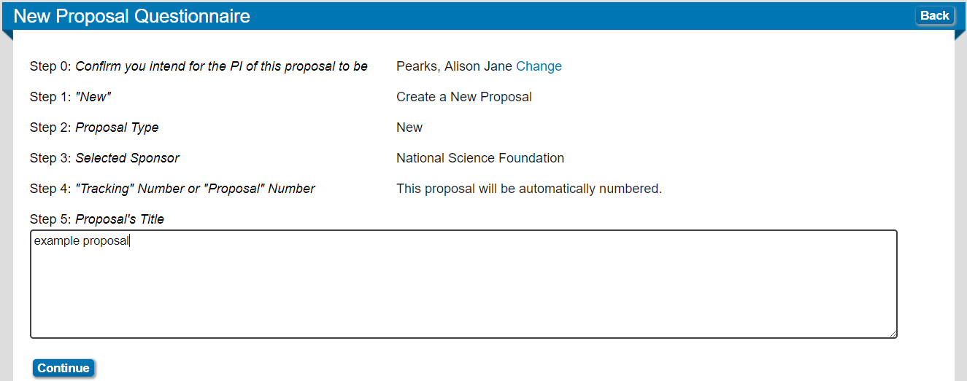

Step 9: Dates. Enter the start and end dates for the project. The system provides a calendar to select the dates, or you can type the date into the box. The date must be in the mm/dd/yyyy format.

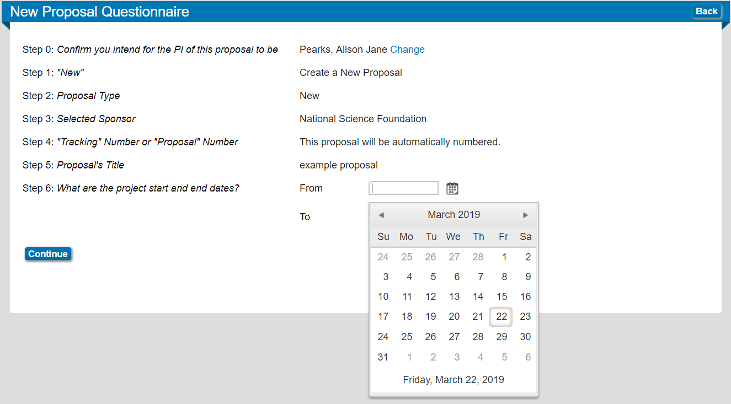

A single budget period will be assigned for each 12-month period. If you need more or fewer periods in the project period, you can indicate that here, or in the budget setup screen later. Click “continue” when done.

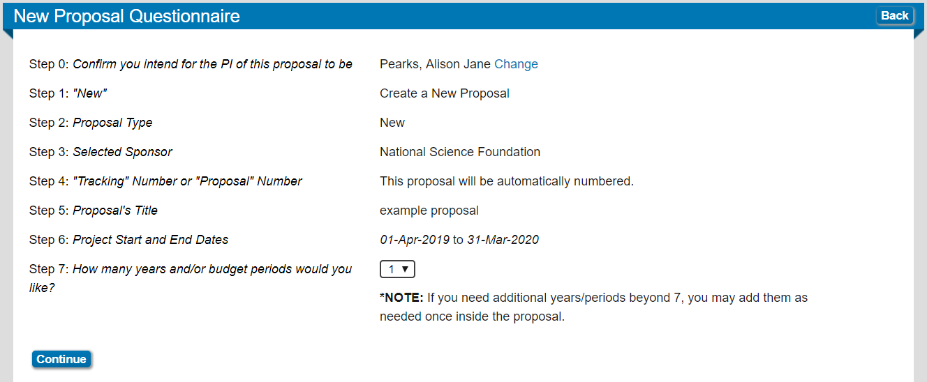

Step 10: Review and confirm the information entered, and if it is correct then click “create proposal” to generate the proposal ID number.

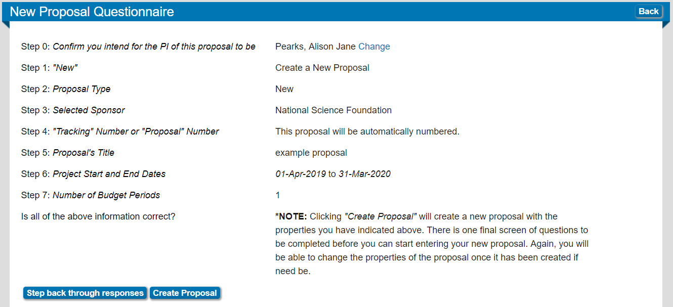

Step 11: Setup screen. When a proposal is created, the setup screen will be shown. Some of the options will be pre-selected, and others will need input. The items that need input are:

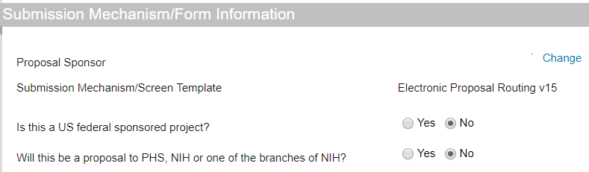

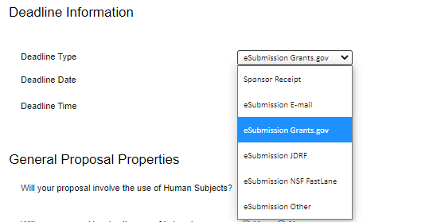

Deadline type definitions
- Sponsor Receipt – PI/Dept is responsible for final submission of competitive new, resubmission or non-competing continuation routing materials.
- eSubmission E-mail - for the rare sponsor that requires an email submission from OGC.
- eSubmission Grants.gov – for all competitive system-to-system Grants.gov submissions done by OGC.
- eSubmission JDRF – All JDRF submissions done by OGC through JDRF RMS360.
- eSubmission NSF Fastlane – All competitive National Science Foundation submissions by OGC through NSF FastLane. Note: Does not include NSF GRFP applications – select Sponsor Receipt.
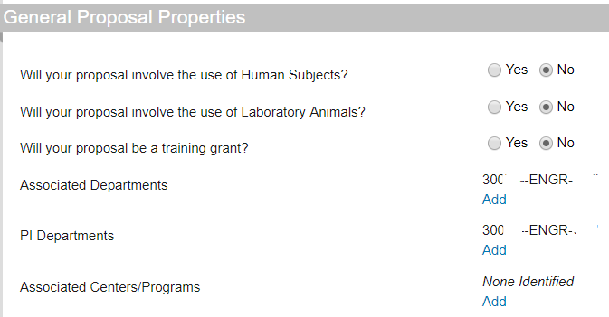

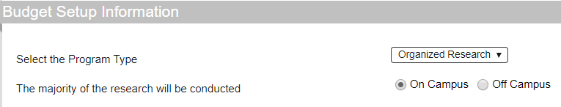

Facilities and administrative cost rate: The CU Denver federally negotiated rate agreement specifies several different facilities and administrative (F&A) costs that apply in different situations. For federal sponsors, the university’s federally negotiated rate must be used unless the federal guidelines for the submission state otherwise. The federally negotiated rate applies to organized research, instruction, and other sponsored activities; these are defined as follows:

Program type | Definition | Associated IDC rate
Organized research | All research and development activities of an institution designed to expand the body of scientific knowledge and to develop new technologies, including training of individuals in research techniques (commonly called research training) where such activities utilize the same facilities as other research and development activities and where such activities are not included in the instruction function. | 55.5% on campus, 26% off campus
Instruction | Instructional grants are designed to improve and enhance the quality of teaching. Instruction means the teaching and training activities of an institution, except for research training as described above. Instruction includes all teaching and training activities, whether they are offered for credits toward a degree or certificate or on a non-credit basis, and whether they are offered through regular academic departments or separate divisions, such as a summer school division or an extension division. Instruction also includes sponsored instruction and training, which means specific instructional or training activity established by grant, contract, or cooperative agreement. | 42% on campus, 26% off campus
Other sponsored projects | The performance of work other than instruction and organized research. Examples are health service projects and community service programs. | 26% regardless of location

The rate is calculated on modified total direct costs (MTDC), which are considered to be the total direct costs (TDC) minus costs for certain categories:
- Equipment
- Capital expenditures
- Patient care charges when provided by external entities (i.e. off-campus)
- Tuition
- Building rental costs
- Scholarships
- Fellowships
- IRB fees
- Any sub-recipient costs in excess of $25,000

There are certain other federally sponsored projects that can have alternate rates. Of note:
Program type | Definition | Associated IDC rate
Career development | Career development awards are usually provided to new researchers to foster their research opportunities. NSF CAREER and NIH K programs are examples. | Often sponsor specific (e.g. K grant indirect costs are capped at 8% MTDC); if no sponsor guidelines, CU Denver default rates apply.
Fellowship | Fellowships generally provide support to pre- and post-doctoral students at various stages of their career to obtain individualized, mentored research training. NSF Graduate Research Fellow and NIH F31/F32/F33 programs are examples. | Often sponsor specific (e.g. NSF Graduate Research Fellowships may not include F&A); if no sponsor guidelines, CU Denver default rates apply
Institutional training project | Training grants provide funding to develop or enhance research training opportunities, usually for pre- or post-doctoral work. Training grants generally provide funding for stipend and tuition support. DOEd GAANN grants and NIH T32/T34/T35/T90/R90 grants are examples. | Often sponsor specific (e.g. DOEd GAANN grants funds may not be used for indirect costs); if no sponsor guidelines, CU Denver default rates apply.

There are some specific situations where the CU system has determined that alternate rates should be applied:
Clinical trial | Non-federally sponsored, controlled, clinical testing in human subjects of investigational new drugs, devices, treatments or diagnostics, or comparisons of approved drugs, devices, treatments or diagnostics, to assess their safety, efficacy, benefits, costs, adverse reactions, and/or outcomes. | 28% of TDC regardless of location
Proof of concept | Specifically for CU Innovations or CU Boulder Venture Partner solicitations | 8%
Non-profit associations and foundations | When the sponsor is a registered non-profit or a registered foundation. | Sponsor policy or 10% TDC if the sponsor does not have a published policy.

There are some exceptions to the above rates:
- If the sponsor is a non-profit association or non-profit foundation and has a published and consistently applied policy on indirect rate recovery, the university will abide by that rate.
- If such a sponsor does not have a published and consistently applied rate, the university will cap the F&A rate at 10% of TDC.
- If a government, association, or foundation issues an RFP with restrictions on indirect cost recovery, the university will accept that restriction.
- For-profit sponsors must accept the university’s full F&A rate regardless of the entity’s established policy. If a private industry sponsor issues an RFP with restrictions on F&A rates or otherwise does not accept the university’s full rate, an F&A waiver will be required. The university highly discourages this practice, and any waiver must provide an extremely compelling reasoning. This process is lengthy and is granted in very limited situations. If the waiver is denied, the PI’s department is responsible for the difference between the university rate and the sponsor’s rate.

On-campus vs off-campus rates: in general, the on-campus rate will apply to organized research, career development, and instruction grants. The off-campus rate applies under the following circumstances:
- The proposed work is taking place at a university-designated off-campus building (identified by searching for “off campus” at http://www.ucdenver.edu/research/OGC/Pages/AtoZ.aspx).
- The proposed work is taking place at a location that requires rent and utilities to be paid and charged to the project.
- The proposed work is taking place at a sponsor-supplied office utilizing sponsor-supplied computer stations and utilities.
- The proposed work has 50% of the entire effort (not budget) occurring off-campus, including any analysis or reporting effort related to the project.

If this is a Grants.gov submission, optional forms may need to be selected for inclusion

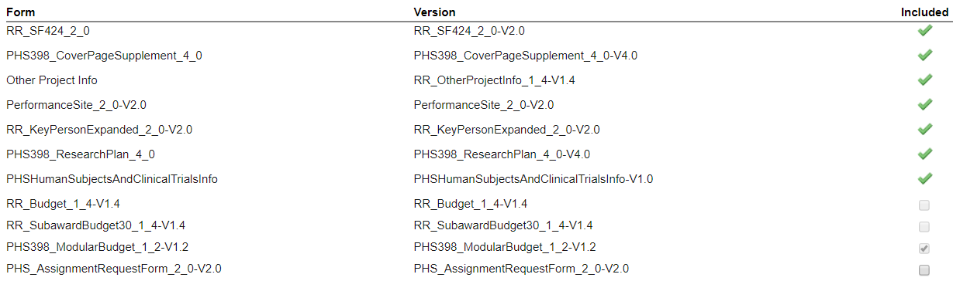

When this page is completed, click the “Completed” box in the right end of the blue ribbon containing “Setup Questions” at the top of the page.

A pop-up box will appear from era.cu.edu that instructs you to click “ok” to save your changes. The page will refresh when the “ok” button is clicked and the answers will then be locked. A blue checkmark will appear next to “Setup Questions” in the menu on the left side of the screen.

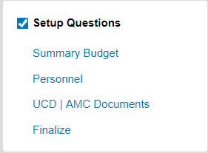

If any of the answers need to be changed, uncheck the “Completed” box to reopen the questions.

Click on the “Summary Budget” link in the menu on the left side of the screen to go to the budget entry page.

Step 12: Budget. The budget screen will open as a popup window. Maximize this window to see the full budget screen.

- Entering the budget into infoEd is required for a system-to-system submission through Grants.gov or ASSIST.
- For manual proposals that are submitted through another portal (ie Fastlane or NSIPRES) or by the PI, it is best practice for the budget to be entered into the infoEd portal.
- Cost-sharing should be entered into the infoEd budget portal and marked as mandatory or voluntary, and in-kind or cash.
- If the sponsor requires different IDC rates to be applied to different elements of the budget, the budget can be entered as Other Direct Costs and the F&A entered manually.
- In all cases where the budget is not submitted system-to-system, OGC will reference the separately uploaded budget spreadsheet before utilizing the budget entered into infoEd.

Salaries: The PI will be autoentered under Key Personnel. To enter the salary information, click on the “detail” button to the left of the PI name; this will open a pop-up window for the budget information.

Budget entry for salaries is best done by entering the number of months, the salary dollar amount, and fringe dollar amount directly. It is not necessary to enter in the base salary or use the included escalation calculator. Click “Save and Close” when the information is entered for all years of the budget.

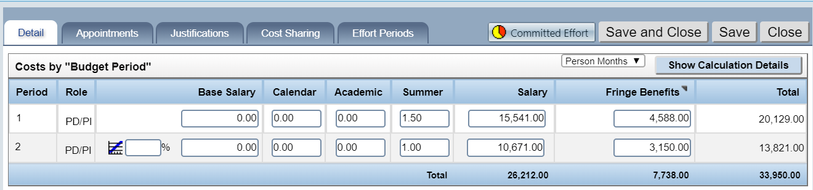

To add co-PIs or other named personnel to the budget, type the last name into the “Begin typing to select Personnel Name” box and select the employee from the drop-down menu. Indicate whether the person is Key or Non-Key and what their role is. Click the “Add person” button to add them to the budget.

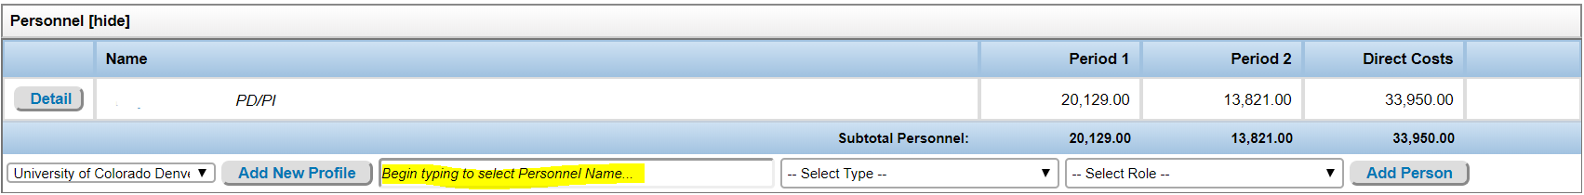

A pop-up window will automatically open for the salary and benefits to be entered. Click “Save and Close” when you are done to save the entry to the budget.

If a To Be Named (TBN) person needs to be added, click on the “Add New Profile” button.

A pop-up box will appear titled “New Profile.”
- Type “TBN (category)” in the Last Name box.
- Click on the blue hyperlink “set” next to Department to open the Department popup box.

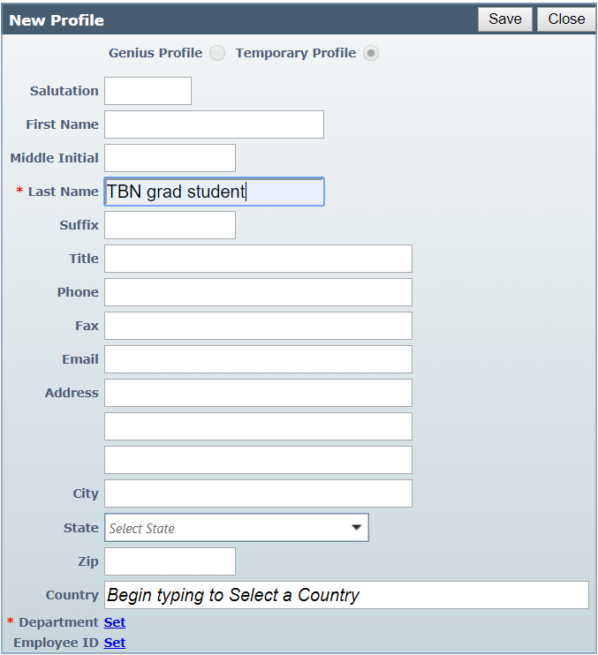

To select the department:
- Enter the name of the department
- Click the name in the drop-down menu
- Click the “locate” button.

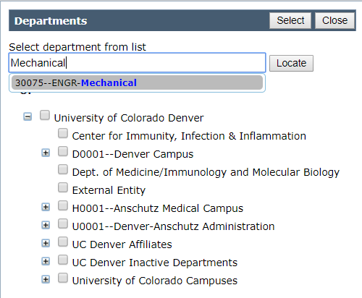

The department will show up in the list beneath the box with a checkmark next to it. Click “select” to close the popup box.

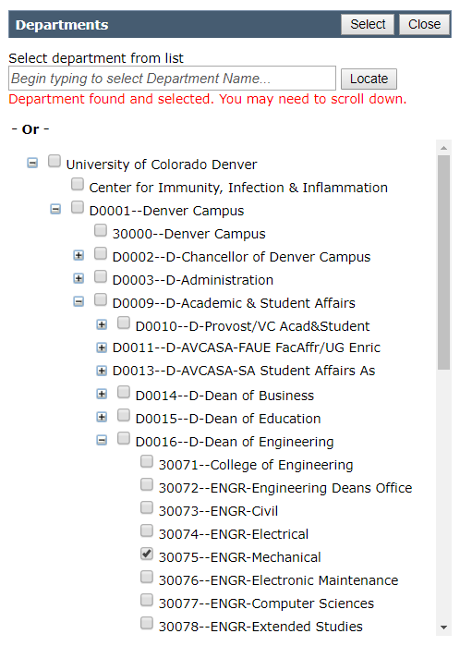
The department should now be shown as a hyperlink where the word “set” used to be next to “Department.” Click the “Save” button.
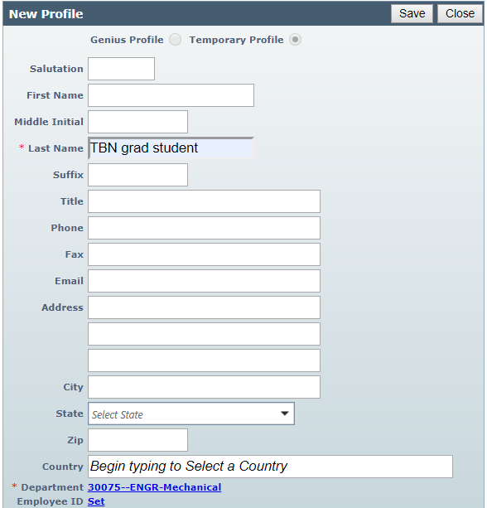

The pop-up window will close and the TBN person will be added on the main budget window. The personnel type and role need to be selected on the main screen before the “Add Person” button can be clicked.

A salary popup will then open and the TBN personnel’s salary can be entered. For Non-Key personnel, more than one person can be entered per category if they are working at the same level of effort and for the same salary. Students can work a maximum of 4.5 academic months and 3 summer months per person. If more than one student is budgeted per line, multiply the number of students by the number of months. The dollar amount of salary and fringe should be given as a total for all personnel listed in the line. Click on “Save and Close” when the entry is complete.

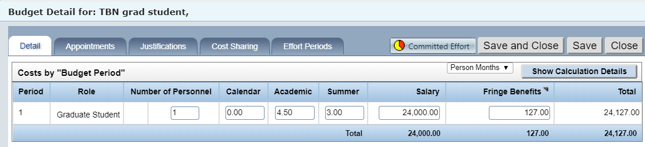
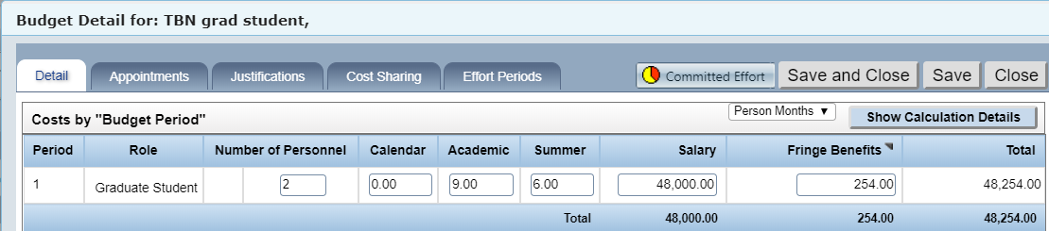
Other Direct Costs: Drop-down menus are available for Other Direct Costs categories. This list can vary depending on sponsor; if a category is needed that is not included in the provided list contact eRA Support at erasupport@ucdenver.edu to have the category added. Click on “Add Item” when the category is selected.

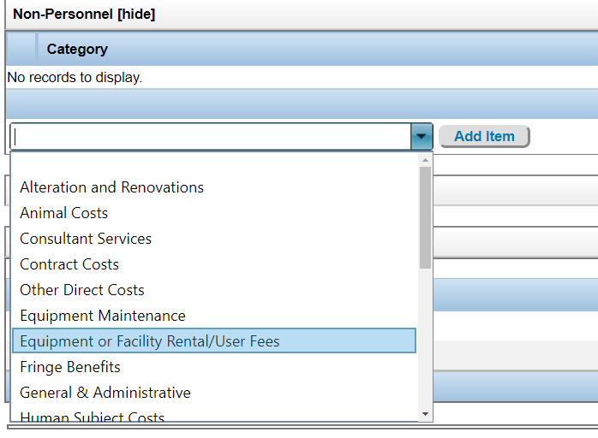

A pop-up window will open. Enter the dollar amount, and click “Save and Close” to add the item to the budget.

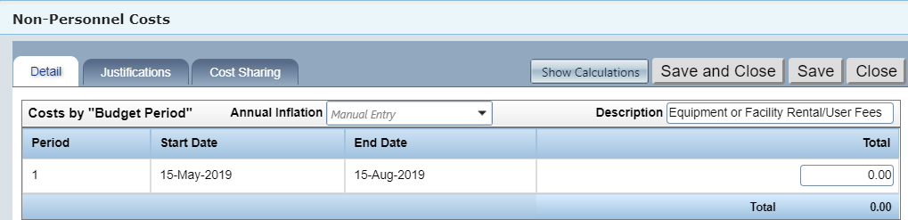

There is an item on the list for tuition remission. Directly entering the total amounts is better than using the included escalation calculation.

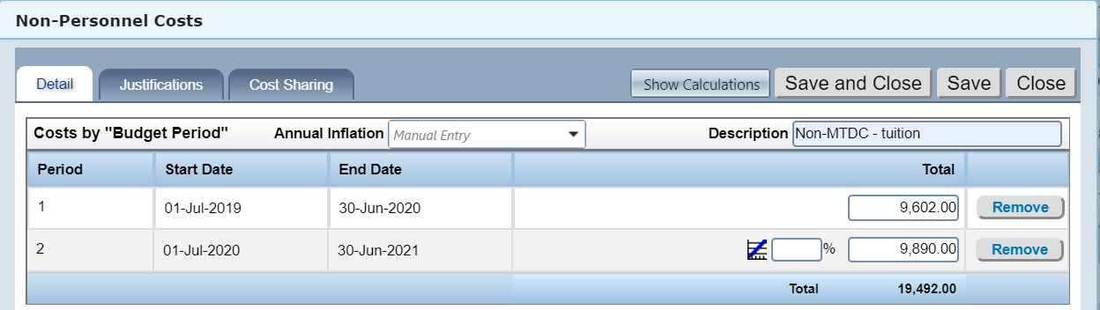
Subrecipients: To add a subrecipient, type the first part of the subrecipient institution name into the “Begin typing to select a Subaward Institution name” box, and select the appropriate institution. Only choose institutions that have asterisks next to them. If the institution you need is not listed, contact erasupport@ucdenver.edu to have it added. Provide the entity name, DUNS number, congressional district, and address.

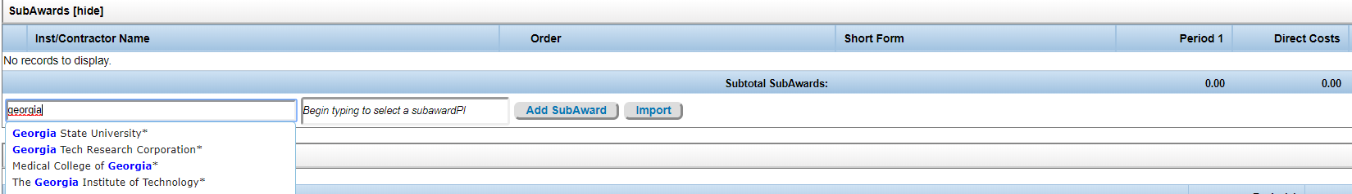

Type the subrecipient PI name into the “Begin typing to select a subawardPI” box. If the appropriate person appears, select the name.

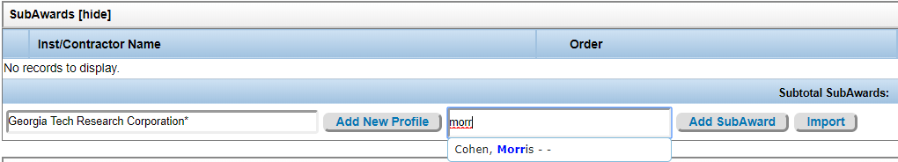

If the subrecipient PI name does not appear, click on the “Add New Profile” button to the left of the PI name box. A pop-up window will appear that is similar to the one used to add TBN personnel. Add the first and last name and select the institution under “Department”. Click on the “Save” button to add the name to the institution.

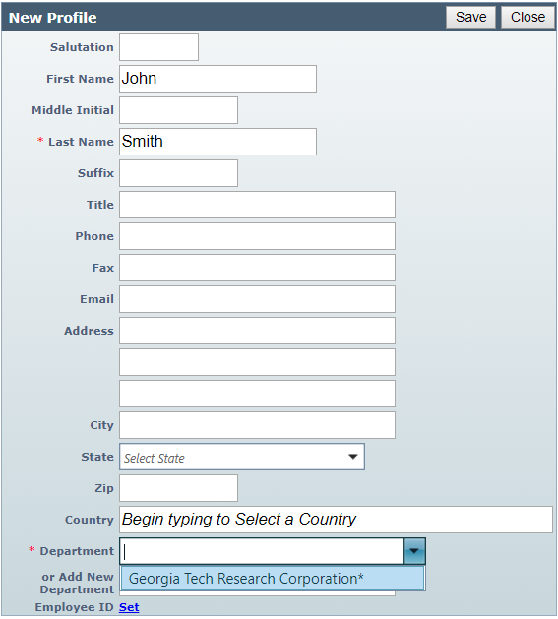

When the subrecipient institution and subrecipient PI are selected, click on “Add Subaward.”

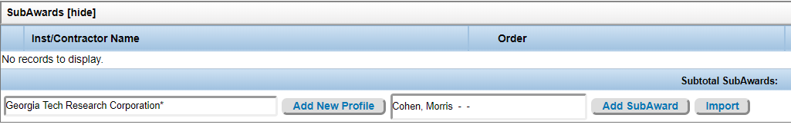
A pop-up window will appear that will permit you to add the subrecipient to some or all of the budget periods. If the subrecipient will only be on the project for some of the project period, here is where you indicate that timeframe.

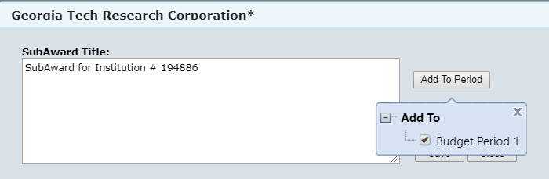

Otherwise, click the “Save” button to add the subrecipient to the budget.

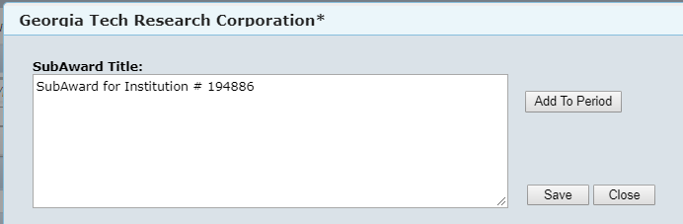

The screen will refresh and a “Detail” button will appear next to the subrecipient name in the budget form. Click on this button to open a separate budget form for the subrecipient.

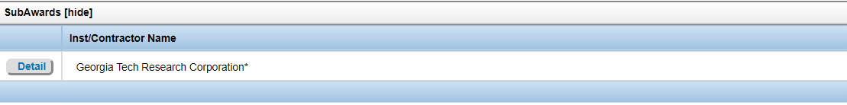

The subrecipient form is completed much like the main budget, with the exception of the F&A rate and amount. As the rate and base of calculation can vary from institution to institution, the fields in the subrecipient budget only are set for manual entry.

Enter the subrecipient’s institutional means of calculating indirect cost (modified total direct cost, or MTDC; total direct cost, or TDC; or salary and wages), their negotiated rate, and the amount of the base for the IDC calculation. The total amount will auto-populate based on the rate and base; if the total amount matches what the subrecipient has provided that indicates the information is correctly entered.

Subrecipient budget justification: The detailed subrecipient budget justification must be uploaded with the subrecipient budget. The menu on the left side of the screen has a hyperlink for the budget justification; clicking on this link opens a window where the justification file can be chosen for uploading.

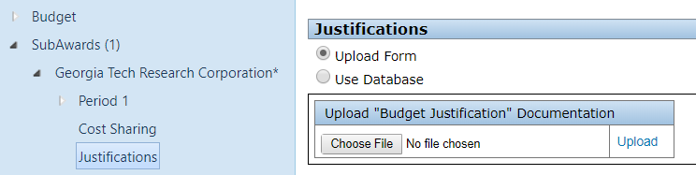

Choose the file from your saved documents and then upload it by clicking on the
Upload hyperlink.
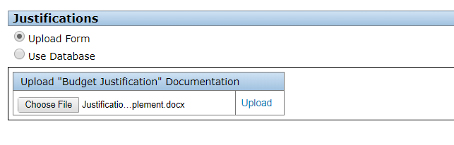

When a file has been uploaded, a set of radio buttons will appear on the page and the document upload box will revert to “no file chosen”.
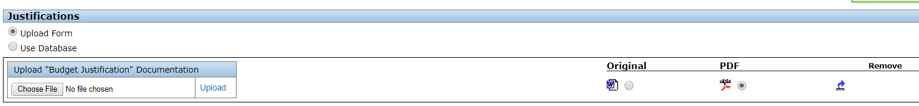

Click the “Save” icon in the upper left corner of the screen and then return to the main budget by clicking on the “Budget” hyperlink.

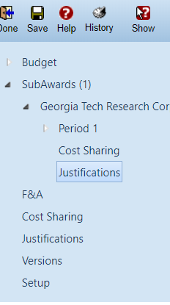
F&A rate: The F&A rate is automatically set by the program type and the on-campus or off-campus designation. If the F&A calculations need to be changed, that can be done on the F&A screen. Click on the F&A hyperlink to get to the F&A screen.

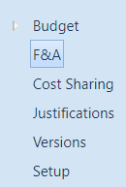

Items that can be changed that will affect the entire F&A calculation are at the top of the screen. Each item has a drop-down menu that provides the other auto-calculate options. If you have incorrectly chosen during the proposal setup whether the type of proposal or whether the on or off campus rate applies, this is where that information can be updated. The information in both the “Institution Base/Target Scheme” and “Scheme” boxes will need to be changed; the “Rate” will auto-update when the “Scheme” is changed. Clicking on the “Apply” button will then apply the correct rate for the updated scheme.

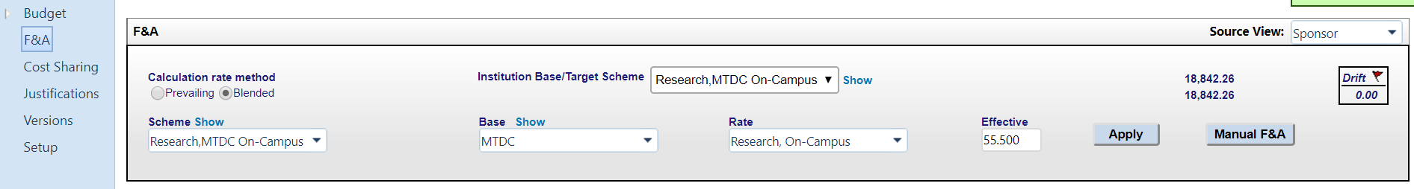

If necessary, clicking on the “manual F&A” button permits line-item editing.

Editing boxes will then appear that will allow the F&A base and requested F&A for each item to be changed. This can help correct instances where F&A has been calculated on a direct cost that is excluded from F&A, such as participant support, tuition, or equipment.

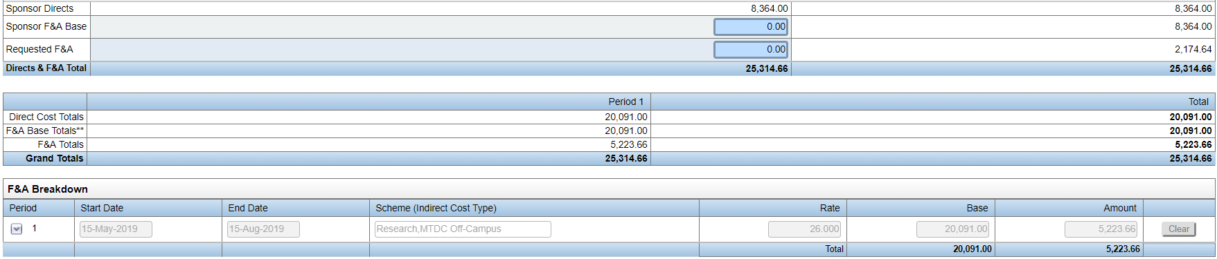

Either the F&A base and requested F&A for an item can be changed, or the overall rate and base in the F&A breakdown can be changed, but not both.

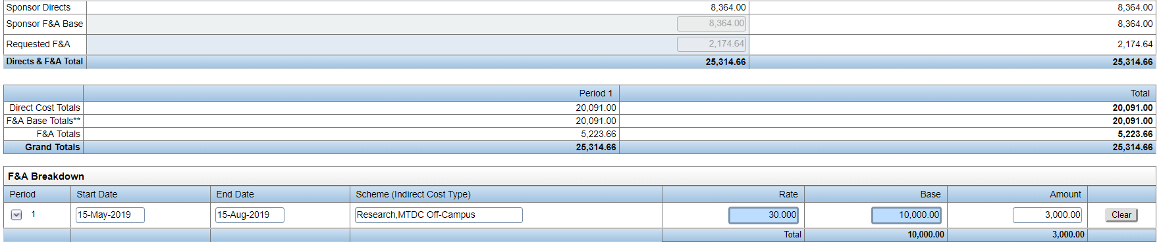

To save your changes, click the “save” icon in the upper left corner of the screen. However, getting the system to save these changes is a bit hit-or-miss. If the budget is going in system-to-system and must be accurate and there are issues with entering the budget, contact eRA Support at erasupport@ucdenver.edu. If you need to modify any of your changes, you will need to push the “Apply” button. This will reset all calculations to the overall budget scheme. Any changes that have been made to individual entries will revert, and you will have to redo all changes that need to be made.

Cost share: Cost sharing is accessed in one of two ways. The cost sharing screen can be accessed by clicking on the “Cost Sharing” hyperlink. Clicking on the “detail” button opens up a screen for the cost sharing details.

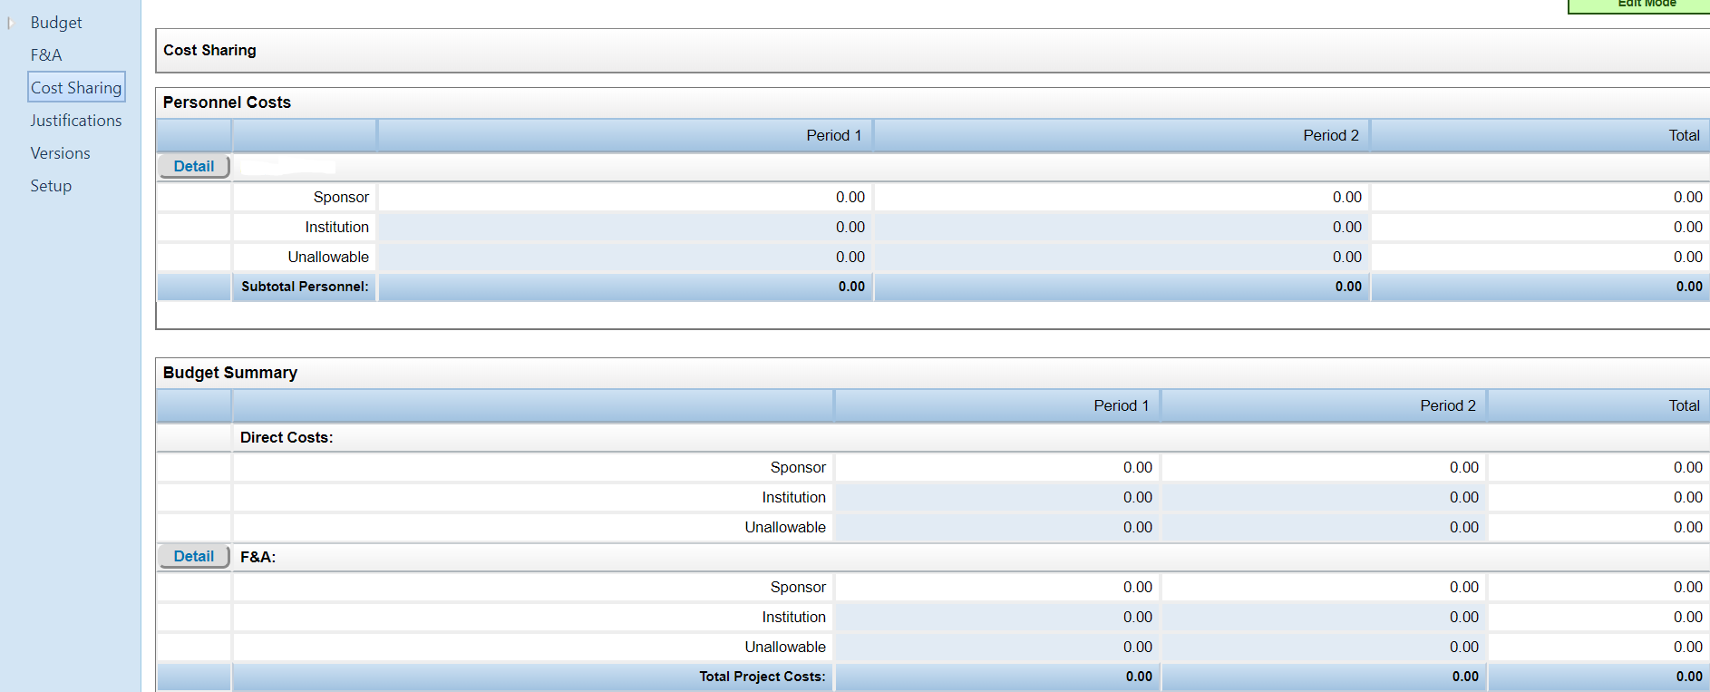

Alternatively, in the main budget screen, when each item is opened to access its details, there is a tab available for cost sharing information.

Cost sharing can be done for individual direct costs or just for F&A. If a direct cost has cost sharing on it, the F&A for that amount will auto-calculate and be included in the cost sharing amount. Be aware of this if the sponsor does not permit F&A to be cost shared on direct costs.

Cost sharing is normally split between the sponsor and the institution. There is a section for cost sharing that is named “unallowable”; this is for items such as the auto-calculated amount of salary over a salary cap that cannot be used to satisfy cost-sharing requirements. This type of cost should be auto-entered by the system.
Cost sharing can be entered either in a breakdown manner or in a build-up manner. If the breakdown method is chosen, the percent, salary amount, or fringe amount can be manually entered in any of the three categories (sponsor, institution, or unallowable), and the other entries for that period will autocalculate. The percent must total to 100%.
If the build up method is chosen, you will have to manually enter the splits between sponsor and institution. The percent must total to 100%.
Choose the type of cost sharing and the category. Only two types are pertinent:
- Mandatory: required by the sponsor
- Voluntary Committed (aka Obligatory): not required but stated and therefore must be tracked

Categories; only two types are pertinent:
- Cash: contributions from an allowable CU Denver fund to cover the costs of personnel effort expended on the project
- In-kind: non-cash contributions made by sources outside of CU Denver

When done click on the “Save and Close” button to save the entries.
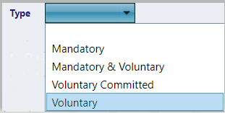
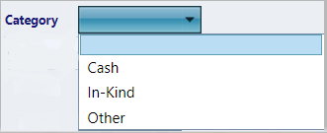
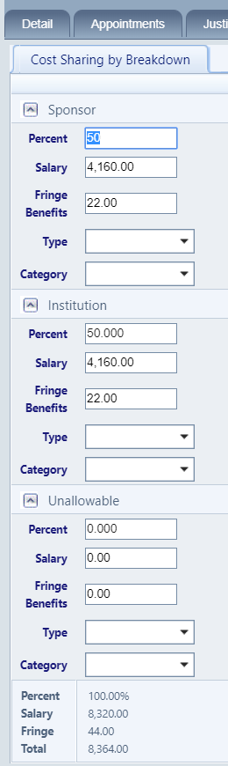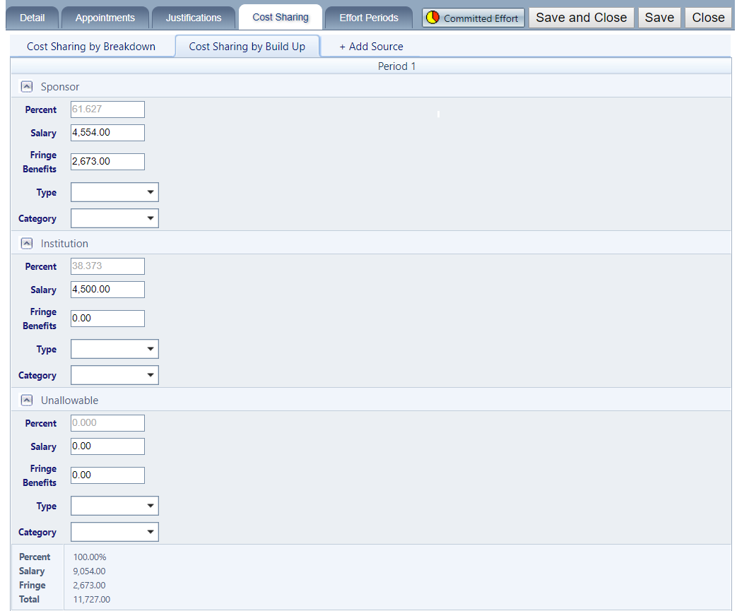
Budget justification: The budget justification for the main budget must be uploaded in the budget portal. This is separate from the justification you would have loaded earlier for any subrecipients. The menu on the left side of the screen has a hyperlink for the budget justification; clicking on this link opens a window where the justification file can be chosen for uploading.
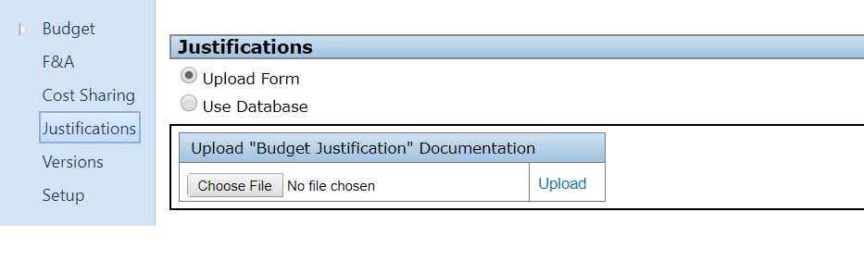

Choose the file from your saved documents and then upload it by clicking on the
Upload hyperlink.

When a file has been uploaded, a set of radio buttons will appear on the page and the document upload box will revert to “no file chosen”.

Click the “Save” icon in the upper left corner of the screen to save the uploaded justification.

Changing budget dates or PI: Should you need to change the budget dates or PI designation this can be done in the setup section of the budget. Entering a new Project Start date in the Shift Project Dates section will keep the original budget length and shift the entire budget to the new timeframe. If either the end date or the entire budget period needs to be changed, that is best done in the Budget Period section. Entire budget periods can also be added or deleted in this section. If a sponsor requires multiple budget periods within a calendar year, this is where the budget periods can be changed to meet those specified timeframes.

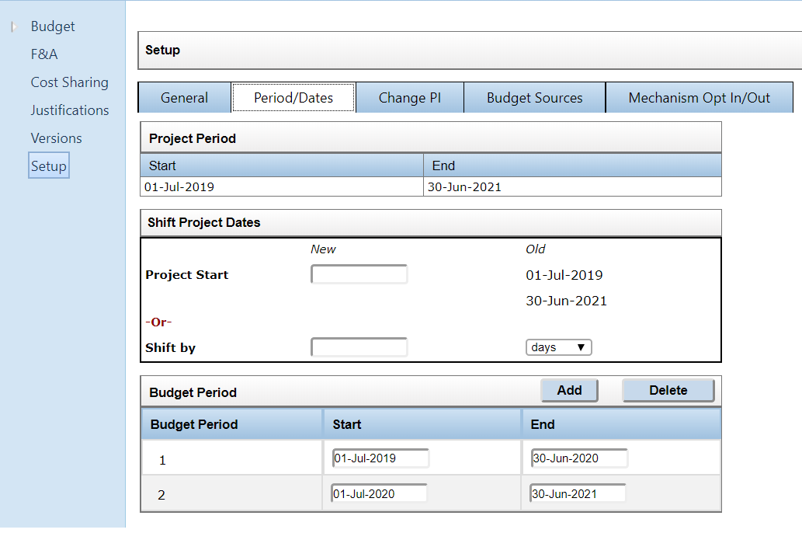

Click on the “Save” icon in the upper left corner of the screen to save your changes.

There are two options when replacing the PI: leave the current PI on the proposal or remove the PI entirely. Select the appropriate option from the dropdown menu in the “Change PI” tab in the Setup section.

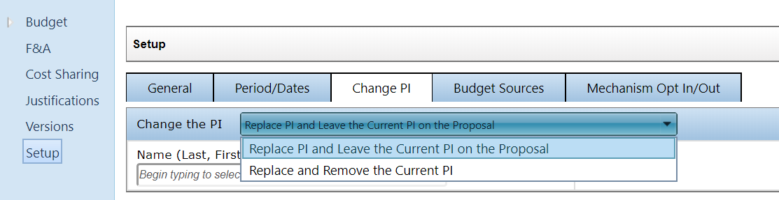

Type in the person’s name and select it from the drop-down menu. Click on the “Add New PI” button to add the person to the proposal.

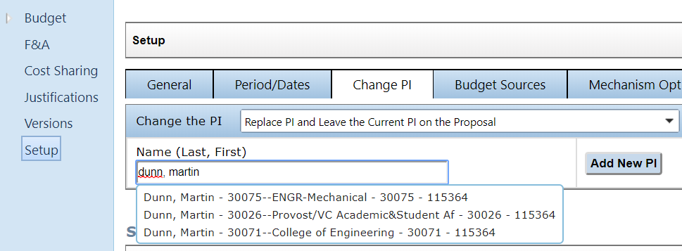

If the PI needs to be changed to a different person already on the budget, that can be done on the same page. Check the box next to the new PI and click on the “Select” button.

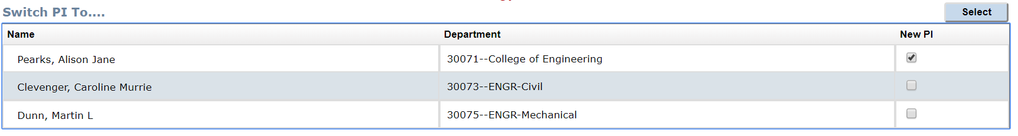Click on the “Save” icon in the upper left corner of the screen to save your changes.
Removing personnel from a budget is done in the main budget screen. The remove button for a PI only appears after a new PI has been added.
Completing the budget: The budget section is considered complete when the following items are entered:
- CU Denver personnel showing time, salary, and fringe amounts
- Any CU Denver direct costs (materials and supplies, travel, consultants, publications, computer services, tuition, equipment, participant support, etc)
  - Consultant costs should include travel costs
  - Travel costs are for CU Denver employees only
  - Tuition, equipment, and participant support do not have F&A calculated on them
- Any subrecipients with their own detailed budgets and budget justifications
  - CU Denver F&A should be calculated on the first $25K of each subaward
- Any cost sharing
- Any F&A modifications
- A budget justification for CU Denver costs, including the cost breakdown of any consultants.

When the budget is complete and the justification is loaded, the budget should be marked as complete prior to routing. Click on the “Complete Budget” button on the top right of the front page of the main budget. This will lock down the budget for routing.

Step 13: The Personnel tab will show the personnel that have been added to the budget, their designation of Key or Non-Key, whether they are up-to-date on COI requirements, and any certifications the have and the related expiration dates.

For certain proposals, this is where the biosketch and current and pending documents are loaded. Check with the solicitation for submission-specific instructions.

This should be marked as completed once the budget is done by checking the “Completed” box.

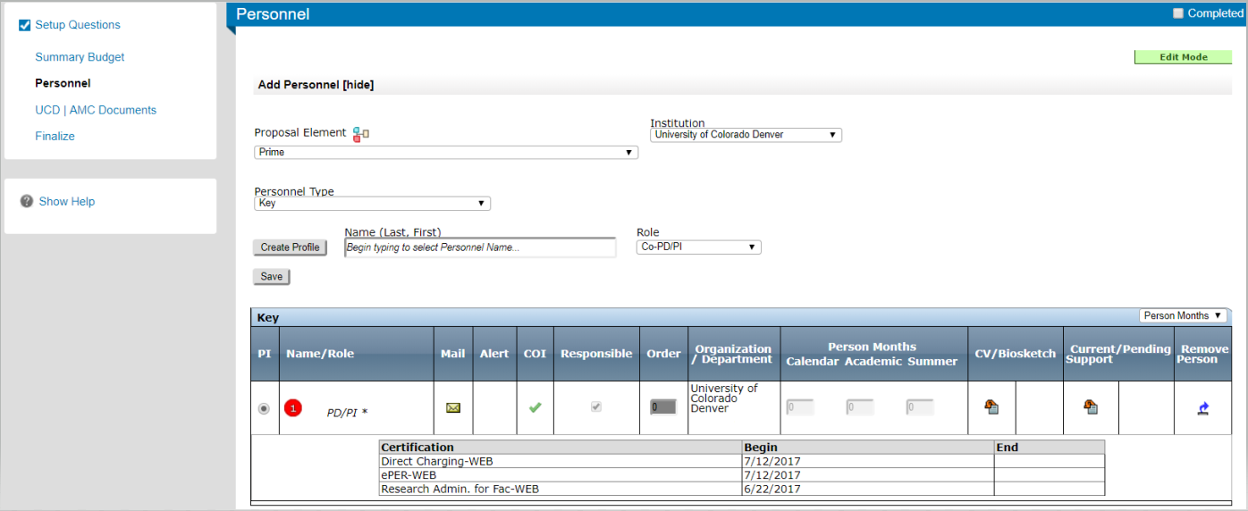

However, if you have added a subrecipient PI in the budget who was not previously in the system, you will get an error message indicating that information is missing for that person. Click on the hyperlinked person’s name to add the missing information and then click the “Save” button to save the information to the proposal.
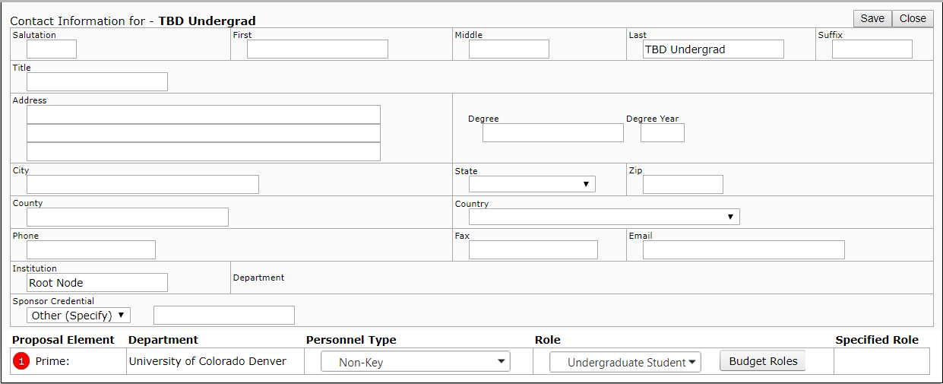
Step 14: Performance Site. If the proposal is going in as a system-to-system submission, there will be tabs for sponsor-required elements. The Performance Site tab will be where the office locations for the PI and each co-PI are entered. If there are multiple PIs from the downtown campus, use a single entry for the downtown campus. If there are subrecipients, consultants, or collaborators, enter each location separately. Check the “Completed” box when all entries have been made.

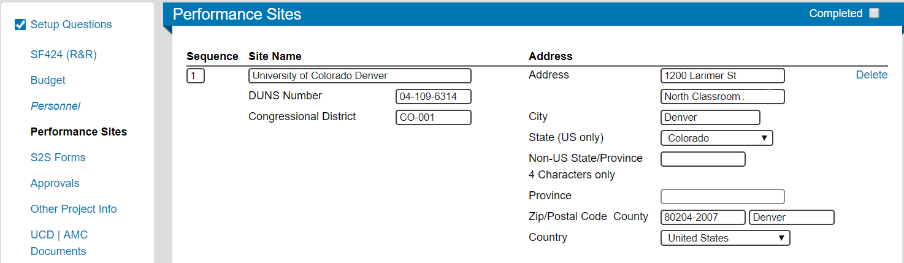

Step 15: The S2S forms are general institution forms that need to be provided with the submission, such as the SF-LLL form for lobbying. Clicking on the “edit” hyperlink leads to the form. This form needs to be completed indicating no lobbying is being conducted. Both the SF-LLL form page and the tab for the S2S forms need to have the “Completed” box checked prior to routing.

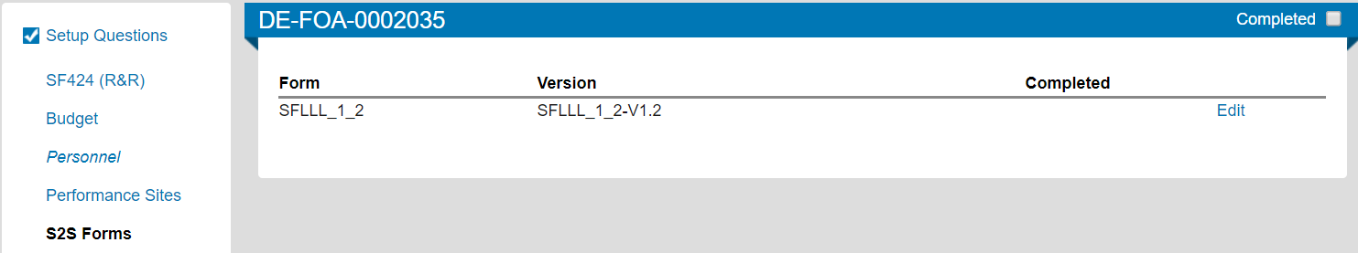

Step 16: Approvals. If any approvals are needed for work with human subjects, lab animals, biohazards, radiation, cost-share, F&A waivers, or course buyouts, that information will show under Approvals for system-to-system proposals. Click on the “Add” button to bring up the approvals page

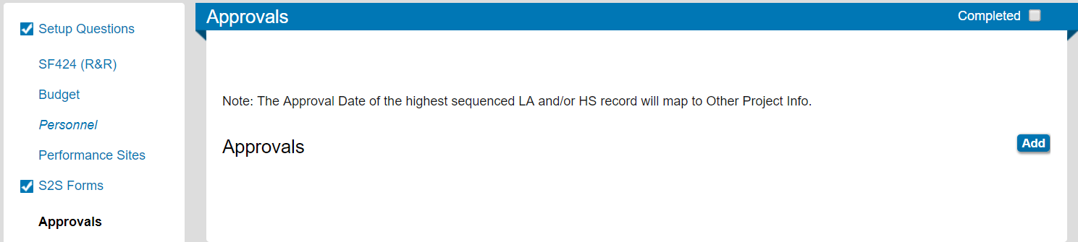

Choose the type of approval needed from the drop-down menu; then click on the “continue” button.

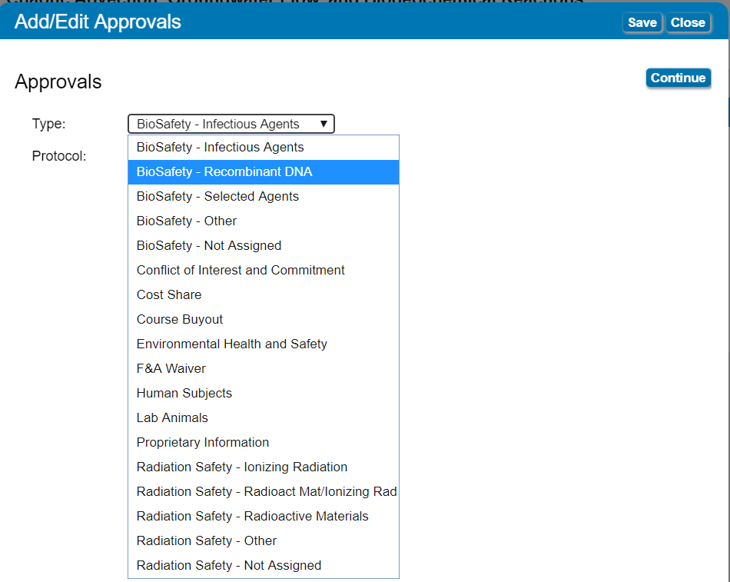

Enter the information for the approval, and click on the “Save” button to save the information before closing the box.

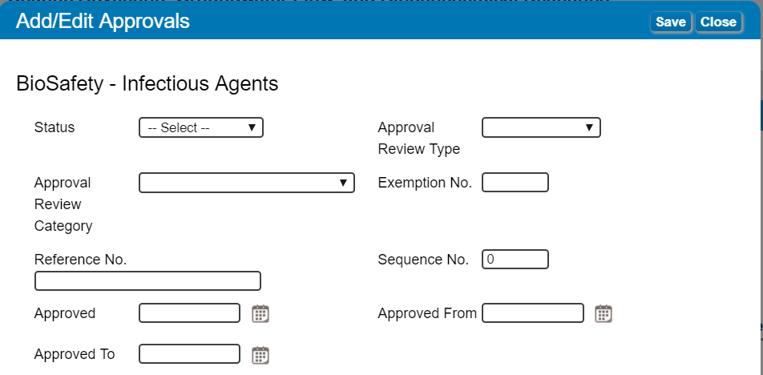

The information will now show on the main proposal page and the proposal will be flagged for review by the appropriate office. Once all information is entered, or if no approvals are required, the “completed” box can be checked on the main page.

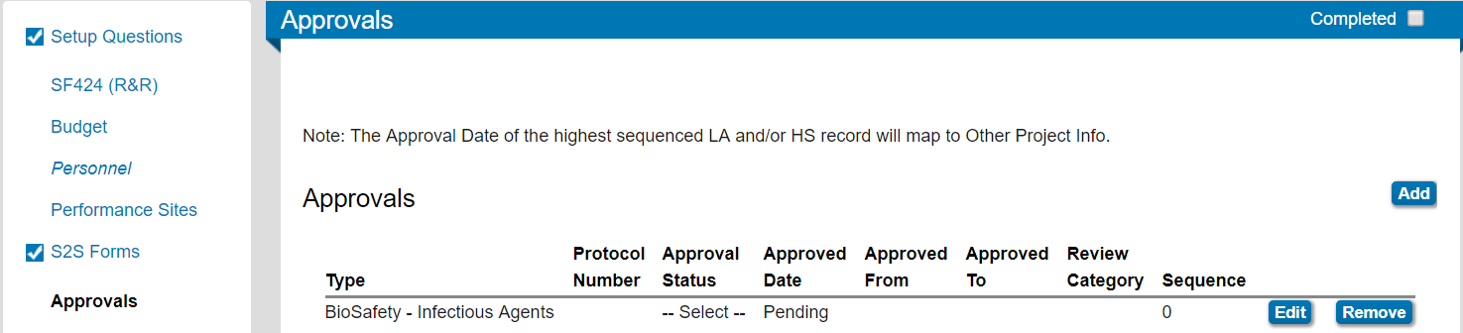

Step 17: Other Project Info. If the proposal is being submitted system-to-system, the Other Project Info tab is where the proposal documents are loaded. Be aware that this is a generic form and that sponsor requirements supersede this form. For instance, the sponsor may require all proposal documents to be loaded as a single PDF into the “Project Narrative” area instead of as separate documents into each area. Always make sure to follow the sponsor instructions in the solicitation. This includes all instructions as to file type, naming conventions, and PDF bookmarks.

To add a file, click on the “Add Attachment” button and search for your file in your saved documents. Upload the file.

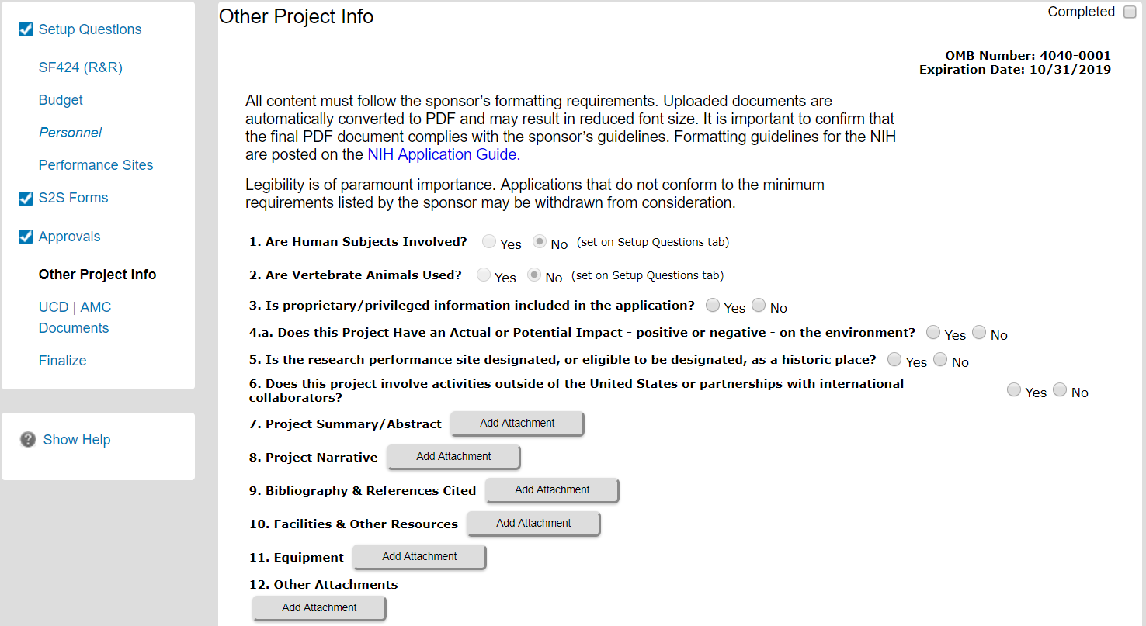

To add a file, click on the “Add Attachment” button and search for your file in your saved documents. Upload the file. The “Add Attachment” button will change to a “Delete Attachment” button and a radio button indicating that a PDF file was uploaded will appear.

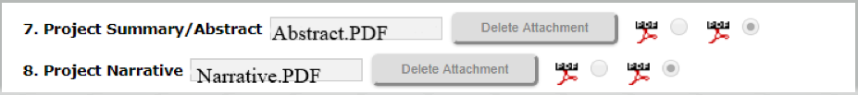

Check the “Completed” box when all files are uploaded.

Step 18: The UCD/AMC Documents tab is where the proposal documents are loaded for a manually setup proposal (as opposed to a system-to-system proposal). It is also where the OGC routing form is located. The solicitation and any instructions from the sponsor for the proposal or submission should be loaded here. The detailed budget form is also loaded here.

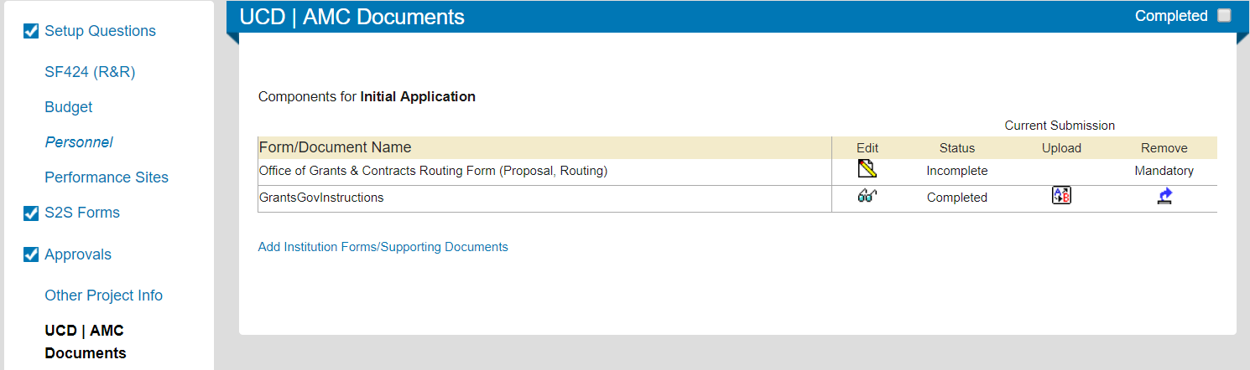

Routing Form: Clicking on the icon under “edit” brings up the first page of the routing form. If the title needs to be updated, this done here. This is also where the proposal is designated as monetary or non-monetary. If the proposal will involve money, it is monetary, and when “yes” is chosen a hyperlink appears to the proposal form.

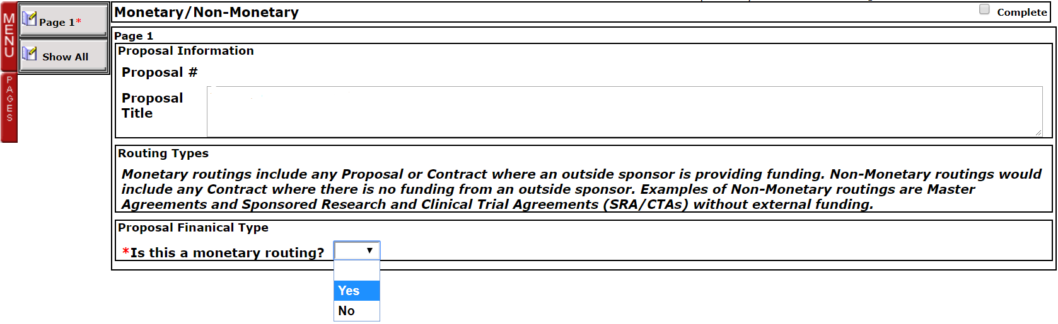
If the proposal is not a monetary routing (for instance, a master agreement, sponsored research agreement, or clinical trial agreement) a second drop-down menu appears if “no” is chosen. Choose the appropriate agreement type and then click on the hyperlink that appears to go to the routing form.
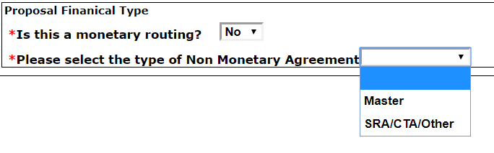

Any item on the routing form with a red asterisk requires an entry. In some cases, completing entries will trigger other entries to appear. The information on this form will be used by OGC PreAward, Contracts, and university regulatory offices, and is the first item that OGC will review when it receives the proposal. While any proposal is always subject to change upon award, it can make the contract and awarding process smoother if the information on this form is as complete and correct as possible.
The first portion of the form is for PI information. If this is a training or fellowship grant, the box indicating so should be checked, and a section for the mentor’s information will appear. In these cases, the student or post-doc who is the mentee is usually given as the PI.
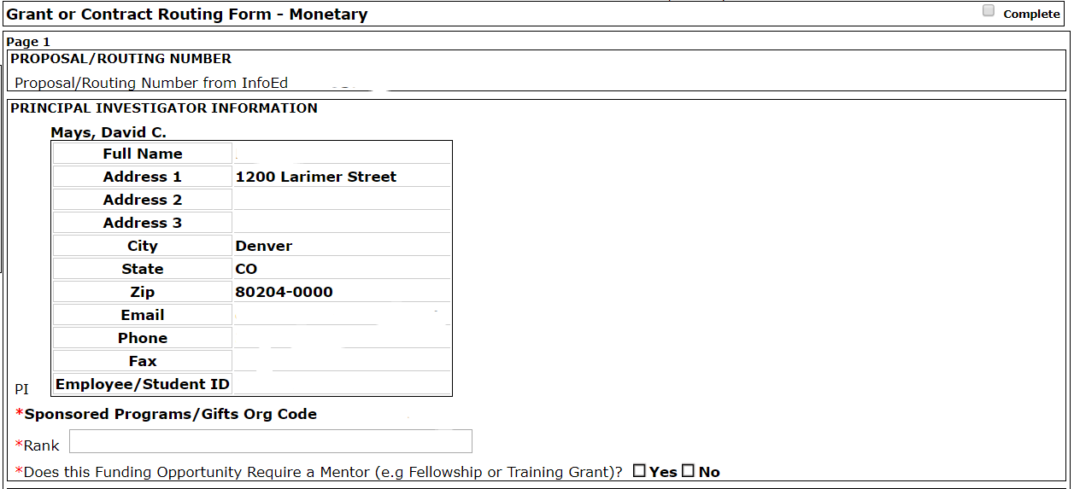

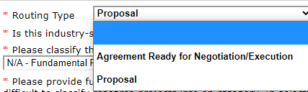
The second section describes the proposal. The first item in this section is for the routing type. The two routing type choices are “proposal” and “agreement ready for negotiation/execution.”

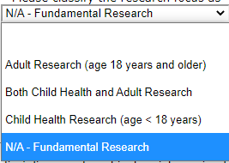
The second item indicates what type of research is being conducted.

The third item indicates the classification of the research.

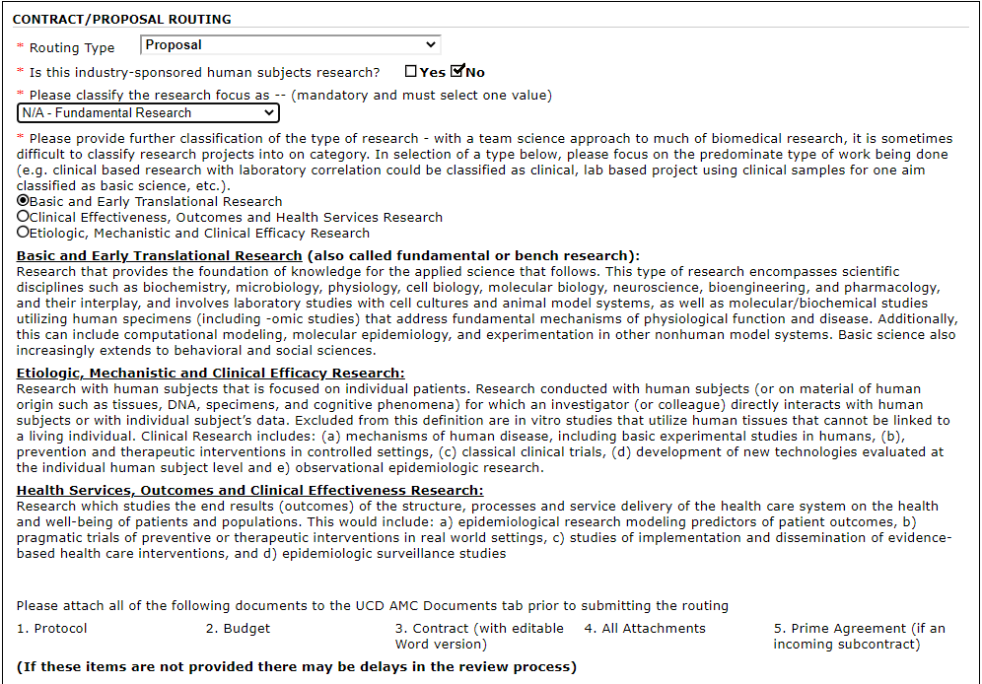

The third section gives information on the sponsor. Do not enter the sponsor contact email unless the solicitation or the sponsor specifies this information; this minimizes confusion at the contract negotiation stage. If the proposal is a subrecipient proposal, checking the “yes” box for the flow-through question will allow the prime information to be entered. If either the sponsor or the prime are federal agencies, enter the CFDA number from the solicitation.

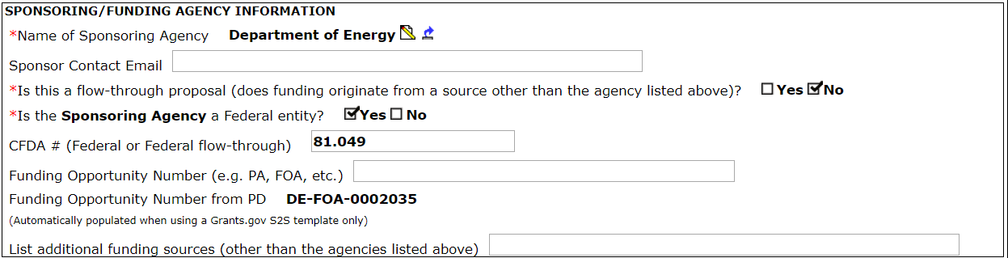

The fourth section gives the title and the project type. These are carried over from when the proposal was set up; if the title needs to be changed that should be done on the previous page of the routing page. If the proposal type (“project type”) needs to be changed that can be done here.
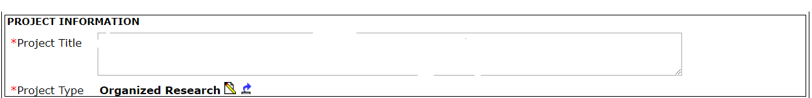

The fifth section provides the project and budget periods for the proposal. If this is a non-compete continuation (NCC) or amendment, the budget period should match what is specified on the award document. If this is an NCC, amendment, or supplement, link the current proposal to the previous routing and award number by providing the previous proposal number, CU Denver award number, and agency award number.

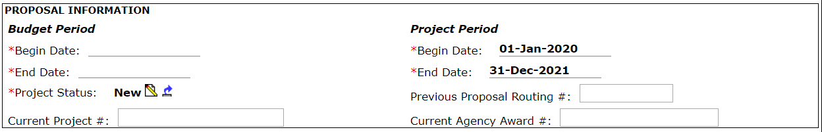

The sixth section tells OGC how the proposal will be submitted, what the deadline date and time are, and when the department is requesting the proposal to be returned after review. OGC usually wants 5 business days to review a proposal.
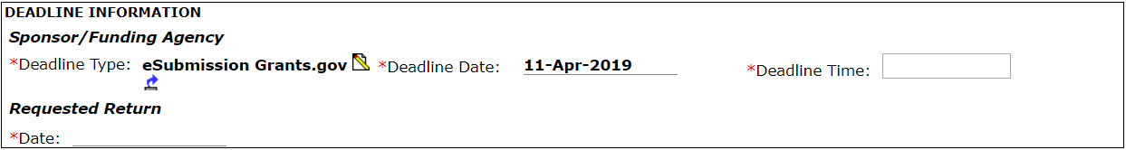

The seventh section provides the administrative and financial manager contact information for the proposal. For downtown CEDC proposals, the administrative contact is Ali Pearks and the financial manager is Kathryn Brocko. For bioengineering proposals, the administrative contact is Karen Gilbert and the financial manager is Kate Hoch for reporting, with Kathryn Brocko added as fiscal staff as the expense approver.

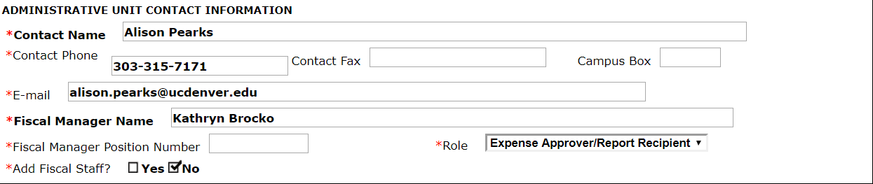

The eighth section describes where the proposed work will happen. The default location is the PI’s office; for off-campus proposals, the office base for the PI should be given.

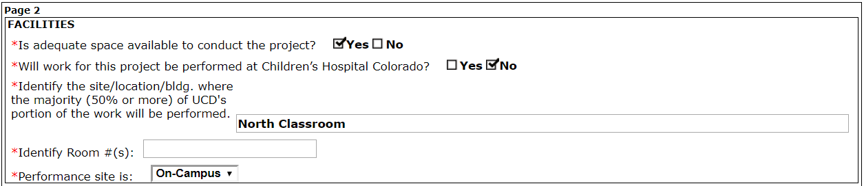

The ninth section runs through the potential hazards that could be associated with the proposed work. Clicking “yes” for any of these will flag the proposal for review by the appropriate safety office. As most sponsors do not expect any permits or approvals to be in place at the proposal stage, listing “pending” will be acceptable for routing and submission. The exceptions are if the sponsor requires approvals to be in place at the time of routing, or if the routed proposal is for a NCC or amendment of an award that requires approvals. In that case, the current approval number should be provided if requested.
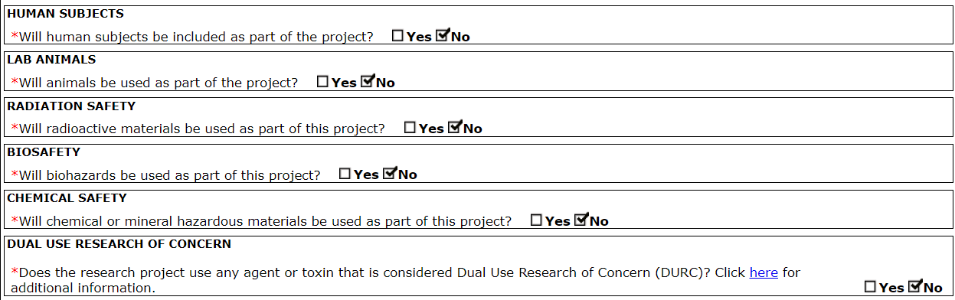

The tenth section provides regulatory information on conflict of interest, clinical trials, and export controls. Each PI and co-PI must have a COI disclosure on file before the proposal can be submitted.

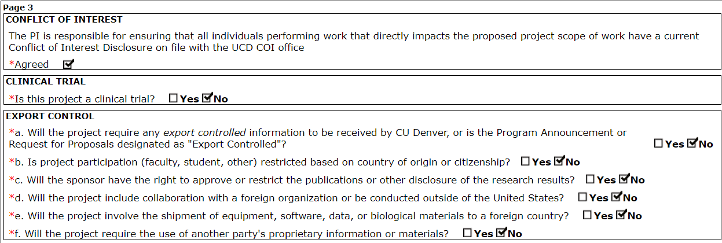

The final section of the proposal is where any notes to OGC can be made highlighting particular issues or circumstances of the proposal. If the solicitation limits indirect cost recovery, use the Notes space to provide OGC with the page number that has that statement. Information on the number of subcontractors, the type and amount of cost sharing, and the F&A rate incorporated into the budget is also given in this section.
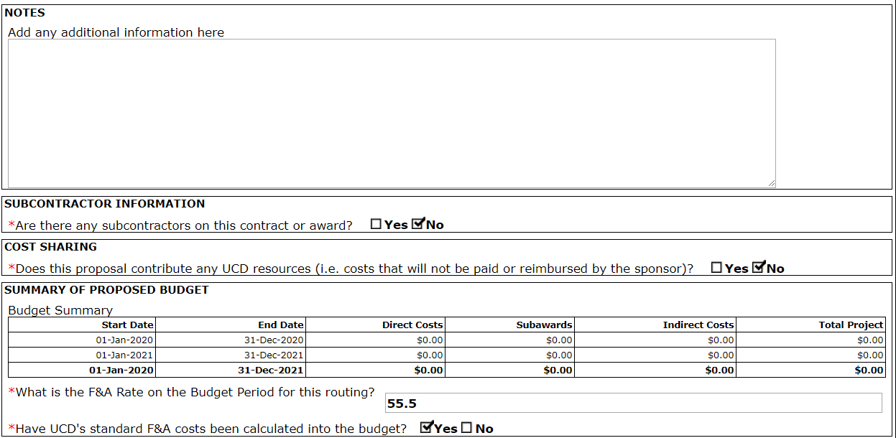

Save the routing form using the button in the upper left of the page, and when the form is complete check the “completed” box.

If any items have not been completed, a warning will be given by the system indicating the missing information. When this form has been completed, close the window using the red “X” in the upper right corner. There will be no “done” or “close” button.

Save the main form with the title, and check the completed box on that page as well. The main form window can be closed at that point using the red “X” in the upper right corner. There will be no “done” or “close” button.

Supporting documents: To add the other forms to the UCD/AMC Documents tab, click on the blue hyperlink for Add Institution Forms/Supporting Documents.

The window that will open has a checkbox for adding the detailed budget spreadsheet, the multiple PI form, and the F&A waiver, should those documents be required. Check the box next to the document needed and click the add button.

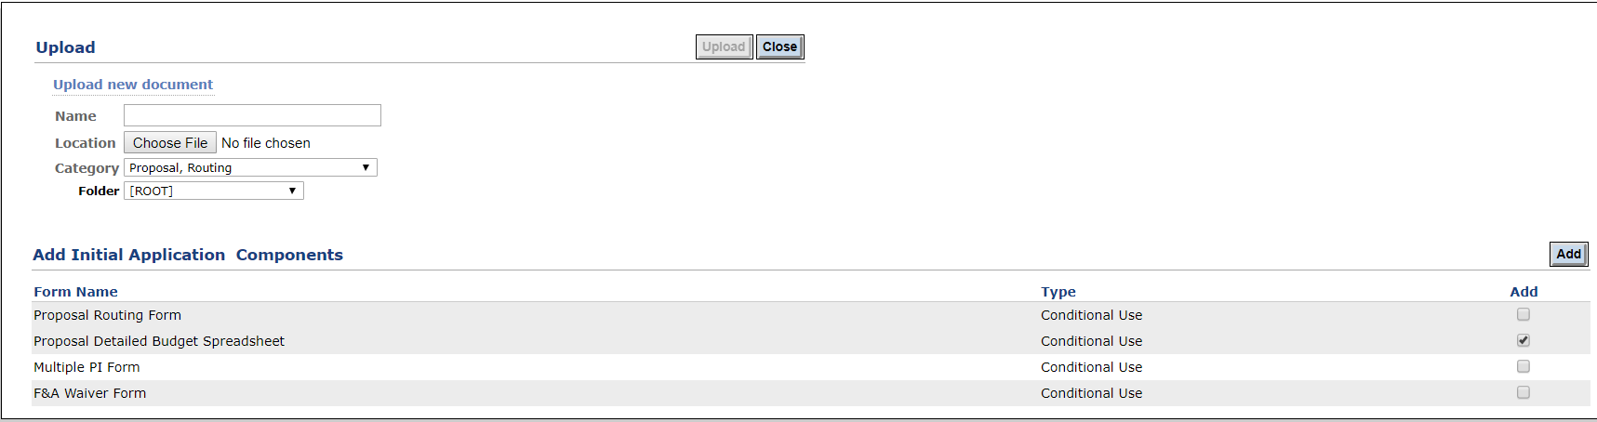

A line for the requested form is now available on the UCD/AMC Documents page. Click the icon in the column headed “Upload.”
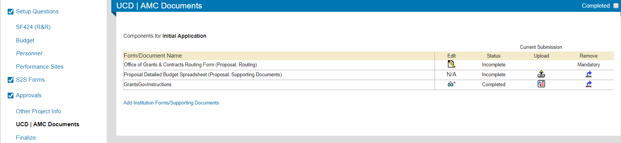

A window will open that allows for the budget xcel file to be identified for upload. Find the file and then click the “upload” button to add the file to the proposal. The window will close automatically; you will not need to click the “close” button.

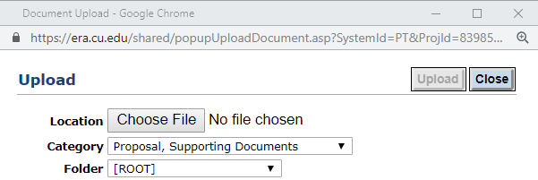

Other supporting documents, such as the solicitation, emails from the sponsor requesting a proposal or providing specific instructions for the proposal, limited submission confirmations, or award notifications can be uploaded through the blue hyperlink for Add Institution Forms/Supporting Documents. If the proposal is submitted through another sponsor portal (such as Fastlane or NSPIRES), or if the proposal is being submitted by the PI via email to the sponsor, a PDF of a full copy of all sponsor-required documents should be uploaded in this manner.

The file can be located through the “choose file” button for upload. Select the file and click on the “upload” button. The screen will reload but stay in place. This permits you to select multiple files for uploading. When you have uploaded all your files, click the “close” button; this will close the window and your uploaded files will then appear in the UCD/AMC Documents screen.

When all items have a status of “Completed” on the UCD/AMC Documents tab, the “Completed” box can be checked for this tab.

Step 19: Finalize When the proposal is ready to be routed, the Finalize tab is used for a final check. If the proposal is being submitted by the PI or is being submitted through a sponsor portal other than Grants.gov, skip to the section on assembling the application.

If the proposal is being submitted system-to-system via Grants.gov, the first step is to build the proposal PDF and check it for bookmarks and that the filenames are in compliance. Click the “build” button to build the proposal; once the proposal is fully assembled click on the orange “XML” button to check for bookmarks. Many sponsors retrieve the .xml file during submission to validate the proposal and to auto-populate their own systems.

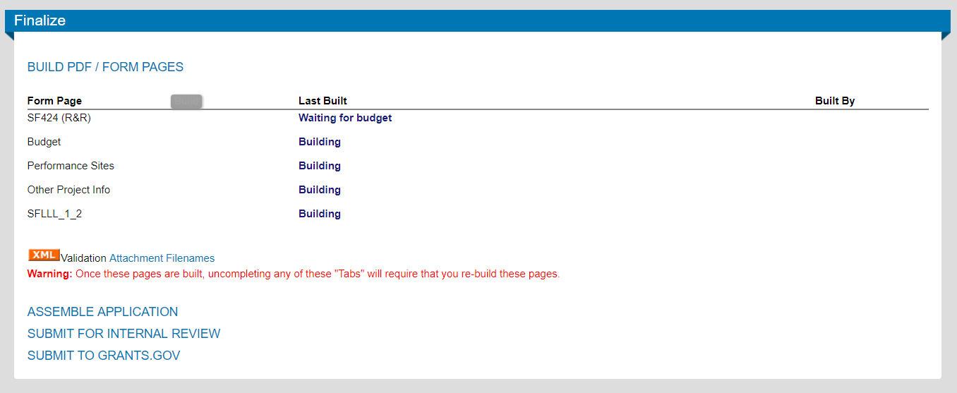

A warning window will pop up if any bookmarks are found that will identify which document contains them.

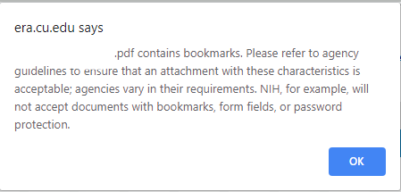

Clicking “ok” on this window will start the XML check. A separate popup window will appear with the XML validation information.

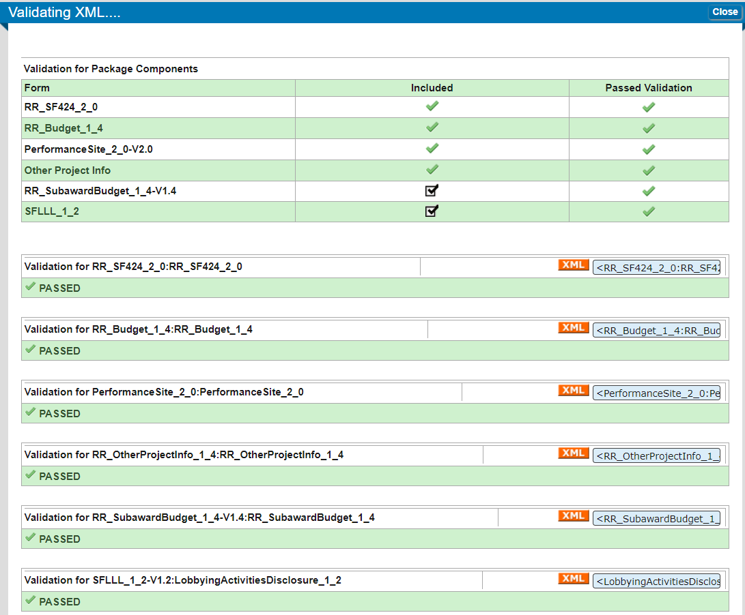

The XML validation button allows a check for missing elements and any PDF bookmarks. You can correct any items found and re-run the XML validation check as needed. Close the window after the check is complete and you know if you need to fix any documents or if all documents have passed.

To check for file name and file size compliance with Grants.gov conventions, click on the “Attachment Filenames” hyperlink.

A popup window will appear with the file names and file sizes. Grants.gov requires filenames to be 50 characters or less, and to be created with the following characters only: A-Z, a-z, 0-9, underscore, hyphen, space, period, parenthesis, curly braces, square brackets, ampersand, tilde, exclamation point, comma, semi colon, apostrophe, at sign, number sign, dollar sign, percent sign, plus sign, and equal sign. Sponsors can limit the size of the files; Grants.gov suggests limiting the total size of all attachments to 200MB.

You can save the information in this popup window, or click the “close” button to close the window.

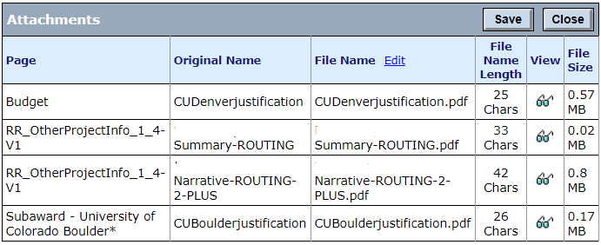

Once any issues have been corrected with bookmarks, file names and sizes, or missing information, the application will move to the assembling phase.

For Grants.gov proposals, there will be a button to assemble the Grants.gov application.

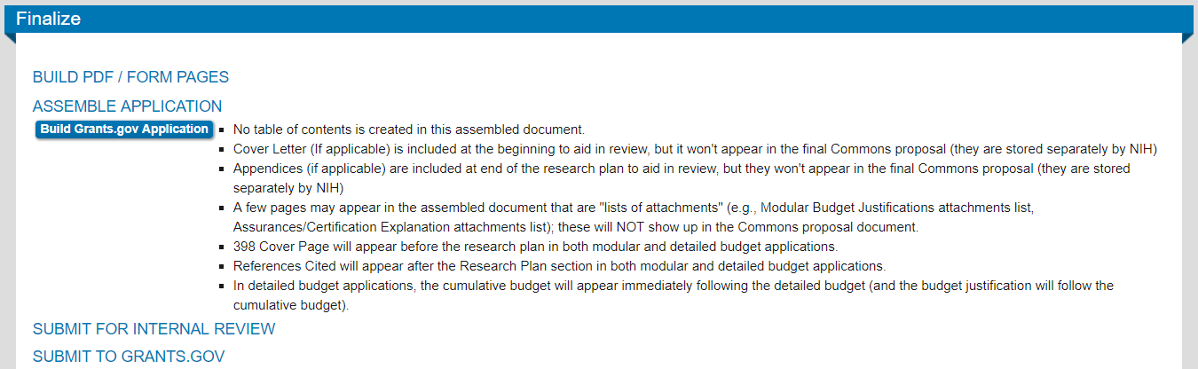

For PI submissions and submissions through portals other than Grants.gov, this will be the initial screen when accessing the Finalize tab. Assemble the application by clicking the “build” button.

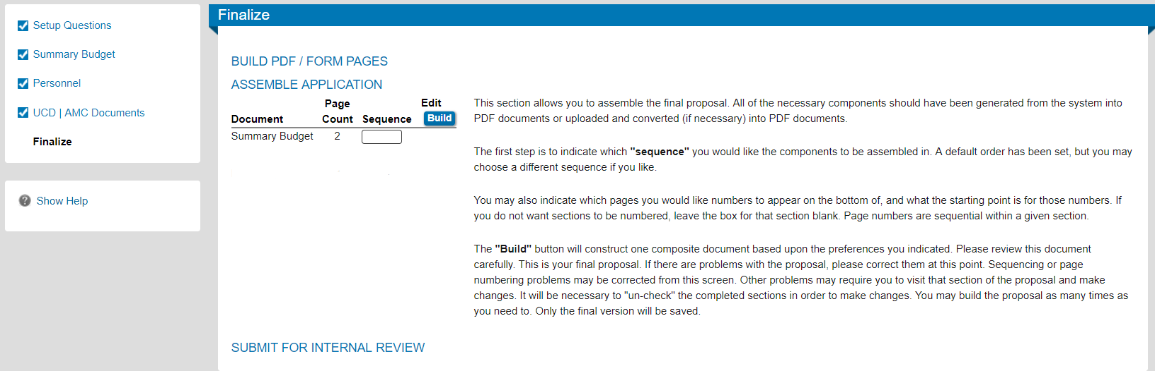

The screen will refresh and the application components will appear. If this is a Grants.gov submission, you can review the assembled document before routing by clicking on the eyeglass icon for the Assembled Doc. Clicking on the thumbs up icon next to “Submit Final Review” initiate the routing process.

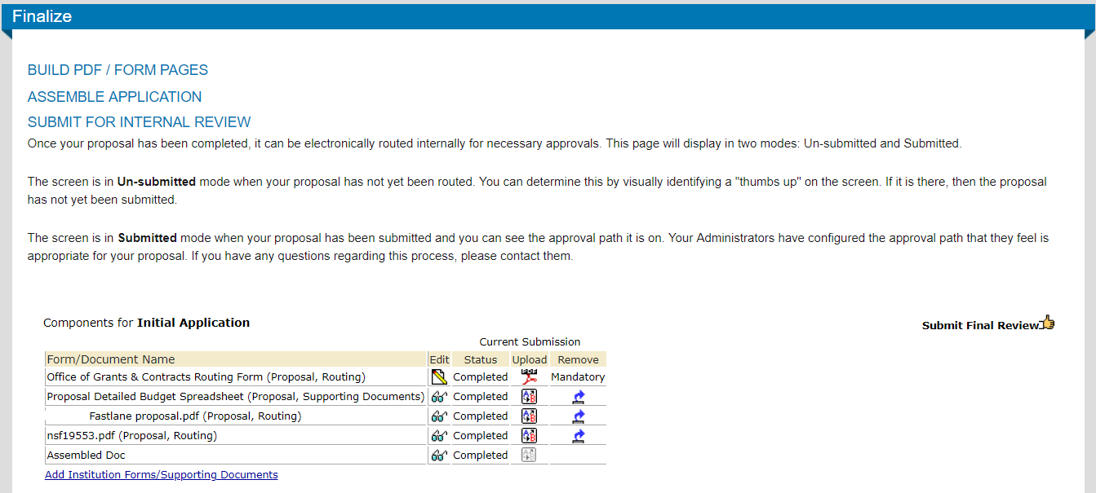

The first popup window will be for the submitter to attest that the proposal is true, complete, and accurate to the best of your knowledge. Selecting the “accepted” option and clicking the “continue” button will bring up the routing path.

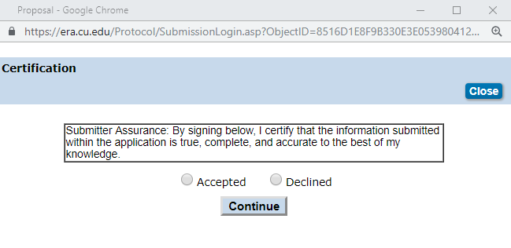

The routing path window permits any co-PIs to be added to the routing path using the insert icon next to the PI’s name.

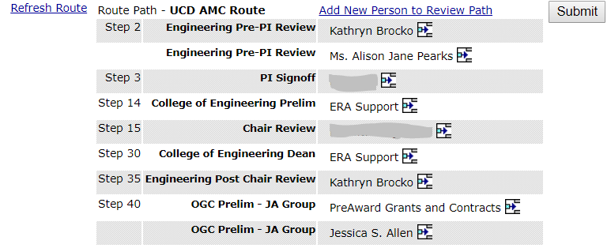

A pop-up window will appear to add a step to the routing path. The co-PI’s name should be chosen from the dropdown menu and added to the proposal. The co-PIs will receive the routing in the order they are added to the routing path.

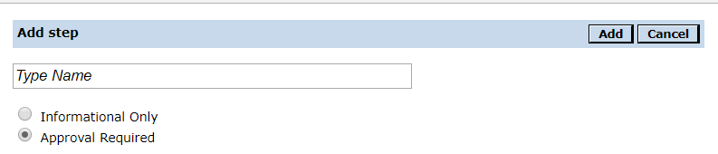

When the “submit” button is clicked on the routing path page, the proposal is then in routing and locked for further editing until OGC returns the proposal.

Step 20: Submission. When OGC has returned a routed proposal that will be submitted to Grants.gov via system-to-system, the proposal will be unlocked so the routed documents can be revised prior to submission. When the final files are uploaded and all the proposal tabs are marked as completed, go through Step 19 again to check for bookmarks, file names and types, and overall verification for Grants.gov compliance. Assemble the application as before. If you want to save a copy of your assembled application, do so. Then STOP. DO NOT PROCEED. DO NOT CLICK ANY BUTTON THAT SAYS SUBMIT TO GRANTS.GOV.

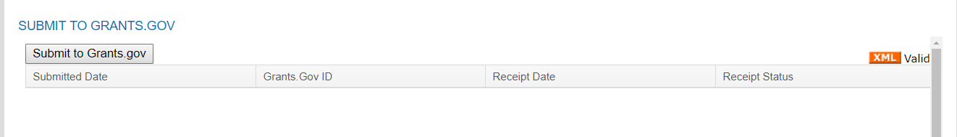

Instead, click the “Done” button in the upper left corner of the main proposal window.

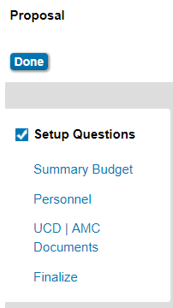

Send an email to eapp.xenia@ucdenver.edu and let OGC know the proposal is ready for submission. In the subject line of the email, put “System to System <Sponsor> Grants.gov #<CU Denver proposal number and PI last name>”. The proposal needs to be submitted by an authorized organizational representative, and so must be submitted by OGC.

If the proposal is to be submitted by the PI or through another sponsor portal, follow the instructions provided by the sponsor.

Good luck with the proposal!

