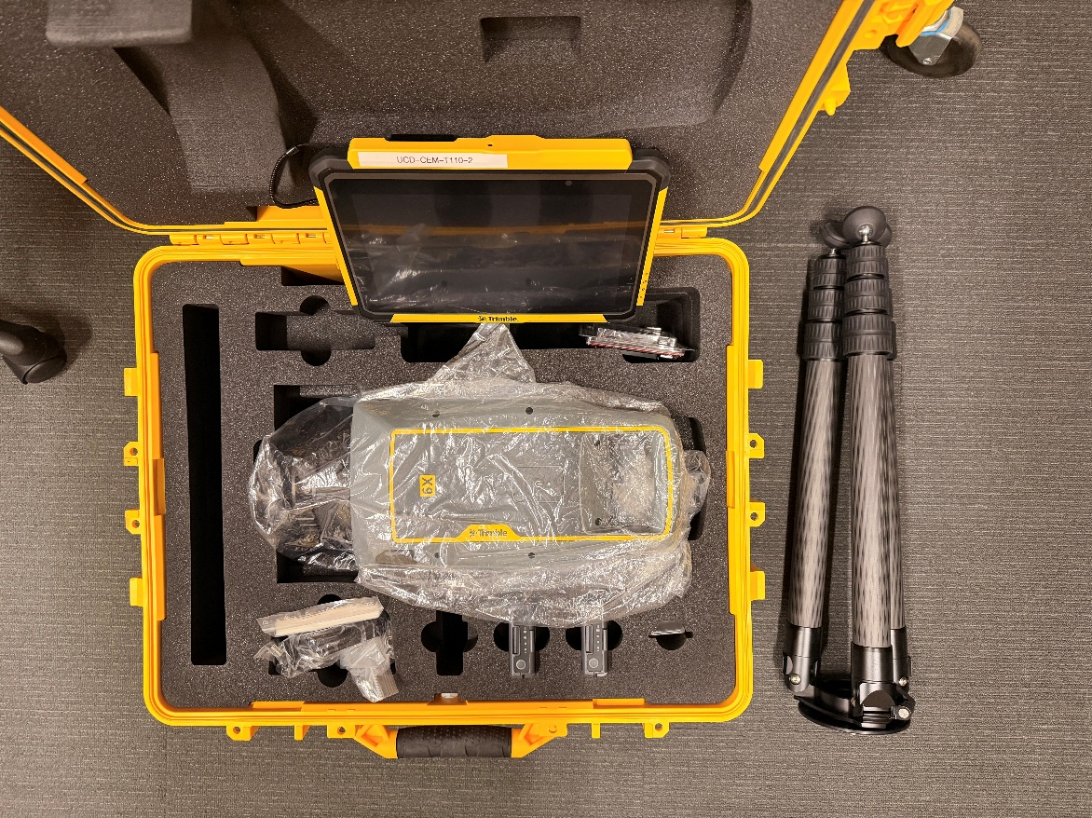
Trimble X9 Laser Scanner
User Guide

What Is the X9?
The Trimble X9 is a professional-grade 3D laser scanner that maps the physical world by measuring millions of points per second using a laser. The result is a point cloud: a highly detailed, three-dimensional record of every surface the scanner can see from a given position.
Compared to the TX8, the X9 is a more advanced instrument. It is self-leveling, connects wirelessly to a tablet controller (the Trimble T110 running Trimble Perspective software), and includes built-in automatic registration, meaning it can stitch scans from multiple positions together on its own, in the field, without manual work in the office. It also captures high-resolution color panoramas alongside the point cloud.

Common uses include:
- Documenting existing building conditions for renovation or BIM workflows
- Creating accurate as-built records of constructed spaces
- Topographic and site surveys
- Forensic documentation and inspection
- Heritage recording and preservation

Key Concepts Before You Begin

What Is a Scan Station?
Each time you place the scanner in a position and take a scan, that is called a station. A complete project typically involves many stations, each one capturing the view from a different spot. Together, they cover an entire building or site.

What Is Registration?
Registration is the process of aligning all your separate scan stations into one unified point cloud. Each station is captured independently; registration figures out how they fit together spatially. The X9 does this automatically in the field after each new scan, trying to match overlapping geometry between the new station and the ones already captured. You review the result on the T110 screen before moving on.

What Is Overlap?
Overlap is the amount of shared, visible geometry between two adjacent scan stations. For automatic registration to work reliably, each new station must clearly "see" a significant portion of the previous station: the same walls, corners, floors, or structural features. Without enough overlap, the scanner cannot confidently match the scans together and registration will fail or be unreliable. Managing overlap is the most important field skill when using the X9.

Equipment Overview
Confirm all items below are in the kit before leaving the lab. The X9 has more components than the TX8, so take a few minutes to familiarize yourself with each one.

Item | What It Is and Does
Trimble X9 Scanner | The main instrument. Self-leveling 3D laser scanner with integrated camera for color panoramas. Stores data to the SD card. Communicates with the T110 tablet wirelessly.
Tripod | The three-legged stand. Must be set up stably. The X9 can self-level within a range, but a very poorly leveled tripod will exceed that range.
Trimble T110 Tablet | A rugged field tablet running Trimble Perspective. This is your control interface for creating projects, connecting to the scanner, setting scan parameters, reviewing results, and exporting data.
Trimble Perspective (software) | The field software on the T110. All scanner operations are performed through this application. You do not interact with the scanner directly other than to power it on.
Battery (×2 recommended) | Rechargeable power source. Slides into the battery compartment on the instrument body. Bring two and charge both overnight.
SD Card | The memory card that stores all scan data. Must be inserted before the scanner is powered on. Keep it with the scanner kit at all times.
Battery Charger | For recharging batteries between sessions. Keep in the kit bag.
Lens Cleaning Kit | Blower and cloth for keeping the scanner lens clean. Never use paper towels or household cleaners.
Carrying Case | The hard padded case the X9 is stored and transported in. Use it for any vehicle transport.

Equipment Checklist
Go through this list before every field session.

✓ | Item | Check For
☐ | Trimble X9 Scanner | In carrying case; no visible damage to lens or body
☐ | Tripod | All legs extend and lock; feet intact
☐ | T110 Tablet | Charged to at least 80%; Trimble Perspective opens correctly
☐ | Two fully charged batteries | Check the indicator on each; charge overnight before fieldwork
☐ | SD Card | Present in the kit; not full; not damaged
☐ | Battery charger | In kit bag
☐ | Lens cleaning kit | Blower and cloth present
☐ | Field notebook + pencil | For sketching station positions and recording notes

Section 1: Planning Your Scan Stations
Good planning before you place a single tripod leg will save you significant time in the field and in the office. The X9 is powerful, but it can only see what is directly in its line of sight. Anything behind a wall, around a corner, or inside a cabinet is invisible to it. Your job as the operator is to choose scan positions that together cover everything you need, with enough overlap between positions for registration to work.

Choosing Scan Locations
Before setting up the tripod, walk through the space and make a rough plan. Think about the following:

- Line of sight: can the scanner see the surfaces you need to capture from this position? Walls, furniture, columns, and other obstacles block the laser. Position the scanner where it has maximum visibility of the area you are trying to document.
- Overlap between stations: each new position must share visible geometry with at least one previous position. As a rule of thumb, 30% shared surface area is a minimum; more is better. Corners of rooms, doorways, and structural columns are ideal overlap zones because they are distinct and easy to match.
- Shadows and occlusions: every object in the space casts a "shadow" in the point cloud (an area the laser cannot reach). Plan additional stations to cover those hidden areas.
- Access and safety: make sure each planned position is safe and accessible. Avoid positions where people will need to pass close to the operating scanner.
- Registration chain: think about how your stations connect to each other. Each station should be able to register to at least one neighboring station. A long chain of stations where each one only overlaps with the immediately previous one is more vulnerable to cumulative registration error than a layout where multiple stations share overlap.

Note: A hand-drawn sketch of the floor plan with numbered station positions takes about five minutes and will guide you through the entire session. It also helps if you need to re-scan a missed area later.

Spacing Guidelines
The X9 documentation provides general spacing recommendations. These are maximums, not targets. Staying within them gives registration the best chance of succeeding automatically.

Environment | Scan Resolution | Max Recommended Spacing
Outdoors | High resolution | < 10 m between stations
Indoors | Low resolution | < 2 m between stations
General (any) | Any | Closer is always better for registration quality

Note: Even if a larger spacing technically meets the guidelines, do not push to the maximum. The closer your stations are, the more overlap you get, and the more reliably automatic registration works. When in doubt, add a station.

Section 2: Setting Up the X9

Step 1: Let the Scanner Acclimatize (If Needed)
The X9 contains precision optics and sensors that are sensitive to temperature changes. If the scanner has been in a significantly different environment, for example stored in a cold vehicle and brought into a warm building, or taken from an air-conditioned lab to a hot outdoor site, it needs time to adjust before use. Scanning too soon after a large temperature change can introduce measurement errors.

- Estimate the temperature difference between where the scanner was stored and where you are scanning.
- Apply the acclimation rule: temperature difference in °C × 2 = minutes to wait (or temperature difference in °F = minutes to wait). For example, moving from 20°C storage to 5°C outdoors is a 15°C difference, so wait 30 minutes before scanning.
- Set the scanner out of its case in the scanning environment and leave it unpowered during the acclimation period.

Note: For small temperature differences (less than 5°C / 9°F), acclimation is usually not necessary. For moves between heated indoor spaces and cold outdoor environments in winter, always acclimate.

Step 2: Set Up the Tripod
The X9 is self-leveling, but only within a limited range of roughly ±5° from horizontal. If the tripod is set up too far out of level, the scanner's internal motors cannot compensate and it will display a leveling error. Getting the tripod reasonably level before mounting the scanner takes about two minutes and prevents that problem entirely.
The tripod has three legs, and each leg has two separate extendable sections. A locking clamp or collar at each joint is what holds the leg at the chosen length.

- Loosen the leg clamps by twisting or flipping them open (the mechanism depends on your tripod model: twist-lock collars turn counterclockwise to release, and lever clamps flip outward). Extend both sections of each leg by pulling them downward.
- Adjust the height so the tripod head sits at approximately your chin height when standing. This puts the scanner at a good working height for most indoor spaces and keeps the display comfortable to read.
- Lock each section firmly: twist collars clockwise to tighten; flip lever clamps inward to lock. Give each leg a firm downward tug after locking to confirm it will not slip. A leg that slips during a scan will corrupt that scan.
- Carry the tripod to your planned scan position. Spread the legs outward into a wide, stable triangle. Imagine an equilateral triangle when viewed from above. The wider the stance, the more stable the setup.
- Plant the rubber feet firmly. Make sure all three are in contact with the floor and none is rocking.
- Look at the tripod head from the side. It should appear roughly horizontal, not tilted noticeably to one side. If it is visibly tilted, adjust individual leg lengths: shorten the leg on the high side, or lengthen the leg on the low side, until the head looks level by eye. You do not need perfection at this stage. The X9 will finish the job, but you do need to be reasonably close.
Note: On sloped floors or outdoor terrain, place two legs pointing downhill and one uphill. This gives the most stable base and makes it easier to get the head roughly horizontal.

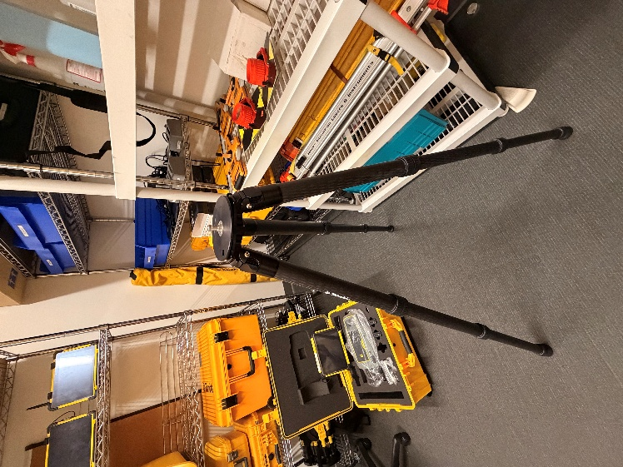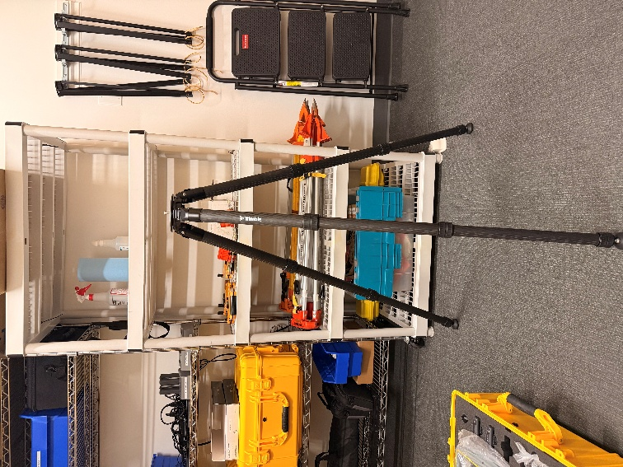

Step 3: Mount the X9 on the Tripod
The X9 mounts to the tripod using a clip or bayonet mechanism depending on your specific tripod model. Both methods are shown below.

- Lift the X9 from its case using both hands. Support it from the base, not by the lens dome or any protruding part.
- Standard threaded mount: align the scanner base with the tripod head and thread the central screw until the scanner is firmly attached.
- Clip mount: release the clip on the scanner base, seat the scanner on the tripod head, and close the clip until it locks. Verify it is locked before letting go.
- With either mounting method, grip the scanner body and try to twist or lift it off. It should not move. If it does, remount it.
Warning: Never carry the X9 by the lens dome on top. The dome contains the rotating mirror and optics, and any impact or stress on it can cause permanent internal damage.

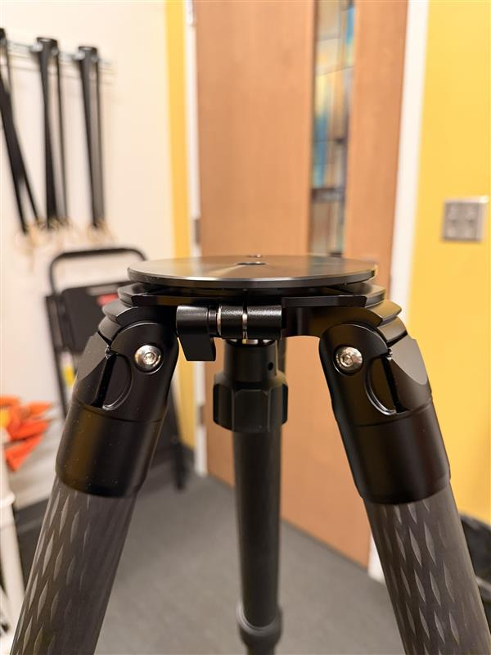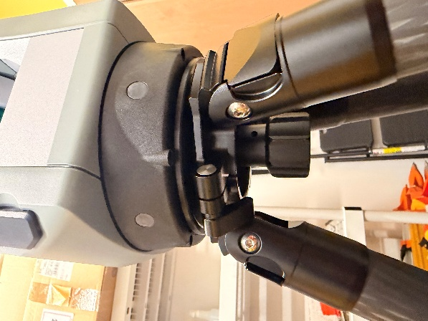

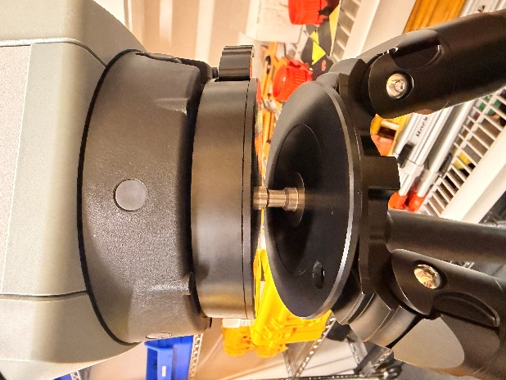

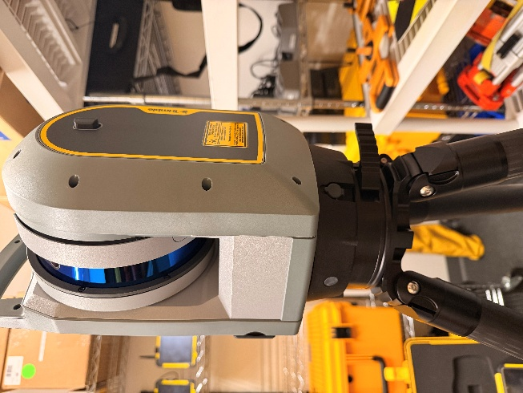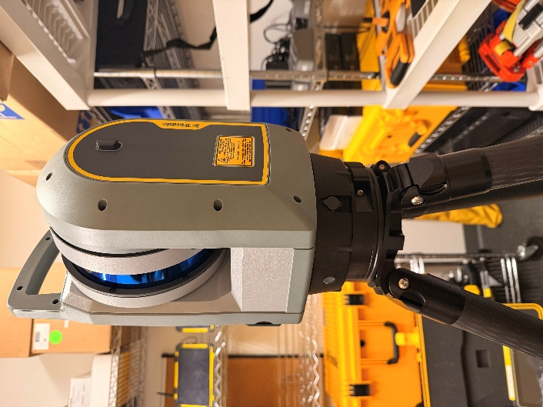

Step 4: Insert the Battery
The battery compartment is on the side of the X9 instrument body.

- Press the battery compartment lock downward to release it and open the compartment door.
- Insert the battery with the contacts aligned. Slide it in fully until it is seated.
- Close the compartment door and confirm the lock has re-engaged.
Note: Insert the battery before powering on. If you need to swap batteries mid-session, power down the scanner first, swap, and power back on.

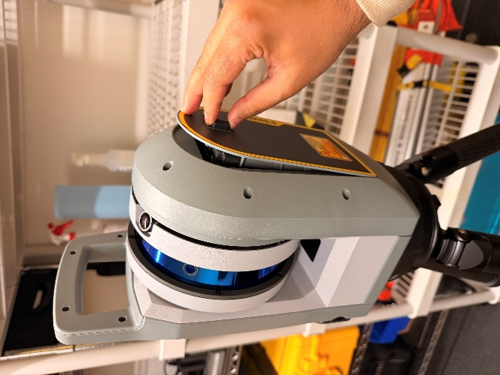
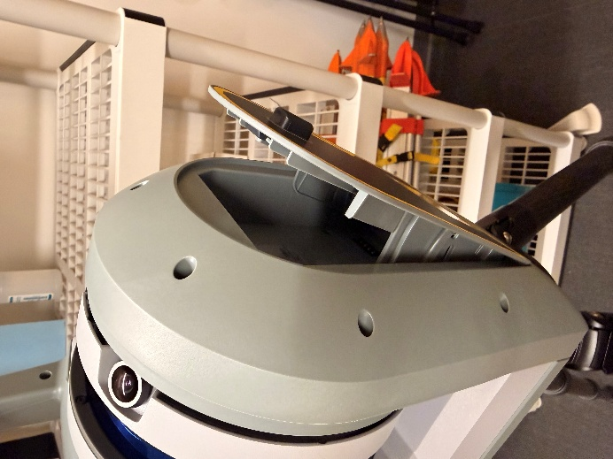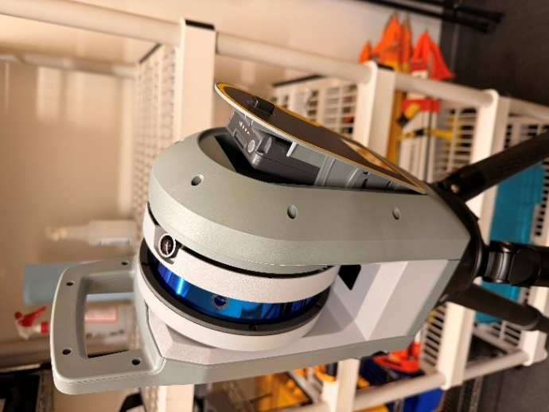

Step 5: Insert the SD Card
The SD card is where all scan data is stored. It must be inserted before the scanner is powered on. Inserting or removing the card while the scanner is on can corrupt data.

- Confirm the scanner is powered off.
- Locate the SD card slot cover on the instrument body and open it.
- Orient the SD card correctly (the card will only fit in one direction, so do not force it) and slide it in until it clicks.
- Close the slot cover.
Warning: Never remove the SD card while the scanner is powered on or while a scan is in progress. Data loss and card corruption are likely.

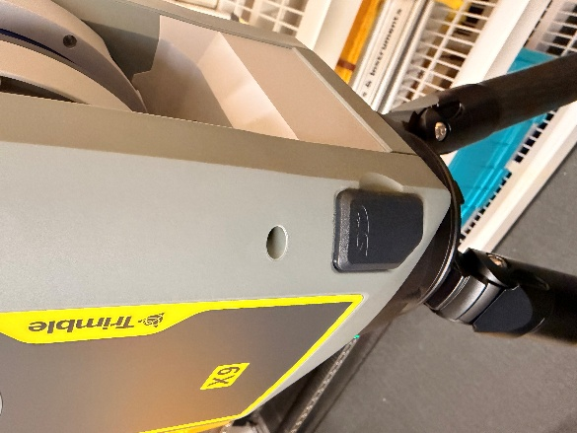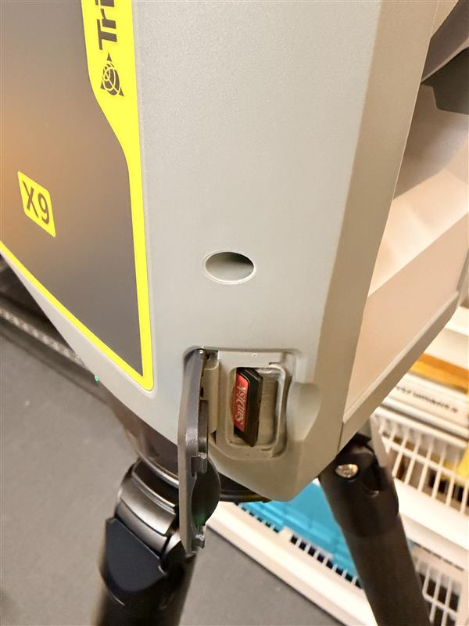

Section 3: Powering On and Understanding the LEDs

Powering On
- Press the power button briefly. Do not hold it down. The scanner will give a series of ascending beeps as it starts up. This takes about 30–60 seconds.
- Wait for the LEDs to stabilize before doing anything else. The startup sequence includes a self-check and initial calibration.

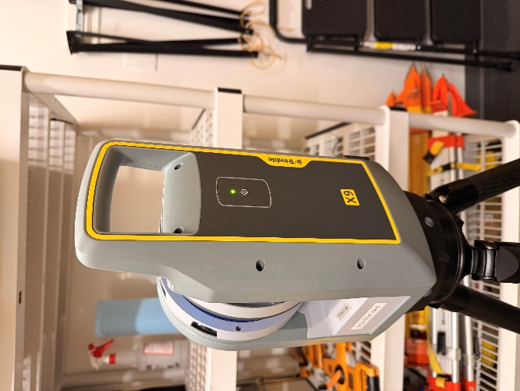

Understanding the LED Status Indicators
The X9 uses two sets of LEDs to communicate its status: an on/off LED (single indicator) and multi-color ring LEDs. Learn what each state means so you can diagnose problems quickly in the field.

LED State | What It Means
On/Off LED, slow flashing yellow | Scanner is on and ready, but not connected to the T110 tablet
On/Off LED, solid yellow | Scanner is on, ready, and connected to the T110 tablet
Ring LEDs, solid green | Scanner is fully ready to scan
Ring LEDs, flashing blue | Scanner is initializing, leveling, calibrating, or actively scanning. Do not interrupt.
On/Off LED or Ring LEDs, solid red | An error has occurred (battery, SD card, leveling, calibration, or hardware issue). Check the T110 screen for details.

Self-Leveling and Leveling Feedback
Once powered on, the X9 will attempt to self-level automatically. The tripod does not need to be perfectly level, but it needs to be close enough for the scanner's internal motors to compensate. The LED ring provides feedback during this process.

- All five leveling LEDs solid green: the scanner has successfully leveled itself and is ready to proceed.
- Three LEDs flashing: the tripod needs manual adjustment. The color of the flashing LEDs tells you which direction to adjust:
- A blue LED near a tripod leg means that leg is too low. Raise it.
- A red LED near a tripod leg means that leg is too high. Lower it.

- After powering on, watch the LEDs. If the scanner levels successfully (all green), proceed. If it signals an adjustment is needed, make the indicated tripod leg adjustment and wait for the scanner to re-attempt leveling.
- Repeat until all leveling LEDs are solid green.

Note: The self-leveling motors can handle a range of about ±5° from horizontal. If your tripod is more than about 5° out of level, the scanner will not be able to self-level regardless of how long you wait. Re-adjust the tripod legs.

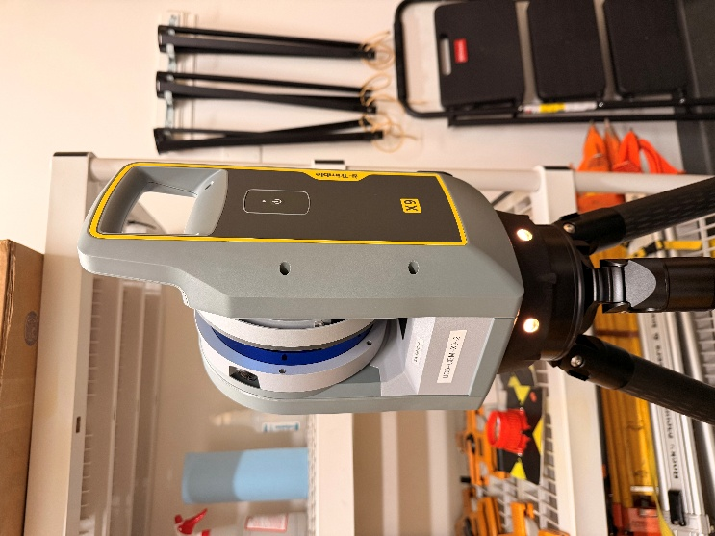

Section 4: Creating a Project in Trimble Perspective
All scanner operations, from creating a project to reviewing scans to exporting data, are done through Trimble Perspective on the T110 tablet. You do not press buttons on the scanner itself after powering it on; you control everything from the tablet.

Step 1: Open Trimble Perspective on the T110
- Power on the T110 tablet if it is not already on.
- Tap the Trimble Perspective icon on the home screen to open the application. Wait for it to fully load and you will see the main Perspective dashboard.

Step 2: Create a New Project
Every scan session should live in its own clearly named project. Creating a new project takes about one minute and keeps your data organized.

- In Trimble Perspective, tap New Project.
- Enter a project name that includes the location and date. For example: Architecture_Building_20220513. A clear name makes the project easy to identify when you transfer data to the office.
- Set any project-level options presented (coordinate system, units, etc.) according to your project requirements. If you are unsure, ask the lab supervisor before creating the project.
- Tap Create or OK to confirm. The project is now active.
Note: If you are scanning a large site over multiple sessions, decide before your first session whether to use one project for the entire site or separate projects per session. One project per site is usually simpler for registration and export.

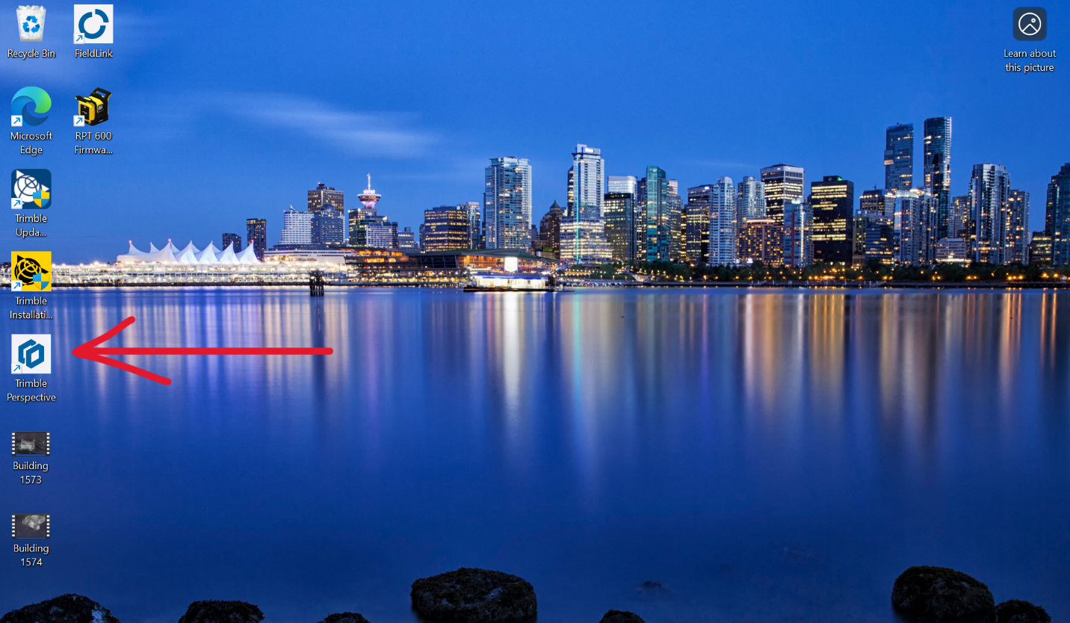
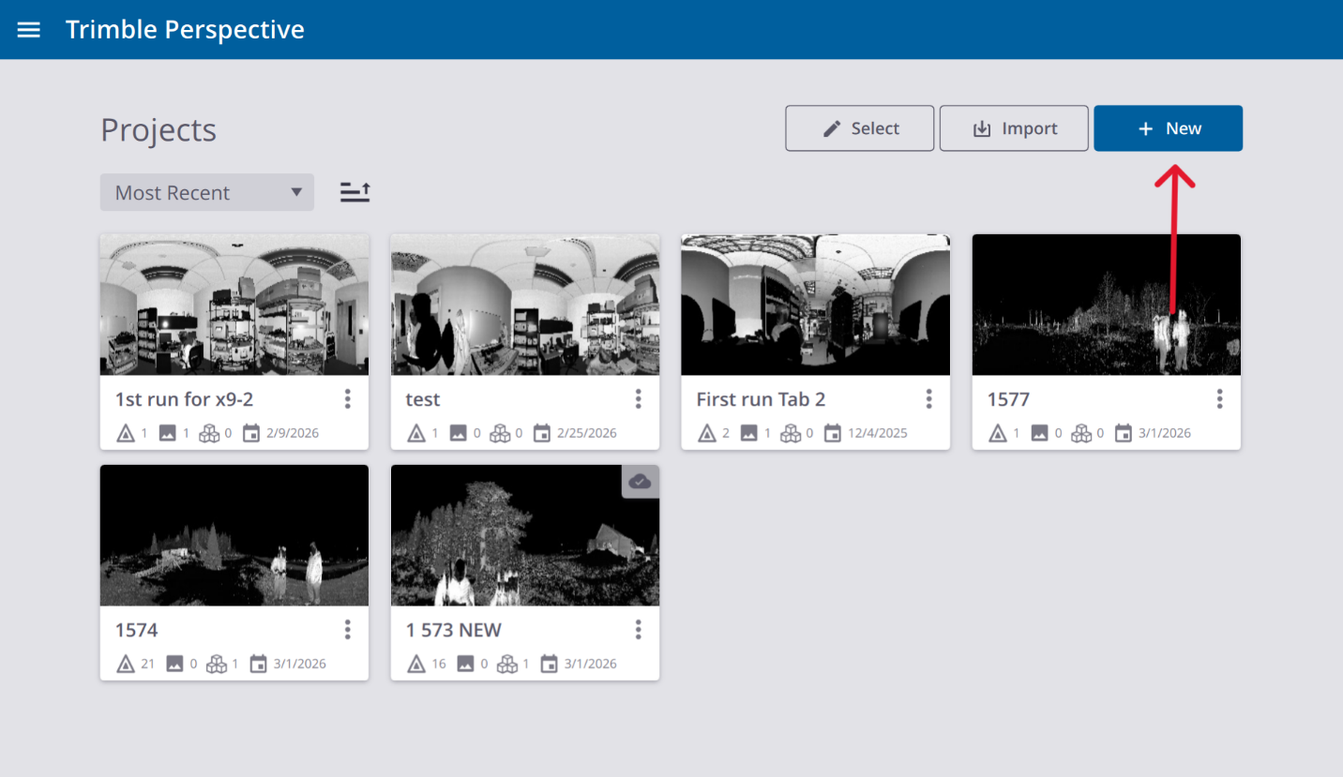
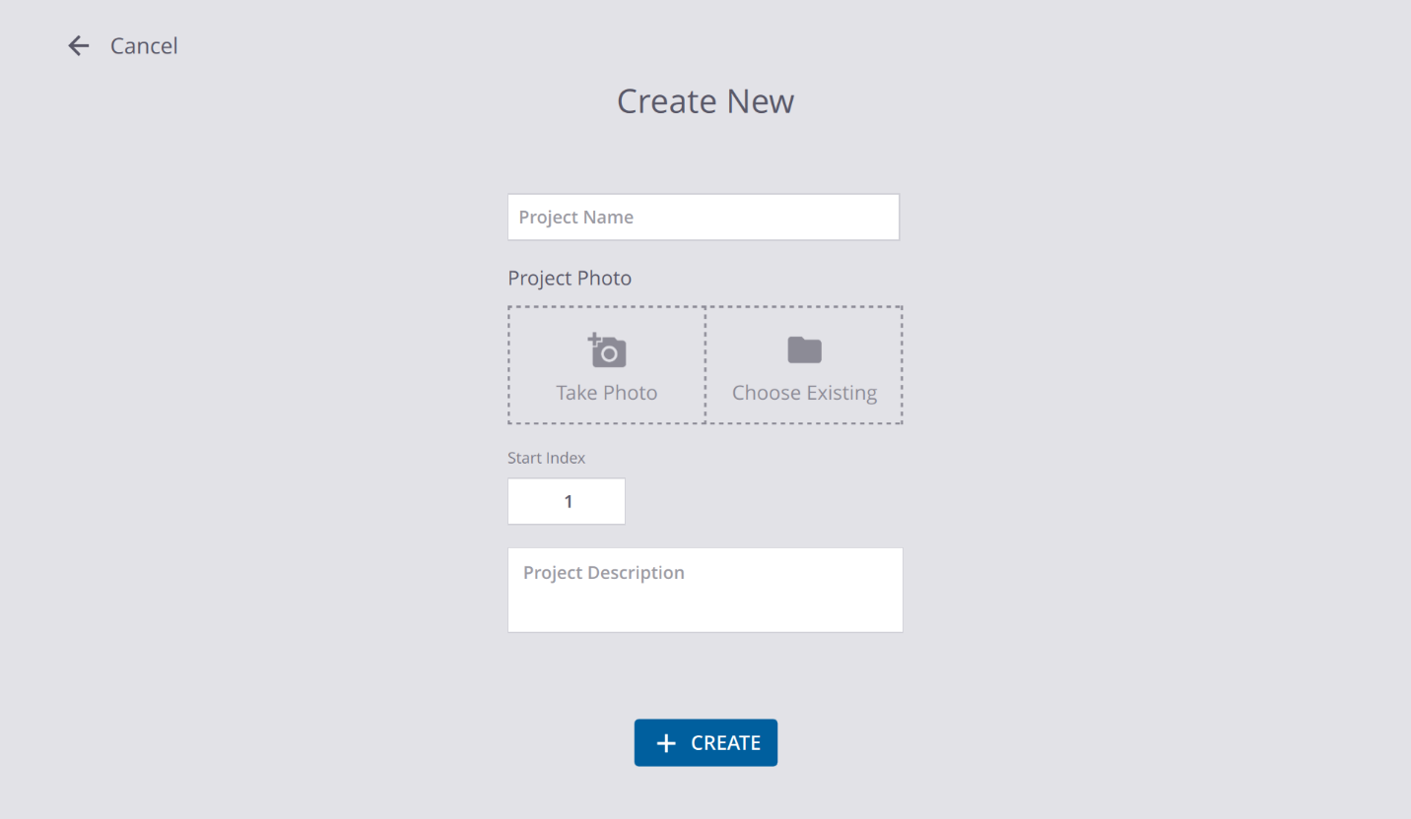
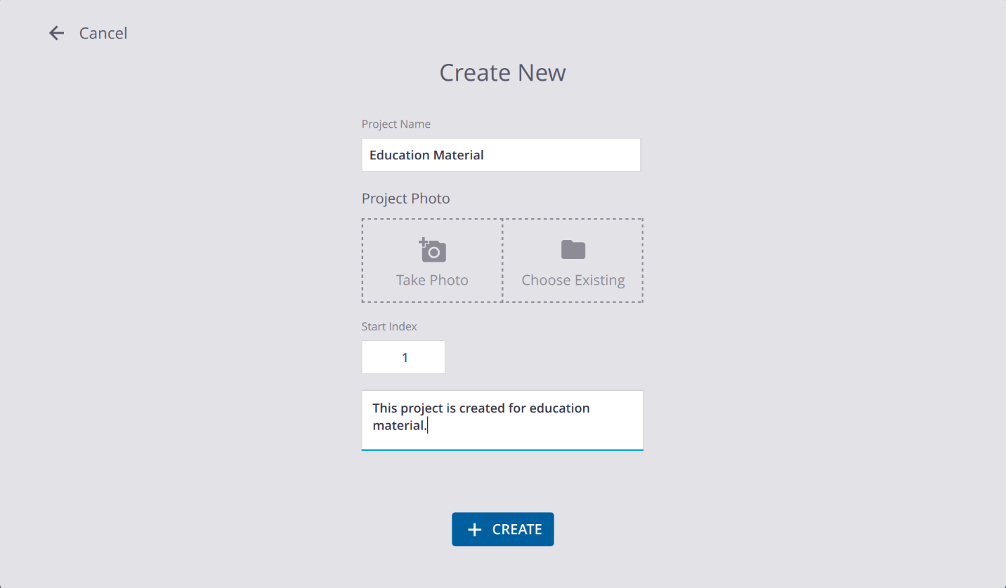

Section 5: Connecting the T110 to the X9
The T110 and X9 communicate wirelessly. They should be automatically connected once you turn on both of them. If they are not connected, you connect them through Trimble Perspective in the beginning a session.

- In Trimble Perspective, open the Connections panel (look for a connection or instrument icon in the toolbar or menu).
- The application will search for available scanners. Select your X9 from the list. If no scanner appears, confirm the X9 is powered on and the LEDs indicate it is ready.
- Tap Connect. The connection process takes a few seconds.
- Once connected, the scanner's on/off LED will change from flashing yellow to solid yellow, and the Trimble Perspective status bar will confirm the connection.

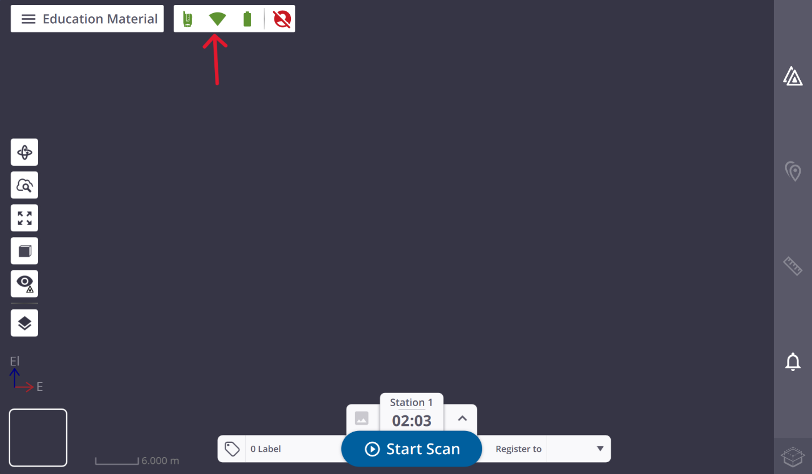
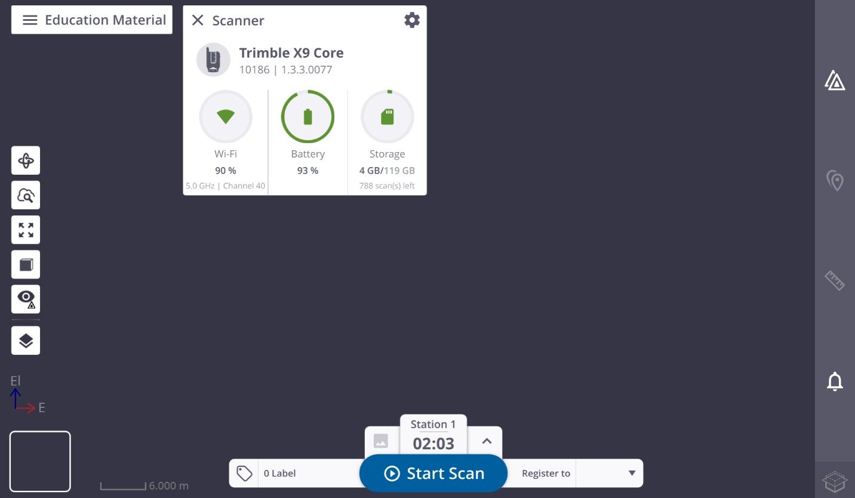

After connection, confirm that Perspective shows the scanner status as ready and connected before proceeding.
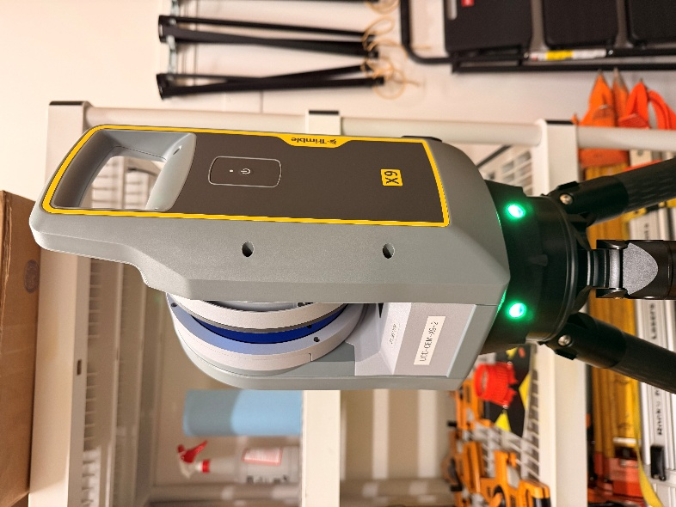

Section 6: Setting Scan Parameters
Before capturing each station, you configure the scan parameters in Trimble Perspective. These settings control the quality, completeness, and capture time of the scan. You can set them once at the project level and adjust per-station as needed.

Key Parameters
Parameter | What It Controls
Scan Resolution | How densely the laser samples the space. Higher resolution = more points = longer scan time. Use higher resolution only where the detail is needed.
Scan Area | Whether to scan a full 360° sphere or limit the scan to a defined angular window. Full sphere is standard unless you specifically need to exclude a direction.
Image Capture | Whether to take photographs for colorizing the point cloud or creating panoramas. Adds time but produces more useful deliverables.
Registration Behavior | How the scanner attempts to register this new station to the existing project. Leave on automatic unless you have a specific reason to change it.
Coordinate Display | How coordinates are shown in the project. Match this to your project coordinate system.

Practical Guidance on Resolution
Scan resolution is the most consequential parameter for balancing quality and field time. Higher resolution captures more points and more detail, but each scan takes longer. With many stations, this adds up quickly.
- For large spaces (open floors, atriums, outdoor areas) where you are capturing overall geometry, standard or medium resolution is usually sufficient.
- For detailed areas (mechanical rooms, intricate facades, areas being modeled in high detail), use high resolution only for those stations.
- Do not default to maximum resolution for every station. Review the deliverable requirements before the session and set resolution accordingly.

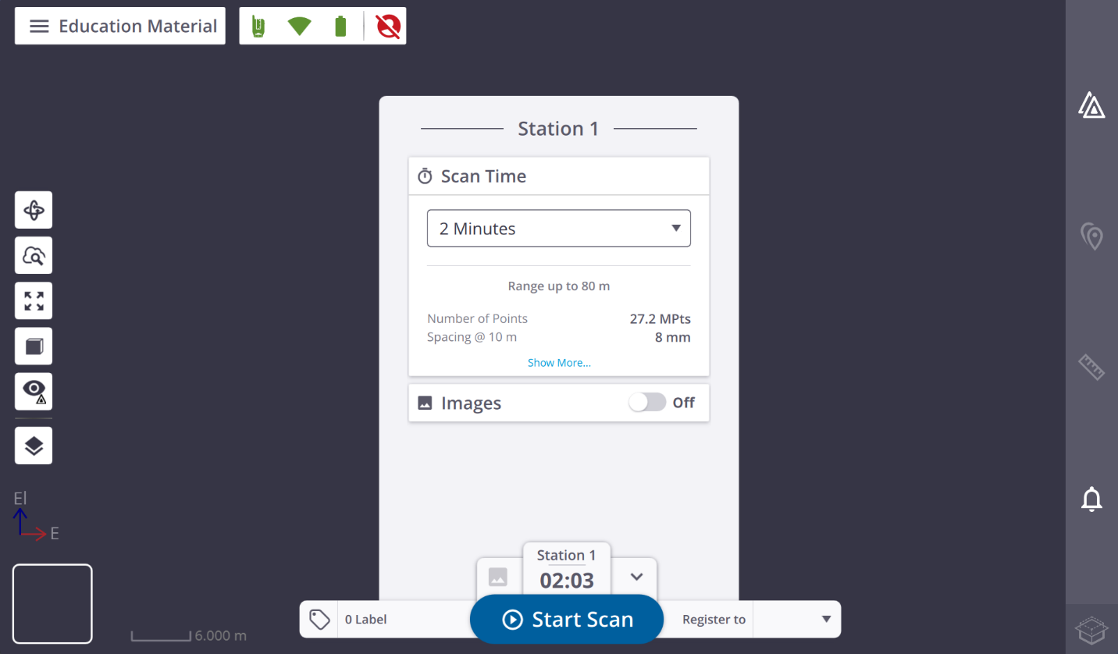
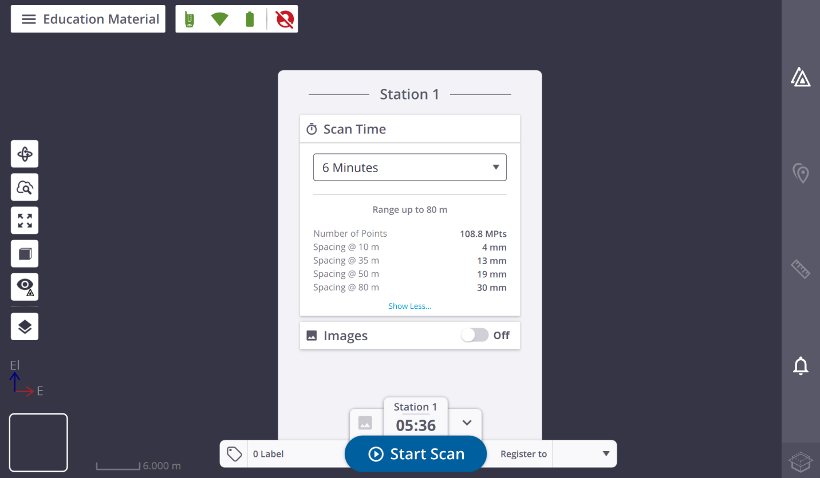

Section 7: Capturing a Scan Station
With the project created, the scanner connected, and parameters set, you are ready to capture your first station.

Starting the Scan
- In Trimble Perspective, tap Start Scan.
- The scanner will run through an automatic sequence: initialization, final leveling check, calibration, and then the actual scan. The ring LEDs will flash blue throughout this sequence.
- Move away from the scanner immediately after starting the scan. Any person, object, or movement within the scanner's line of sight during scanning will appear in the point cloud as an artifact. Move to a position where the scanner cannot see you, such as behind a wall, doorway, or column.
- Do not approach the scanner until the ring LEDs return to solid green and Trimble Perspective shows the scan is complete.
- Review the captured point cloud on the T110 screen. It should look like a recognizable map of the space with clear walls, floor, and ceiling. If it looks wrong (few points, gaps in obvious areas, or clearly misaligned), investigate before moving on.
Warning: Do not touch or bump the tripod while scanning. Even a small movement will introduce a shift in the point cloud that makes registration difficult or impossible. Keep other people away from the tripod area during scanning.

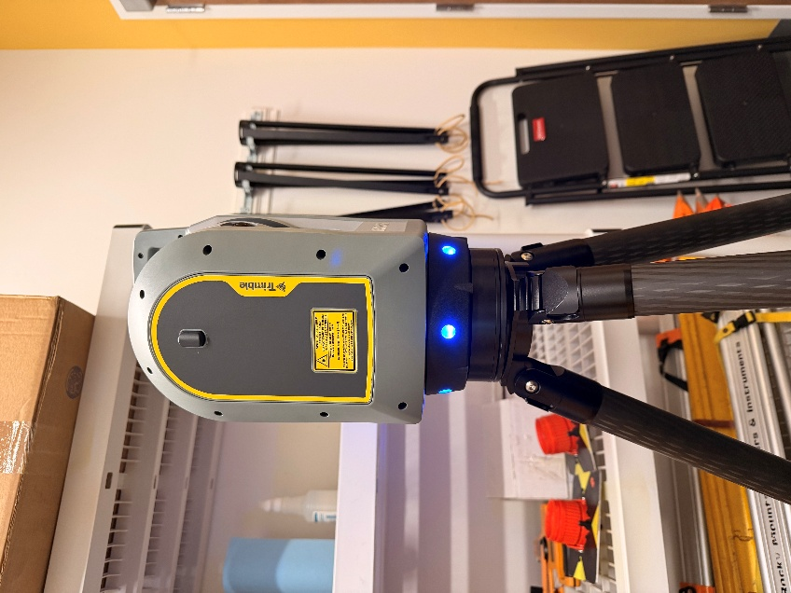

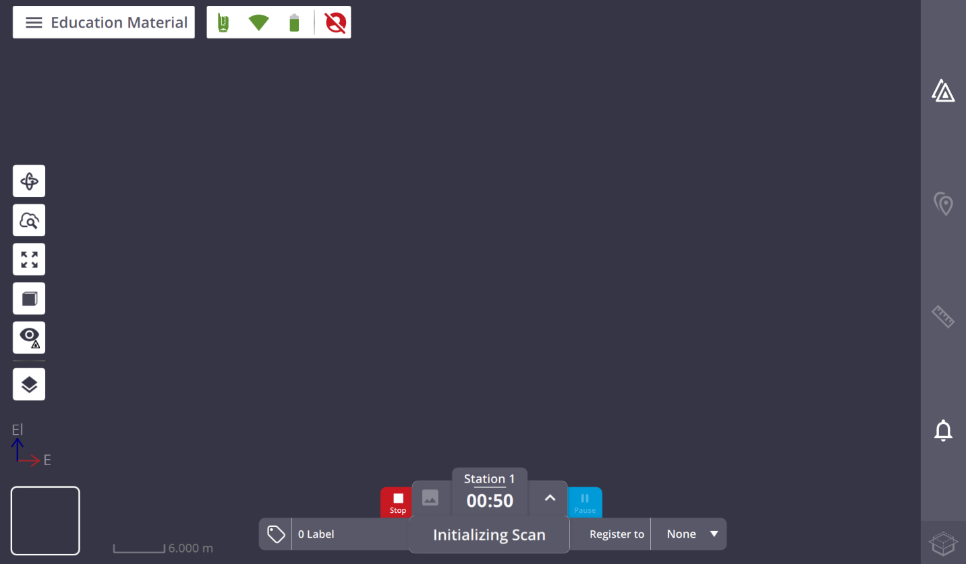
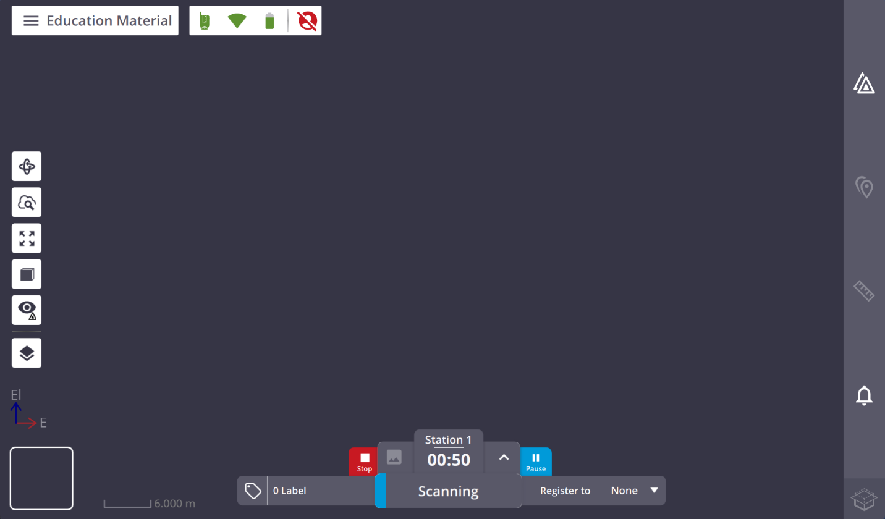
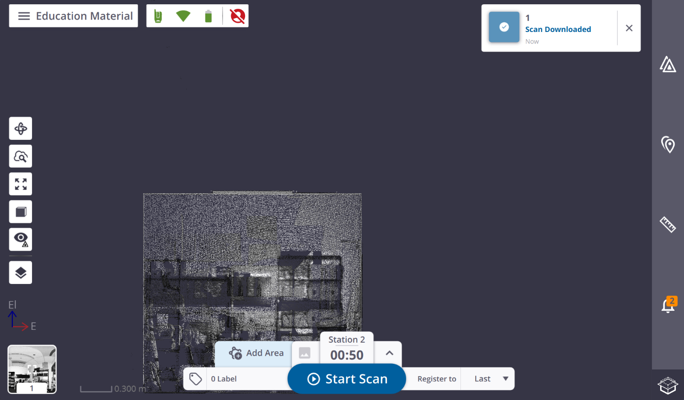
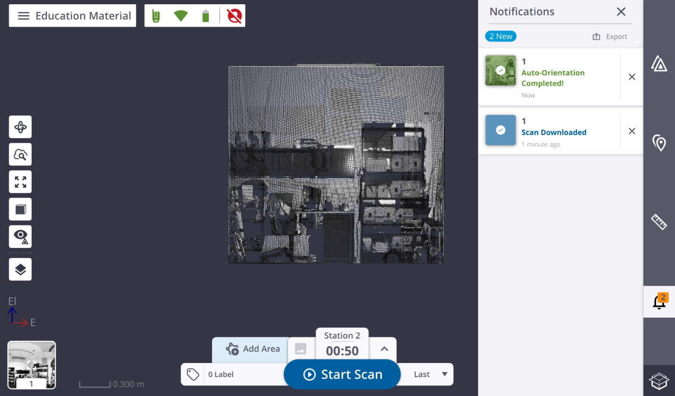

For the First Station
The first station sets the foundation for every subsequent scan in the project. Choose it carefully:
- Pick a central position with broad visibility, one from which you can see a large portion of the overall space.
- Avoid starting in a corner or narrow corridor if possible. The more of the space that is visible from the first station, the more geometry subsequent stations have to register against.
- The first station does not register to anything (there is no previous station). Subsequent stations each register to what has already been captured.

Section 8: Registration and Stitching the Scans Together
Registration is what transforms a collection of individual scan stations into a single, unified point cloud. The X9 handles this automatically after each new scan is captured, but you need to understand how it works and how to check it.

How Automatic Registration Works
After you capture a new station and review it, Trimble Perspective automatically attempts to register it to the accumulated project, which is the combined set of all previous stations. It does this by finding matching geometry (the same walls, corners, and surfaces) in both the new scan and the existing data, then computing the spatial transformation that aligns them.
When it succeeds, the new station "snaps" into place relative to the rest of the project. When it fails or is uncertain, Perspective will show you a warning or notification.

Reviewing Registration After Each Scan
Do not move the scanner to the next position until you have reviewed the registration of the current station. Fixing a registration problem in the field takes minutes. Discovering it back in the office can require a return trip to the site.

- After each scan completes, watch for the automatic registration result in Trimble Perspective.
- Visually inspect the registered point cloud by zooming out and looking at the combined result. The new station should fit seamlessly into the existing data. Look for obvious misalignments: walls that do not line up, doubled surfaces, or gaps where there should be none.
- If Perspective shows a "Check Registration" warning, take it seriously. This does not automatically mean the registration is wrong, but it does mean the software is not confident. Inspect the result carefully and decide whether to accept or re-do the scan.
- If the registration looks correct visually, proceed to the next station. If it looks wrong, use Manual Registration (described in the next section) before moving on.

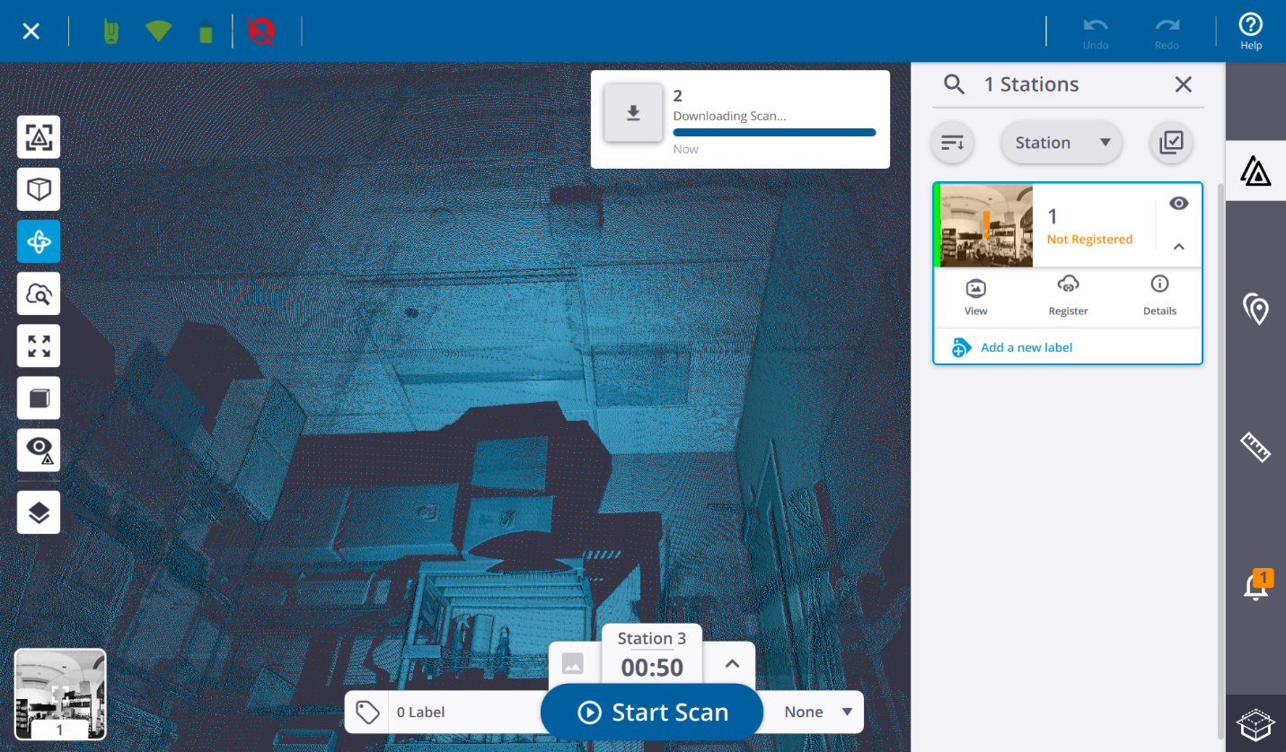
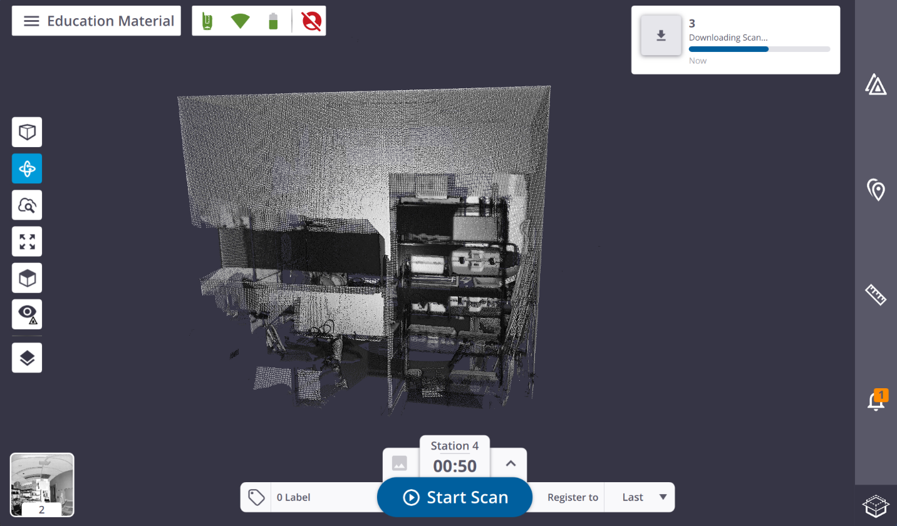
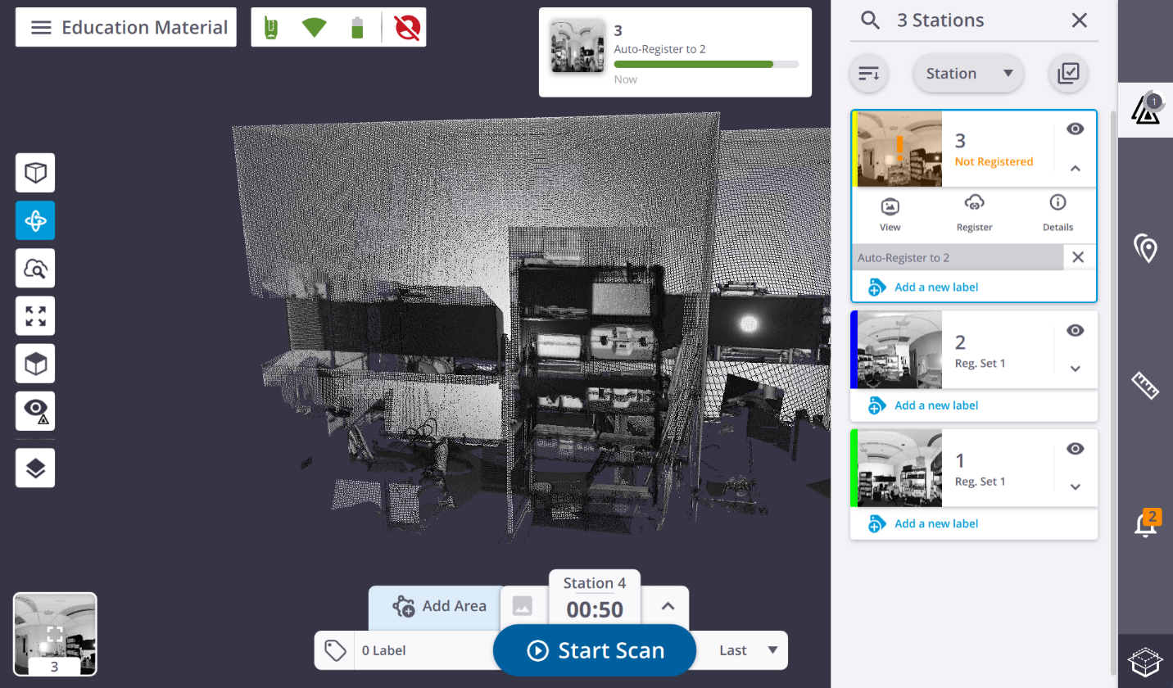
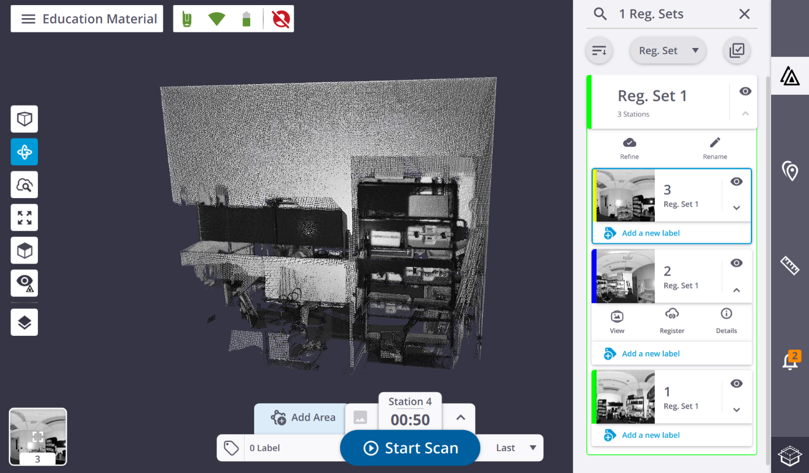

Section 9: Manual Registration
If automatic registration fails or produces an incorrect result, you can perform manual registration in Trimble Perspective. Manual registration works by identifying the same physical points in two scan stations and using those matching points to compute the alignment.

When to Use Manual Registration
- Automatic registration returned a "Check Registration" warning and visual inspection confirms something is wrong.
- Two stations that should overlap are not aligning automatically. This often happens because the overlap area had repetitive or featureless geometry (a long blank corridor, for example).
- You are connecting scans from two sessions that were not automatically linked.

Manual Registration Workflow
- In Trimble Perspective, open the two stations that need to be matched and select Manual Registration.
- Identify a clear, sharp, permanent feature that is visible in both scans, such as a corner edge, a bolt head, the center of a target, or the edge of a structural column. Vague surfaces with no distinct geometry do not work well.
- Place a precision point (annotation) on that feature in both scans. Be as precise as possible. Zoom in and place the point at exactly the same physical location in each scan.
- Add at least three matching point pairs distributed across the overlap area. Three widely spaced points give a much more reliable result than three points clustered in the same corner.
- Run the manual registration and review the result visually. If it looks correct, Accept. If not, refine the point placements and try again.

Note: The best manual tie points are: corner edges, target centers (if targets were placed), bolt or plate corners, checkerboard targets. Avoid flat wall surfaces or floors with no distinctive features.

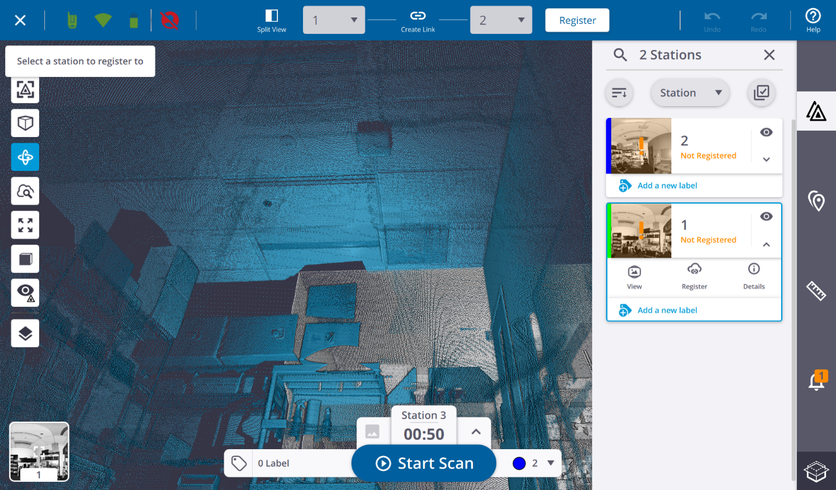
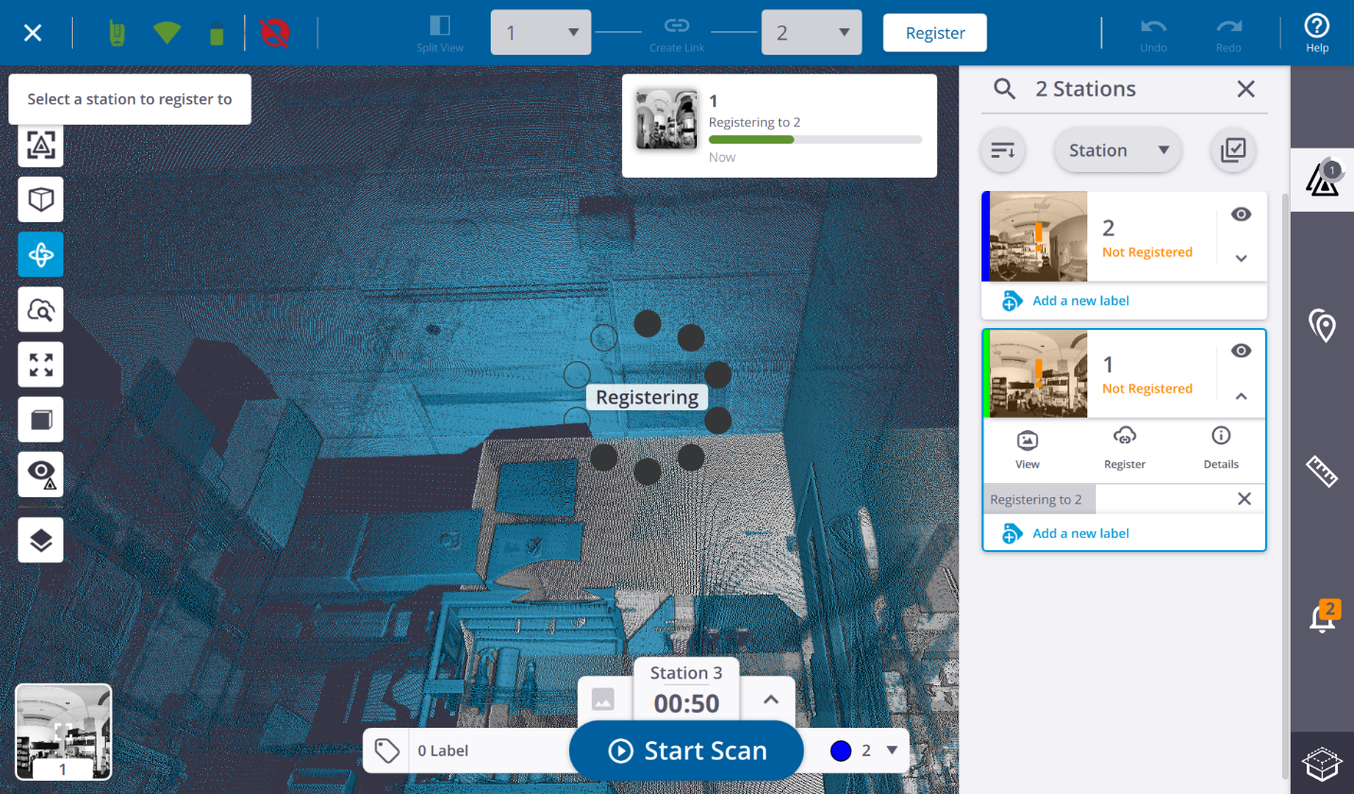
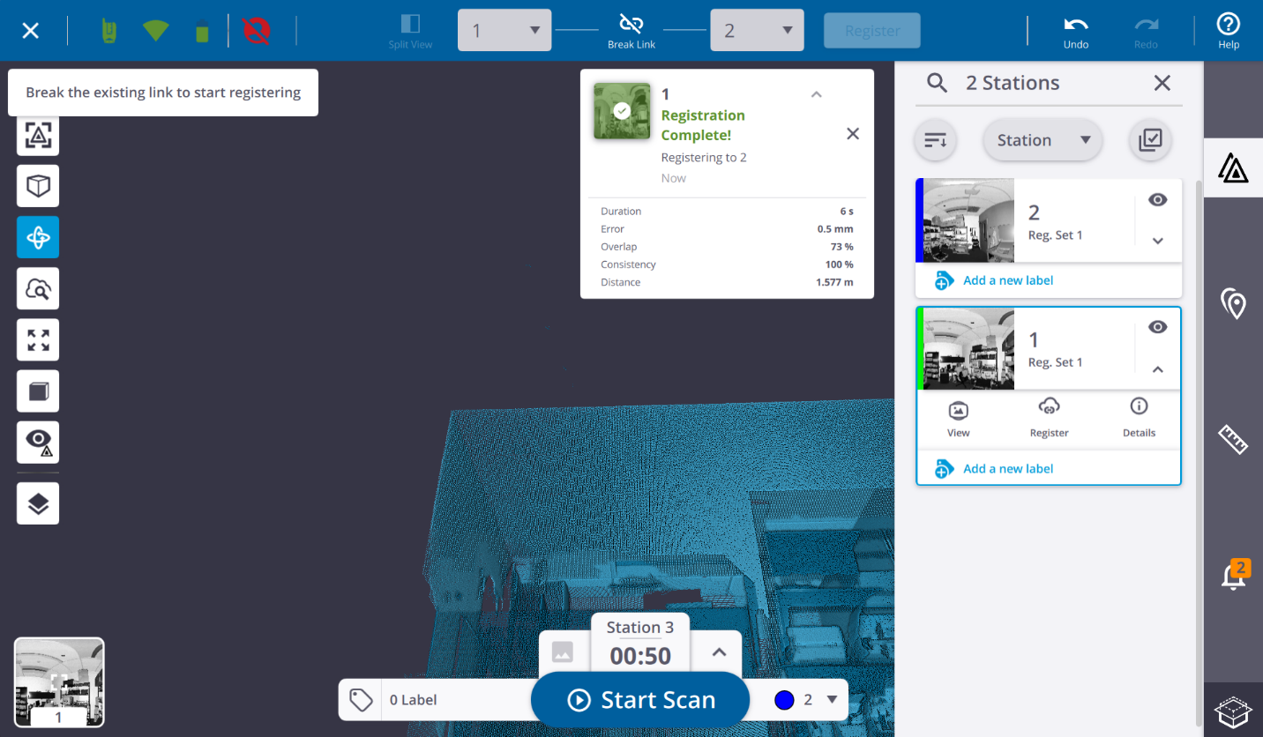

Section 10: The Station-by-Station Workflow
Once you are past the first station, you repeat the same cycle for every subsequent position. Internalizing this loop is what makes field work efficient.
- Move the scanner to the next planned position.
- Set up the tripod so it is stable and level by eye.
- Mount the scanner and confirm it is secure.
- Power on the scanner and wait for the leveling LEDs to turn solid green.
- Connect through Trimble Perspective if the connection dropped during the move.
- Confirm or adjust the scan parameters for this station.
- Tap Start Scan and move clear of the scanner immediately.
- Wait for the scan to finish, then review the captured point cloud on the T110.
- Review the automatic registration and visually confirm it appears correct.
- If the registration is incorrect, perform manual registration before continuing.
- Check coverage:
  - Is coverage complete from this position?
  - Are there any shadows or gaps that still need to be addressed?
- Repeat Steps 1–11 until all planned stations have been captured.

Field Quality Checks to Ask After Every Station
- Do I have enough overlap with the previous station? (Look at the combined point cloud, where shared areas should be dense and aligned.)
- Did the new scan cover areas that were in shadow from the previous station?
- Is the registration chain still healthy? (Check that all previous stations are still correctly aligned. A bad registration in the middle can shift everything that came after it.)
- Do I need to capture a panorama or image for this station's deliverable requirements?
- Do I need to add any annotations or precision points here (defect labels, control tie points, important location markers)?

Section 11: Annotations and Field Notes
Trimble Perspective allows you to add annotations and precision points directly to your scans in the field. These are small but valuable because they carry information from the field into the office without relying on memory or paper notes.

- Use annotations to label defects, areas of interest, or important locations ("crack in south wall", "MEP penetration", "control point A").
- Use precision points to tie your scans to known survey control. Place a point on a surveyed target or benchmark and enter its coordinates. This allows you to georeference the entire project in the office.
- Mark any areas where coverage is uncertain, so the office team knows to look carefully during quality control.
- Annotations and precision points can be exported as CSV from Perspective, making them usable in other software.
Note: Take a photo of your hand-drawn station map at the end of each session and attach it to the project notes. A sketch with station numbers and any unusual conditions is invaluable when processing in the office weeks later.

Section 12: Before Leaving the Site
Before packing up, do a final completeness check. Adding a few extra scans on site takes minutes. Returning to re-scan because you missed an area costs hours.

- All intended areas are covered: walk the entire space mentally and confirm every room, corridor, and zone has at least one station.
- No major occlusions remain: think about anything that was blocked in every scan and confirm you captured it from another angle.
- All stations are registered: open the project overview in Perspective and confirm no station is floating unattached from the rest.
- No red LED errors are active on the scanner.
- The project saves correctly to the SD card: confirm in Perspective that the project is intact and the SD card has sufficient remaining space.
- All required panoramas or images were captured.

Section 13: Powering Down and Packing Up

Powering Down the Scanner
- Hold the power button until the shutdown sequence begins. The ring LEDs will flash rapidly while the scanner saves and powers off. Do not remove the battery or SD card during this process.
- Wait until all LEDs go dark before handling the scanner.

Packing Up
- Remove the SD card only after the scanner is fully powered down.
- Remove the battery and store it separately. Never store the scanner long-term with the battery inserted.
- Unmount the scanner from the tripod and place it back in its carrying case.
- Collapse the tripod legs, tighten all clamps, and store the tripod separately.
- Wipe the scanner body with the approved cleaning cloth if it is dusty or dirty. Do not use household cleaners or wet cloths.
- Confirm the carrying case is fully latched before moving it.
Warning: Never store the scanner while it is wet, damp, or dirty. Moisture trapped inside the case will damage the electronics. If the scanner got wet in the field, wipe it dry and leave the case open in a dry room before latching it closed.

Section 14: Finalizing and Exporting in Trimble Perspective
After data capture is complete and all stations are registered, use the Finalize and Export workflow in Trimble Perspective to process, colorize, and export your project.

Finalization Options
Option | What It Does
Colorize Point Clouds | If images were captured during scanning, this process applies the color from those images to each point in the cloud. A scan can only be colorized once, so make sure you are satisfied with the result before accepting.
High-Quality Panorama | Creates a high-resolution 360° panoramic image for each station where images were captured. Useful for visual documentation, client deliverables, and virtual walkthroughs.
Export Project | Exports the entire project (or selected stations) to a folder in your chosen format.
Export Annotations / Points as CSV | Exports all annotations and precision points as a comma-separated file, usable in Excel, AutoCAD, or other software.
Publish to Trimble Reality Capture Platform | Uploads the project to Trimble's cloud service for online viewing and collaboration. Requires an account and internet connection.

Export Formats
The X9 supports several export formats. Choose based on what your downstream software requires:

Format | When to Use It
E57 | The broadest interoperability format. Use this when sharing data with teams using software from different vendors (Autodesk, Bentley, Leica, etc.).
LAS / LAZ | Standard point cloud format for GIS and point-cloud processing tools. Use when downstream tools specifically require LAS.
Trimble Native (.tzf) | Trimble's own format. Use this when staying entirely within the Trimble ecosystem (RealWorks, TBC). Preserves full metadata.
CSV (points/annotations) | Coordinate list for annotations and precision points. Importable into virtually any software.

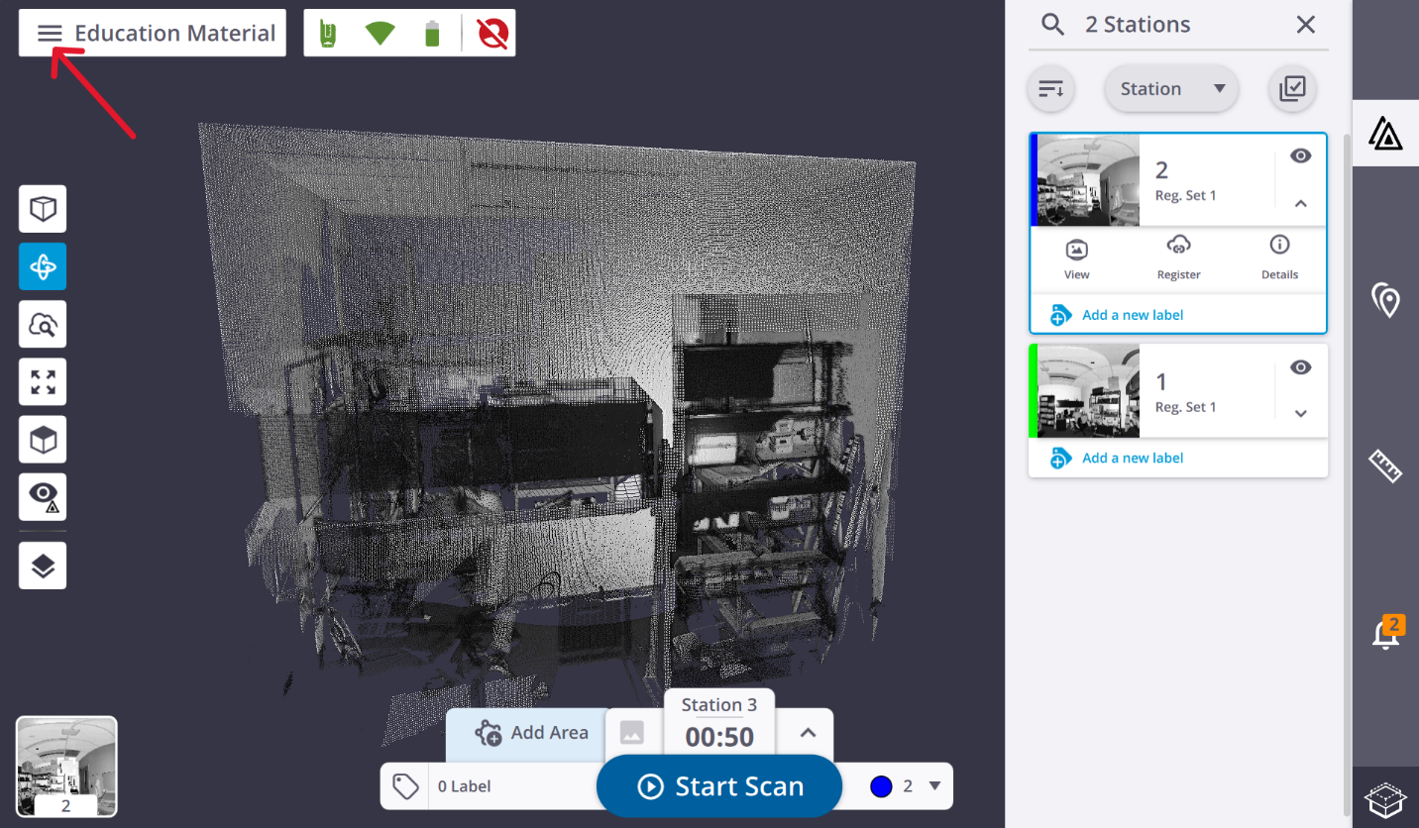

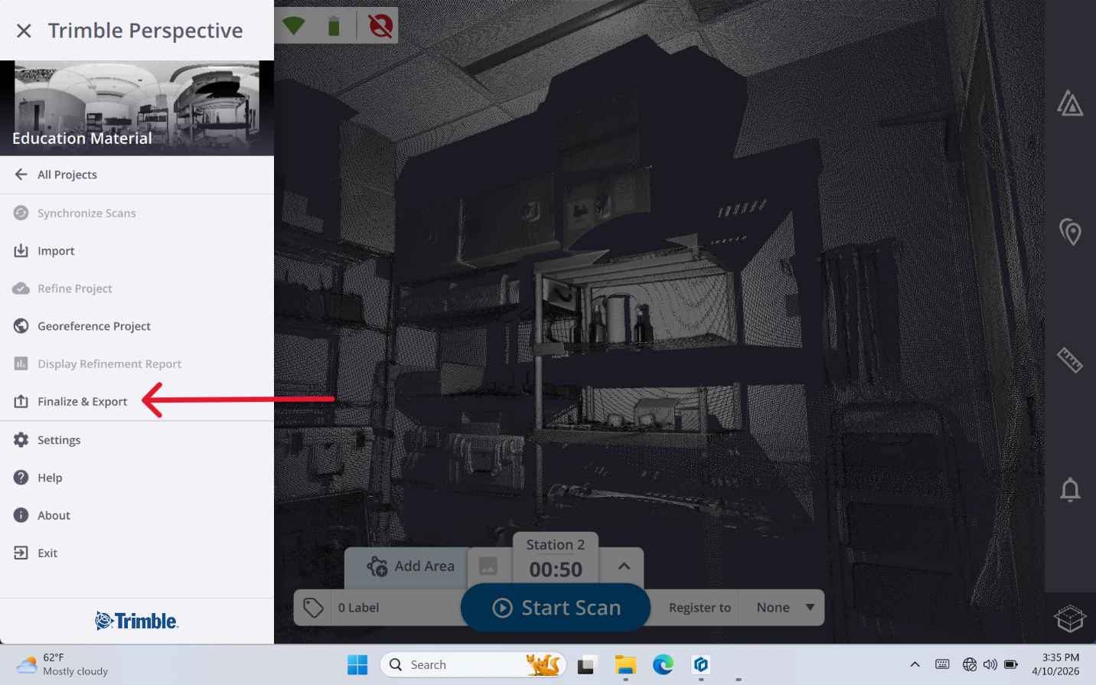
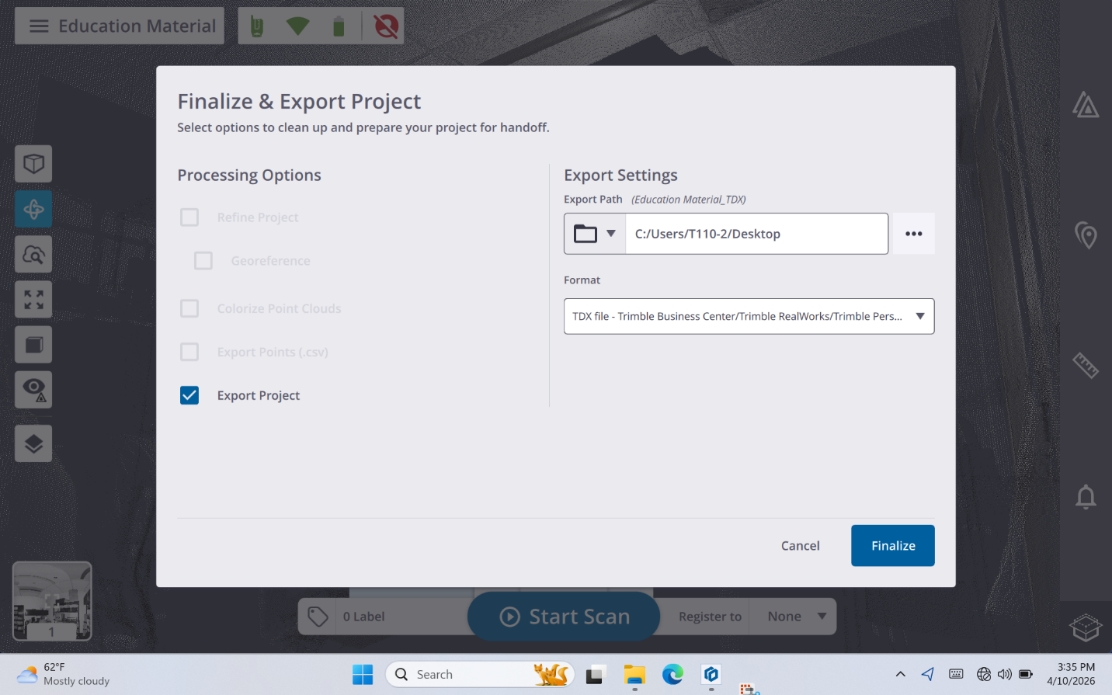

Section 15: Office Processing
Once the project is exported from Trimble Perspective, you bring it into office software for quality control, refinement, and deliverable production.

Typical Office Workflow
- Copy the project folder from the SD card (or the exported folder) to your computer. Back it up to a second location immediately. This is your only copy of the raw data.
- Open Trimble RealWorks or Trimble Business Center (TBC) and import the project. Both applications support X9 project files natively.
- Inspect the registration quality in the office software. Even if everything looked correct in the field, a more detailed inspection in the office can reveal subtle issues.
- Refine registration if needed, since office software provides more powerful registration tools than the field tablet.
- Georeference the project if your deliverable requires real-world coordinates. Use any precision points you placed on known control in the field.
- Clean and classify the point cloud by removing scan noise, unwanted objects, and any artifacts. Most office workflows involve at least basic cleaning.
- Generate deliverables: point clouds, cross-sections, orthoimages, 3D models, measurements, CAD surfaces, or BIM elements, depending on your project requirements.

Note: Trimble offers free training courses for RealWorks at learn.trimble.com. The course "Trimble RealWorks: Forensic I" is a good starting point. Access it at: https://learn.trimble.com/learn/courses/4131/trimble-realworks-forensic-i

Section 16: Best Practices

Lens and Optics Care
- Never touch the lens dome or glass surfaces with your fingers.
- Use the blower first to remove loose dust before using any cloth. Wiping grit drags it across the glass and scratches it.
- Use only the provided lens cloth, gently, when wiping is necessary.
- Store the scanner with the lens cap on.

Data Management
- Always back up the SD card to at least two locations before doing any processing. Raw scan data cannot be re-collected.
- Use a consistent, descriptive project naming convention. Project names that include the site, date, and operator make data management much easier when you have multiple projects.
- Keep a written or digital log of each session: site, date, number of stations, any problems encountered, and any areas that may need a re-scan.

General Field Habits
- Never rush the setup. A stable, level tripod and a proper connection take a few extra minutes but prevent hours of re-work.
- Always review registration before moving to the next station. Never assume it worked.
- Do not leave the field until you have confirmed all stations are captured and registered.
- Keep the SD card with the scanner at all times. It is the only copy of your data until you have backed it up.

Troubleshooting
The following covers the most common problems. If a problem is not listed here or the suggested solution does not resolve it, power down and contact the lab supervisor.

Problem | Likely Cause | What to Do
Scanner will not power on | Battery not seated or discharged | Remove and re-insert battery; try the second battery; confirm battery was charged
Scanner will not self-level (LEDs keep adjusting) | Tripod too far out of level | Adjust individual tripod leg lengths until the head is closer to level, then retry
Solid red LED after startup | Battery, SD card, leveling, or hardware issue | Check T110 screen for specific error message; confirm SD card is inserted; check battery level
T110 cannot find the scanner | Scanner not fully started, or Bluetooth range issue | Wait for scanner startup to complete; move T110 closer; restart Perspective
"Check Registration" warning | Insufficient overlap, or featureless geometry in overlap zone | Inspect the result visually; if wrong, use Manual Registration; consider adding an intermediate station
Scan shows artifacts or smears | Movement during the scan | Confirm area was clear; re-scan; discard the affected scan
SD card not recognized | Card not fully inserted, or inserted while scanner was on | Power down; re-insert card firmly; power on again
Scanner powers off mid-scan | Battery depleted | Replace with fully charged battery; re-scan the affected station
Point cloud looks sparse in a specific area | That area was in shadow (occlusion) from this station | Add a scan station that sees the missing area from a different angle
All stations from a session appear to float (not connected) | First station has no reference and subsequent registrations all failed | Use Manual Registration to link the floating stations to the main project

Quick Reference
A condensed checklist for operators already familiar with the full process.

- Acclimate scanner: Temp difference (°C) × 2 = minutes to wait; skip if < 5°C difference
- Set up tripod: Wide stance; level head by eye; tighten all clamps; test stability
- Mount X9: Secure via thread or clip; no wobble; never lift by lens dome
- Insert battery + SD card: Battery in with power off; SD card in with power off; doors closed
- Power on: Brief press; wait for ascending beeps + LED stabilization
- Self-leveling: All LEDs solid green = ready; blue = leg too low; red = leg too high
- Create project: Trimble Perspective → New Project; descriptive name with date + location
- Connect T110 to X9: Connections panel → select X9 → Connect; confirm solid yellow LED
- Set scan parameters: Resolution per area requirements; enable image capture if needed
- Start scan: Tap Start Scan; move clear immediately; do not touch tripod during scan
- Review registration: Inspect visually after every scan; use Manual Registration if automatic failed
- Station spacing: Outdoors high-res: < 10 m; Indoors low-res: < 2 m; closer is always better
- Before leaving site: All areas covered; all stations registered; no red LEDs; project saves correctly
- Power down: Hold power button; wait for all LEDs to go dark; then remove SD card
- Export formats: E57 for broad compatibility; LAS for GIS tools; Trimble native for RealWorks/TBC

