TITLE OF THESIS OR DISSERTATION IN ALL CAPS
by
YOUR NAME IN ALL CAPS
B.S., Undergrad University Name, Year
M.S., Master’s University if Applicable, Year

A thesis/dissertation submitted to the
Faculty of the Graduate School of the
University of Colorado in partial fulfillment
of the requirements for the degree of
Degree Type
Program Name with the Word ‘Program’ After It
Four-Digit Year
*Do not include a page number on the title page. Although it is counted as page i.
*Do not include certificates/other credentials under your name. Only previously earned degrees.
*Do not add the word ‘Denver’ after ‘Colorado’
*Degree type examples: Doctor of Philosophy, Master of Arts, Master of Science. (Do not include program name on this line). Do not combine any lines into one.
*Do not include any tracks, concentrations, specializations, certificates, etc.
*Do not include running heads anywhere in the document irrespective of what your writing style/format (like APA) calls for.

*You should only include this page if you plan to pay the $85 to copyright your thesis/dissertation upon submitting to ProQuest. Remove it altogether otherwise.

© FOUR-DIGIT YEAR
YOUR NAME IN ALL CAPS
ALL RIGHTS RESERVED

This thesis/dissertation for the Degree Type degree by
Your Name
has been approved for the
Program Name with the word ‘Program’ After It
by

Chair Name, Chair
Advisor Name if Different from Chair, Advisor
Committee Member Name
Committee Member Name
Committee Member Name
Date: Month ##, ####
*Do not include “Dr.” prefixes before any faculty’s name
*Do not include post-nominal letters, like “PhD” after any faculty’s name
*Chair is listed first, Advisor second IF they are different people. Chair is your thesis/dissertation committee chair, not your Department Chair.
*If your Advisor is your Chair, list them first with ONLY the word “Chair” after their name.
*The date is the official end of semester date that corresponds to the term in which you will graduate. See Registrar website for exact date. Do not include your defense date or date of submission. The date should be right-aligned (not in the center) as it is currently formatted.
Last Name, First Name (Degree Initial, Program Name)
Your Thesis or Dissertation Title in Title Case
Thesis/dissertation by Advisor’s Professor Title Professor Name
ABSTRACT
Insert your abstract here. Insert your abstract here. Insert your abstract here. Insert your abstract here. Insert your abstract here. Insert your abstract here. Insert your abstract here. Insert your abstract here. Insert your abstract here. Insert your abstract here. Insert your abstract here.
The form and content of this abstract are approved. I recommend its publication.
Approved: Advisor’s Name

*In line 1, the degree initial and program name in parenthesis should correspond with the degree will you be earning (i.e., the degree you will earn by submitting this thesis/dissertation).
*Anywhere that you list your Advisor’s name, do not include “Dr.” or post-nominal letters like “PhD”
*”Professor title” examples: Professor, Associate Professor, Assistant Professor, etc. Be sure to confirm your Advisor’s official title with them (in case it has changed by the time you submit your thesis). Do not add other titles like “Department Chair” or “Program Director” or “Graduate Advisor.”
*”The form and content…” line is required, be sure to leave it on this page, exactly as its formatted (i.e., right-aligned).
DEDICATION
Type your dedication here in black font, double-spaced.

*This page is not required. Remove this altogether if you do not wish to include a dedication. If you choose to include one, it must appear in this order, i.e., immediately following the abstract. Keep the heading formatted exactly as above.

ACKNOWLEDGMENTS
Type your acknowledgments here in black font, double-spaced.

*This page is not required. Remove this altogether if you do not wish to include an acknowledgments page. If you choose to include one, it must appear in this order, i.e., immediately following the dedication. If you do not include a dedication, then immediately following the abstract. Keep the heading formatted exactly as above.

TABLE OF CONTENTS
CHAPTER
- ACTUAL TITLE OF CHAPTER I 1
Title of Level 1 Heading if Included but Not Required 2
Title of Level 2 Heading if Included but Not Required 3
Title of Level 3 Heading if Included but Not Required 4
- ACTUAL TITLE OF CHAPTER II 7
REFERENCES 9
APPENDIX 10

*You may include leaders (i.e., periods) between each line and the page number column if you prefer. If you do, be consistent and apply to all lines.
*Use a neat, consistent double-space between each line.
*You may include only chapter headings and exclude headings of all other levels (level 1 headings, level 2 headings, etc.) if you choose. It’s up to you but be consistent. You may not include level headings for one chapter but not others.
*Make sure page number column is perfectly aligned on the far right and don’t let text get too close to the page number column.
*Only include an appendix line if you will actually include one in your manuscript, otherwise delete it altogether. If you have more than one appendix (i.e., you will split them as appendix A, B, C, etc.), see format guide sample page for how to format them in the table of contents.

CHAPTER I

ACTUAL TITLE OF CHAPTER I
Sample text in the body of your chapters. Sample text in the body of your chapters. Sample text in the body of your chapters. Sample text in the body of your chapters. Sample text in the body of your chapters. Sample text in the body of your chapters. Sample text in the body of your chapters. Sample text in the body of your chapters. Sample text in the body of your chapters. Sample text in the body of your chapters. Sample text in the body of your chapters. Sample text in the body of your chapters. Sample text in the body of your chapters. Sample text in the body of your chapters. Sample text in the body of your chapters. Sample text in the body of your chapters. Sample text in the body of your chapters. Sample text in the body of your chapters. Sample text in the body of your chapters. Sample text in the body of your chapters. Sample text in the body of your chapters. Sample text in the body of your chapters. Sample text in the body of your chapters. Sample text in the body of your chapters. Sample text in the body of your chapters. Sample text in the body of your chapters. Sample text in the body of your chapters. Sample text in the body of your chapters.
Sample text in the body of your chapters. Sample text in the body of your chapters. Sample text in the body of your chapters. Sample text in the body of your chapters. Sample text in the body of your chapters. Sample text in the body of your chapters. Sample text in the body of your chapters. Sample text in the body of your chapters. Sample text in the body of your chapters. Sample text in the body of your chapters. Sample text in the body of your chapters. Sample text in the body of your chapters. Sample text in the body of your chapters. Sample text in the body of your chapters. Sample text in the body of your chapters. Sample text in the body of your chapters. Sample text in the body of your chapters. Sample text in the body of your chapters. Sample text in the body of your chapters. Sample text in the body of your chapters. Sample text in the body of your chapters. Sample text in the body of your chapters. Sample text in the body of your chapters. Sample text in the body of your chapters. Sample text in the body of your chapters. Sample text in the body of your chapters. Sample text in the body of your chapters. Sample text in the body of your chapters.
Sample Level One Heading in Title Case
Sample text in the body of your chapters. Sample text in the body of your chapters. Sample text in the body of your chapters. Sample text in the body of your chapters. Sample text in the body of your chapters. Sample text in the body of your chapters. Sample text in the body of your chapters. Sample text in the body of your chapters. Sample text in the body of your chapters. Sample text in the body of your chapters. Sample text in the body of your chapters. Sample text in the body of your chapters. Sample text in the body of your chapters. Sample text in the body of your chapters. Sample text in the body of your chapters. Sample text in the body of your chapters. Sample text in the body of your chapters. Sample text in the body of your chapters. Sample text in the body of your chapters. Sample text in the body of your chapters. Sample text in the body of your chapters. Sample text in the body of your chapters. Sample text in the body of your chapters. Sample text in the body of your chapters. Sample text in the body of your chapters. Sample text in the body of your chapters. Sample text in the body of your chapters. Sample text in the body of your chapters.
Sample text in the body of your chapters. Sample text in the body of your chapters. Sample text in the body of your chapters. Sample text in the body of your chapters. Sample text in the body of your chapters. Sample text in the body of your chapters. Sample text in the body of your chapters. Sample text in the body of your chapters. Sample text in the body of your chapters. Sample text in the body of your chapters. Sample text in the body of your chapters.
Sample Level Two Heading in Title Case
Sample text in the body of your chapters. Sample text in the body of your chapters. Sample text in the body of your chapters. Sample text in the body of your chapters. Sample text in the body of your chapters. Sample text in the body of your chapters. Sample text in the body of your chapters. Sample text in the body of your chapters. Sample text in the body of your chapters. Sample text in the body of your chapters. Sample text in the body of your chapters. Sample text in the body of your chapters. Sample text in the body of your chapters. Sample text in the body of your chapters. Sample text in the body of your chapters. Sample text in the body of your chapters. Sample text in the body of your chapters. Sample text in the body of your chapters. Sample text in the body of your chapters. Sample text in the body of your chapters. Sample text in the body of your chapters. Sample text in the body of your chapters. Sample text in the body of your chapters. Sample text in the body of your chapters. Sample text in the body of your chapters. Sample text in the body of your chapters. Sample text in the body of your chapters. Sample text in the body of your chapters.
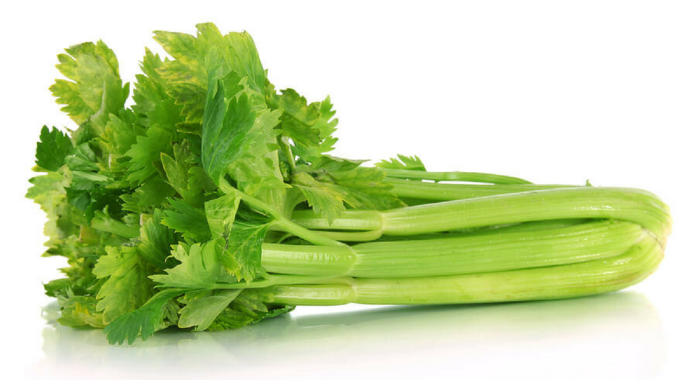
Figure 1.1. Caption in Title Case
Sample text in the body of your chapters. Sample text in the body of your chapters. Sample text in the body of your chapters. Sample text in the body of your chapters. Sample text in the body of your chapters. Sample text in the body of your chapters. Sample text in the body of your chapters. Sample text in the body of your chapters. Sample text in the body of your chapters. Sample text in the body of your chapters. Sample text in the body of your chapters. Sample text in the body of your chapters. Sample text in the body of your chapters. Sample text in the body of your chapters. Sample text in the body of your chapters. Sample text in the body of your chapters. Sample text in the body of your chapters. Sample text in the body of your chapters. Sample text in the body of your chapters. Sample text in the body of your chapters. Sample text in the body of your chapters. Sample text in the body of your chapters. Sample text in the body of your chapters. Sample text in the body of your chapters. Sample text in the body of your chapters. Sample text in the body of your chapters. Sample text in the body of your chapters. Sample text in the body of your chapters.
Table 1.1. Title of Table in Title Case
Table | Example | For | Thesis
Random | Words | Here | This
Is | Just | An | Example

Sample Level Three Heading in Title Case
Sample text in the body of your chapters. Sample text in the body of your chapters. Sample text in the body of your chapters. Sample text in the body of your chapters. Sample text in the body of your chapters. Sample text in the body of your chapters. Sample text in the body of your chapters. Sample text in the body of your chapters. Sample text in the body of your chapters. Sample text in the body of your chapters. Sample text in the body of your chapters. Sample text in the body of your chapters. Sample text in the body of your chapters. Sample text in the body of your chapters. Sample text in the body of your chapters. Sample text in the body of your chapters. Sample text in the body of your chapters. Sample text in the body of your chapters. Sample text in the body of your chapters. Sample text in the body of your chapters. Sample text in the body of your chapters. Sample text in the body of your chapters. Sample text in the body of your chapters. Sample text in the body of your chapters. Sample text in the body of your chapters. Sample text in the body of your chapters. Sample text in the body of your chapters. Sample text in the body of your chapters.
Sample text in the body of your chapters. Sample text in the body of your chapters. Sample text in the body of your chapters. Sample text in the body of your chapters. Sample text in the body of your chapters. Sample text in the body of your chapters. Sample text in the body of your chapters. Sample text in the body of your chapters. Sample text in the body of your chapters. Sample text in the body of your chapters. Sample text in the body of your chapters. Sample text in the body of your chapters. Sample text in the body of your chapters. Sample text in the body of your chapters. Sample text in the body of your chapters. Sample text in the body of your chapters. Sample text in the body of your chapters. Sample text in the body of your chapters. Sample text in the body of your chapters. Sample text in the body of your chapters. Sample text in the body of your chapters. Sample text in the body of your chapters. Sample text in the body of your chapters. Sample text in the body of your chapters. Sample text in the body of your chapters. Sample text in the body of your chapters. Sample text in the body of your chapters. Sample text in the body of your chapters. Sample text in the body of your chapters. Sample text in the body of your chapters. Sample text in the body of your chapters.
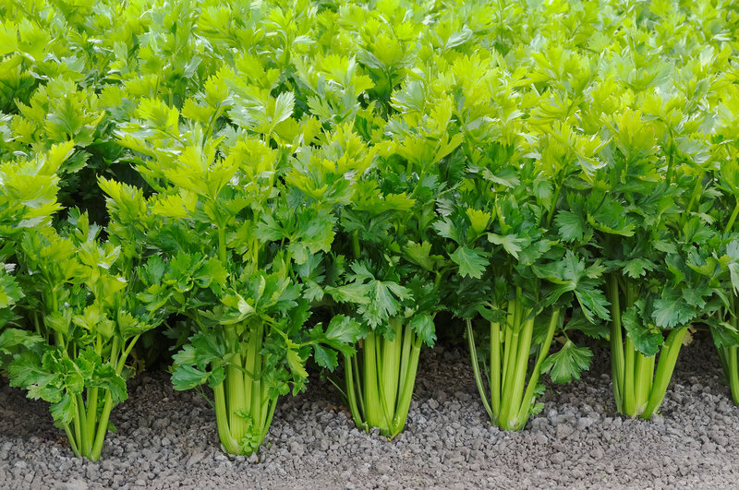
Figure 1.2. Figure Caption for Large Figure

CHAPTER II

ACTUAL TITLE OF CHAPTER II
Sample text in the body of your chapters. Sample text in the body of your chapters. Sample text in the body of your chapters. Sample text in the body of your chapters. Sample text in the body of your chapters. Sample text in the body of your chapters. Sample text in the body of your chapters. Sample text in the body of your chapters. Sample text in the body of your chapters. Sample text in the body of your chapters. Sample text in the body of your chapters. Sample text in the body of your chapters. Sample text in the body of your chapters. Sample text in the body of your chapters. Sample text in the body of your chapters. Sample text in the body of your chapters. Sample text in the body of your chapters. Sample text in the body of your chapters. Sample text in the body of your chapters. Sample text in the body of your chapters. Sample text in the body of your chapters. Sample text in the body of your chapters. Sample text in the body of your chapters. Sample text in the body of your chapters. Sample text in the body of your chapters. Sample text in the body of your chapters. Sample text in the body of your chapters. Sample text in the body of your chapters.
Sample text in the body of your chapters. Sample text in the body of your chapters. Sample text in the body of your chapters. Sample text in the body of your chapters. Sample text in the body of your chapters. Sample text in the body of your chapters. Sample text in the body of your chapters. Sample text in the body of your chapters. Sample text in the body of your chapters. Sample text in the body of your chapters. Sample text in the body of your chapters. Sample text in the body of your chapters. Sample text in the body of your chapters. Sample text in the body of your chapters. Sample text in the body of your chapters.

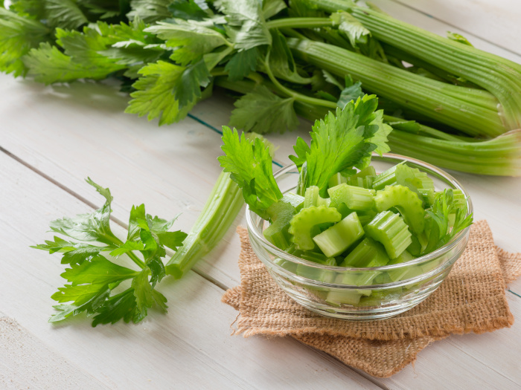
Figure 2.1. Caption For Figure in Title Case

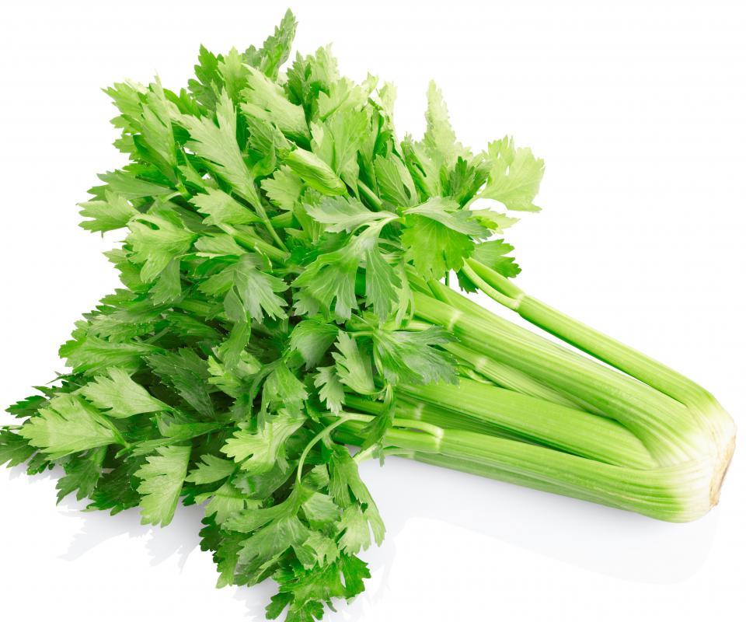

Figure 2.2. Caption For Figure in Title Case

REFERENCES

Achen, Christopher, and Larry Bartels. 2017. Democracy for Realists: Why Elections Do Not

Produce Responsive Government. Princeton, NJ: Princeton University Press.

Adona, Natalie, Paul Gronke, Paul Manson, and Sarah Cole. 2019. “Stewards of Democracy:
The Views of American Local Election Officials.” Democracy Fund Report.
Washington, DC: Democracy Fund.

Alexander, Michelle. 2010. The New Jim Crow: Mass Incarceration in the Age of
Colorblindness. New York, NY: New Press.

Alexander, Michelle. 2020. The New Jim Crow: Mass Incarceration in the Age of
Colorblindness - 10th Anniversary Edition. New York, NY: New Press.

Amar, Akhil Reed. 2012. America's Unwritten Constitution: The Precedents and Principles We
Live By. New York, NY: Basic Books.

Anderson, Carol and Richard J. Durbin. 2018. One Person, No Vote: How Voter Suppression is
Destroying our Democracy. New York, NY: Bloomsbury Publishing.

*The citations above are just examples for how to space out your citations. Use a single-space within citations and one neat and consistent double-space between citations, irrespective of what the citation style you’re using calls for.
*You may use any citation style, e.g., APA, MLA, Chicago, etc. for other aspects of citation formatting, like how to format author names, year, what is italicized or in quotes, etc.
*Do not split citations along a page break. If it spills over to the next page, move the entire citation to the next page.

APPENDIX
*You may include whatever you want here. But all content must fit within 1” margins from all sides, as is the case for the entire document. An appendix is not required, but if you include one, it must be the very last thing in your manuscript and should be included in your table of contents.

*If you only have one appendix, irrespective of how many pages it spans, use the heading above that just says “APPENDIX.” If you have multiple, then you should label each heading as APPENDIX A, APPENDIX B, APPENDIX C, etc., and they should each start on a new/separate page.

